Security Incident Detection and Response Management System
  - Sprint I backend implementation and execution report
Khalil Ayoub, Talia Semaan and Charbel Faddoul
Software Tools Lab | Fall 2026 to 2027
19 October 2026
The backend consists of nine Flask services sharing a SQLite database. This report explains the service responsibilities, API contracts, validation, access controls and actual Postman execution evidence.
Student | Three services | Route prefix
Khalil Ayoub | Assets, threats, vulnerabilities | /khalil-ayoub
Talia Semaan | Users, security audit logs, notifications | /talia-semaan
Charbel Faddoul | Incidents, security reports, playbooks | /charbel-faddoul

2 Table of Contents (Khalil Ayoub, Talia Semaan and Charbel Faddoul)
Responsible team members appear beside each section title. Page numbers refer to this report.
2 Table of Contents (Khalil Ayoub, Talia Semaan and Charbel Faddoul) 2
3 Introduction (Khalil Ayoub, Talia Semaan and Charbel Faddoul) 8
4 System Architecture (Khalil Ayoub, Talia Semaan and Charbel Faddoul) 9
Service communication (Khalil Ayoub, Talia Semaan and Charbel Faddoul) 10
5 Implementation Details (Khalil Ayoub, Talia Semaan and Charbel Faddoul) 11
016 Create critical server (Khalil Ayoub) 12
017 Create workstation (Khalil Ayoub) 13
020 Asset before update (Khalil Ayoub) 14
021 Update asset status (Khalil Ayoub) 15
022 List all assets (Khalil Ayoub) 16
023 Retrieve specific asset (Khalil Ayoub) 17
025 Search assets by asset_name (Khalil Ayoub) 18
026 Search assets by asset_type (Khalil Ayoub) 19
027 Search assets by ip_address (Khalil Ayoub) 20
028 Search assets by department (Khalil Ayoub) 21
029 Search assets by criticality_level (Khalil Ayoub) 22
030 Asset change history (Khalil Ayoub) 23
130 Delete unreferenced asset (Khalil Ayoub) 24
032 Create domain indicator (Khalil Ayoub) 25
033 Create IP indicator (Khalil Ayoub) 26
034 Create hash indicator (Khalil Ayoub) 27
037 List threat indicators (Khalil Ayoub) 28
038 Retrieve threat indicator (Khalil Ayoub) 29
040 Search threats by threat_type (Khalil Ayoub) 30
041 Search threats by threat_value (Khalil Ayoub) 31
042 Search threats by severity (Khalil Ayoub) 32
043 Search threats by source (Khalil Ayoub) 33
044 Update threat severity (Khalil Ayoub) 34
128 Delete threat indicator (Khalil Ayoub) 35
046 Create vulnerability (Khalil Ayoub) 36
047 Create second vulnerability (Khalil Ayoub) 37
049 List vulnerabilities (Khalil Ayoub) 38
050 Retrieve vulnerability (Khalil Ayoub) 39
052 Update vulnerability information (Khalil Ayoub) 40
053 Search vulnerabilities by cve_identifier (Khalil Ayoub) 41
054 Search vulnerabilities by severity (Khalil Ayoub) 42
055 Search vulnerabilities by asset_id (Khalil Ayoub) 43
056 Search vulnerabilities by status (Khalil Ayoub) 44
058 Vulnerability Under Investigation (Khalil Ayoub) 45
059 Vulnerability In Progress (Khalil Ayoub) 46
060 Vulnerability Resolved (Khalil Ayoub) 47
061 Vulnerability Closed (Khalil Ayoub) 48
129 Delete vulnerability (Khalil Ayoub) 49
001 Register user (Talia Semaan) 50
Registration request input (Talia Semaan) 51
006 Update user profile (Talia Semaan) 52
007 List users (Talia Semaan) 53
008 Find user by username (Talia Semaan) 54
011 Assign user role (Talia Semaan) 55
012 Remove user role assignment (Talia Semaan) 56
013 Suspend account (Talia Semaan) 57
015 Reactivate account (Talia Semaan) 58
131 Delete user logically (Talia Semaan) 59
103 Create security log (Talia Semaan) 60
104 List security logs (Talia Semaan) 61
105 Retrieve log record (Talia Semaan) 62
107 Search logs by user_id (Talia Semaan) 63
108 Search logs by action (Talia Semaan) 64
109 Search logs by severity (Talia Semaan) 65
110 Search logs by related_service (Talia Semaan) 66
111 Search logs by date (Talia Semaan) 67
112 Logs for selected user (Talia Semaan) 68
113 User without logs (Talia Semaan) 69
126 Delete security log (Talia Semaan) 70
092 Create notification (Talia Semaan) 71
093 List personal notifications (Talia Semaan) 72
094 Empty user notifications (Talia Semaan) 73
095 Retrieve notification (Talia Semaan) 74
097 Mark notification as read (Talia Semaan) 75
098 Search notifications by user_id (Talia Semaan) 76
099 Search notifications by notification_type (Talia Semaan) 77
100 Search notifications by severity (Talia Semaan) 78
101 Search notifications by status (Talia Semaan) 79
125 Delete notification (Talia Semaan) 80
063 Report employee incident (Charbel Faddoul) 81
064 Create critical incident (Charbel Faddoul) 82
065 List incidents (Charbel Faddoul) 83
066 Retrieve incident (Charbel Faddoul) 84
069 Assign incident to analyst (Charbel Faddoul) 85
070 List assigned incidents (Charbel Faddoul) 86
072 Add investigation note (Charbel Faddoul) 87
073 Retrieve incident with notes (Charbel Faddoul) 88
075 Incident Under Investigation (Charbel Faddoul) 89
076 Incident Mitigated (Charbel Faddoul) 90
077 Incident Resolved (Charbel Faddoul) 91
078 Incident Closed (Charbel Faddoul) 92
115 Generate summary report (Charbel Faddoul) 93
116 Generate incidents report (Charbel Faddoul) 94
117 Generate assets report (Charbel Faddoul) 95
118 Generate threats report (Charbel Faddoul) 96
119 Generate vulnerabilities report (Charbel Faddoul) 97
120 Generate activity report (Charbel Faddoul) 98
079 Create response playbook (Charbel Faddoul) 99
080 Create second playbook (Charbel Faddoul) 100
081 List playbooks (Charbel Faddoul) 101
082 Add response action 1 (Charbel Faddoul) 102
083 Add response action 2 (Charbel Faddoul) 103
085 Action 1 In Progress (Charbel Faddoul) 104
086 Action 1 Completed (Charbel Faddoul) 105
087 Action 2 In Progress (Charbel Faddoul) 106
088 Action 2 Completed (Charbel Faddoul) 107
089 Playbook with ordered actions and history (Charbel Faddoul) 108
127 Delete playbook (Charbel Faddoul) 109
6 Database Design (Khalil Ayoub, Talia Semaan and Charbel Faddoul) 110
Users (Talia Semaan) 111
Users stored records (Talia Semaan) 112
Logs (Talia Semaan) 113
Logs stored records (Talia Semaan) 114
Notifications (Talia Semaan) 115
Notifications stored records (Talia Semaan) 116
Assets (Khalil Ayoub) 117
Assets stored records (Khalil Ayoub) 118
Asset History (Khalil Ayoub) 119
Asset History stored records (Khalil Ayoub) 120
Threats (Khalil Ayoub) 121
Threats stored records (Khalil Ayoub) 122
Vulnerabilities (Khalil Ayoub) 123
Vulnerabilities stored records (Khalil Ayoub) 124
Incidents (Charbel Faddoul) 125
Incidents stored records (Charbel Faddoul) 126
Investigation Notes (Charbel Faddoul) 127
Investigation Notes stored records (Charbel Faddoul) 128
Playbooks (Charbel Faddoul) 129
Playbooks stored records (Charbel Faddoul) 130
Response Actions (Charbel Faddoul) 131
Response Actions stored records (Charbel Faddoul) 132
Action History (Charbel Faddoul) 133
Action History stored records (Charbel Faddoul) 134
Database integrity and retention (Khalil Ayoub, Talia Semaan and Charbel Faddoul) 135
7 Error Handling and Validation (Khalil Ayoub, Talia Semaan and Charbel Faddoul) 136
002 Duplicate username rejected (Talia Semaan) 137
003 Invalid email rejected (Talia Semaan) 138
009 Missing username (Talia Semaan) 139
018 Invalid IP address (Khalil Ayoub) 140
019 Missing asset fields (Khalil Ayoub) 141
024 Missing asset ID (Khalil Ayoub) 142
035 Duplicate indicator rejected (Khalil Ayoub) 143
036 Invalid file hash (Khalil Ayoub) 144
039 Missing threat ID (Khalil Ayoub) 145
048 Invalid CVSS rejected (Khalil Ayoub) 146
051 Missing vulnerability ID (Khalil Ayoub) 147
057 Skipped lifecycle rejected (Khalil Ayoub) 148
067 Missing incident ID (Charbel Faddoul) 149
074 Skipped incident lifecycle rejected (Charbel Faddoul) 150
084 Later action blocked (Charbel Faddoul) 151
090 Missing playbook ID (Charbel Faddoul) 152
096 Missing notification ID (Talia Semaan) 153
106 Missing log ID (Talia Semaan) 154
8 API Documentation (Khalil Ayoub, Talia Semaan and Charbel Faddoul) 155
API reference Khalil Ayoub (Khalil Ayoub) 156
API reference Talia Semaan (Talia Semaan) 159
API reference Charbel Faddoul (Charbel Faddoul) 162
9 Authentication and Authorization (Khalil Ayoub, Talia Semaan and Charbel Faddoul) 165
004 Successful password login (Talia Semaan) 166
005 Failed password login (Talia Semaan) 167
010 Unauthorized user deletion (Talia Semaan) 168
014 Suspended login rejected (Talia Semaan) 169
031 Unauthorized asset deletion (Khalil Ayoub) 170
045 Unauthorized threat deletion (Khalil Ayoub) 171
062 Unauthorized vulnerability deletion (Khalil Ayoub) 172
068 Unauthorized incident assignment (Charbel Faddoul) 173
071 Cross-user incident access denied (Charbel Faddoul) 174
091 Unauthorized playbook deletion (Charbel Faddoul) 175
102 Unauthorized notification deletion (Talia Semaan) 176
114 Unauthorized log deletion (Talia Semaan) 177
121 Unauthorized report generation (Charbel Faddoul) 178
122 Missing bearer token (Khalil Ayoub) 179
123 Authorized same-operation access (Khalil Ayoub) 180
124 Forbidden same-operation access (Khalil Ayoub) 181
10 GitHub and Version Control (Khalil Ayoub, Talia Semaan and Charbel Faddoul) 182
Verified repository contribution (Khalil Ayoub) 183
Verified repository contribution (Charbel Faddoul) 184
Verified repository contribution (Talia Semaan) 185
11 References (Khalil Ayoub, Talia Semaan and Charbel Faddoul) 186

3 Introduction (Khalil Ayoub, Talia Semaan and Charbel Faddoul)
We built a backend for recording cybersecurity incidents, linking affected assets, tracking investigations and remediation, and preserving security activity. The system gives administrators organizational control, analysts investigation tools, regular users personal reporting functions, and auditors read access.
Sprint I covers REST APIs, persistent relational data, authentication, role checks, validation, error responses, API documentation and Postman tests. It does not require a product frontend. Each member owns three distinct services; shared helpers maintain compatible authentication, schema and communication contracts.
The integrated Postman run executed 131 requests with 131 passing status assertions, zero failures and zero runner errors. Expected 400, 401, 403, 404 and 409 responses are successful negative tests. The Python suite also passed 40 tests, including a real HTTP test across all nine applications.

4 System Architecture (Khalil Ayoub, Talia Semaan and Charbel Faddoul)
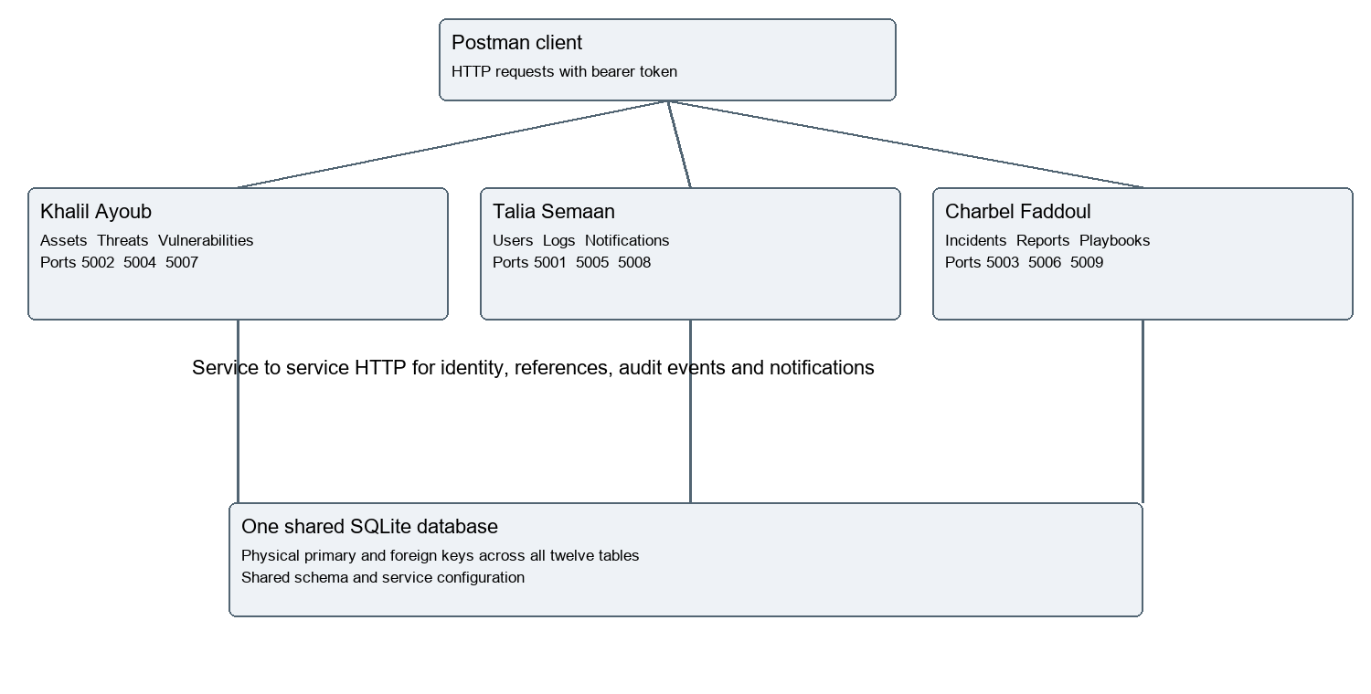
Architecture diagram (Khalil Ayoub, Talia Semaan and Charbel Faddoul). Nine HTTP services use one shared SQLite database.

Service communication (Khalil Ayoub, Talia Semaan and Charbel Faddoul)
Owner | Service | Port
Talia Semaan | users | 5001
Khalil Ayoub | assets | 5002
Charbel Faddoul | incidents | 5003
Khalil Ayoub | threats | 5004
Talia Semaan | logs | 5005
Charbel Faddoul | reports | 5006
Khalil Ayoub | vulnerabilities | 5007
Talia Semaan | notifications | 5008
Charbel Faddoul | playbooks | 5009
Public protected requests carry Authorization Bearer tokens. Services verify those tokens through the identity API. Internal reference lookups, logging and notifications use X-Service-Key from SERVICE_SECRET. Reports fetch authorized source data through HTTP APIs with the caller token. A missing dependency returns an explicit error rather than granting access.
run_services.py starts the nine applications. PROJECT_DB selects the shared database; SERVICE_SECRET is supplied through the environment. The common schema enables foreign keys on every connection. Database work is committed before notification calls where necessary to avoid overlapping SQLite write transactions.

5 Implementation Details (Khalil Ayoub, Talia Semaan and Charbel Faddoul)
Each evidence page names the responsible student, operation and HTTP result. The method, endpoint and request body accompany the original response screenshot. Variables are request templates resolved by Postman during the run; passwords and reusable tokens are excluded from the report.
Figures retain the actual runner responses from 18 October 2026. Reports 115 to 120 precede cleanup 125 to 131; final database views therefore have fewer disposable records. Screenshot response panels may show only the visible portion of a longer JSON response.
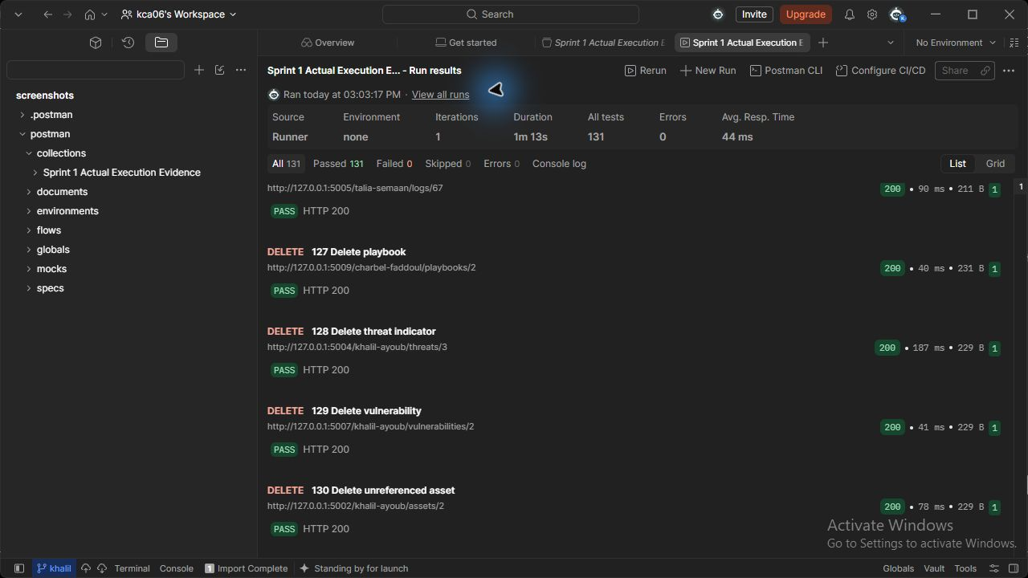
Figure 0 (Khalil Ayoub, Talia Semaan and Charbel Faddoul). Actual Postman collection runner summary: 131 passed, 0 failed, 0 errors.

016 Create critical server (Khalil Ayoub)
POST http://127.0.0.1:5002/khalil-ayoub/assets
JSON body: { "asset_name": "Security Lab Server", "asset_type": "Server", "ip_address": "192.0.2.10", "department": "IT", "owner_id": {{employee_id}}, "location": "AUB Lab", "criticality_level": "Critical" }
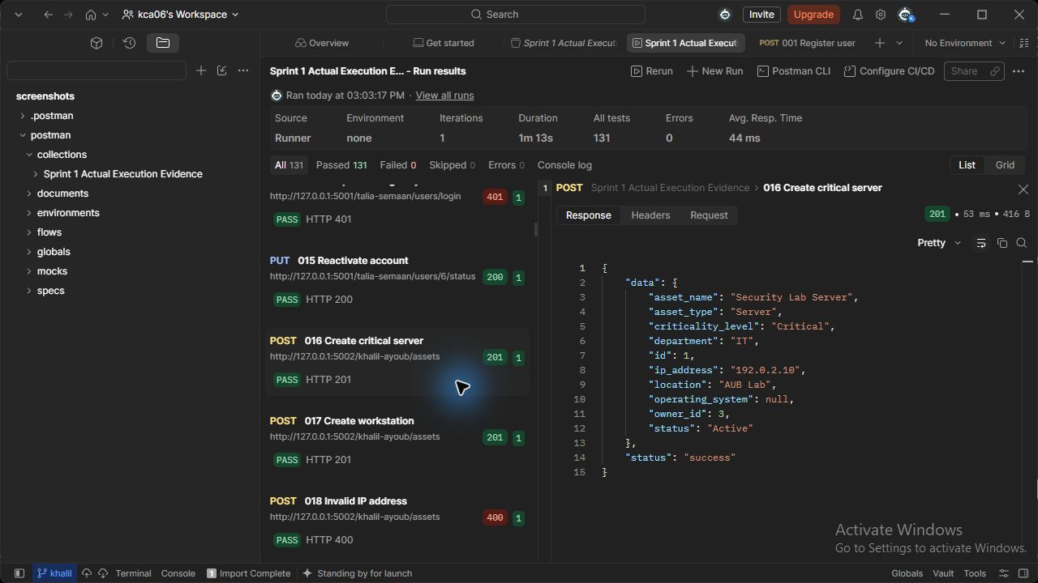
Figure 16 (Khalil Ayoub). assets API - Create critical server. Actual HTTP 201 response; the runner assertion passed.

017 Create workstation (Khalil Ayoub)
POST http://127.0.0.1:5002/khalil-ayoub/assets
JSON body: { "asset_name": "Analyst Workstation", "asset_type": "Workstation", "ip_address": "192.0.2.20", "department": "IT", "owner_id": {{employee_id}}, "location": "AUB Lab", "criticality_level": "Medium" }
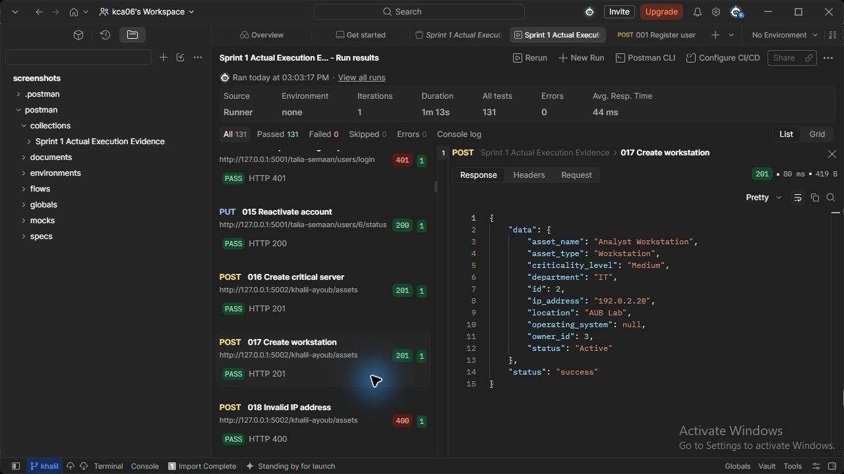
Figure 17 (Khalil Ayoub). assets API - Create workstation. Actual HTTP 201 response; the runner assertion passed.

020 Asset before update (Khalil Ayoub)
GET http://127.0.0.1:5002/khalil-ayoub/assets/{{asset_id}}
Request body: none
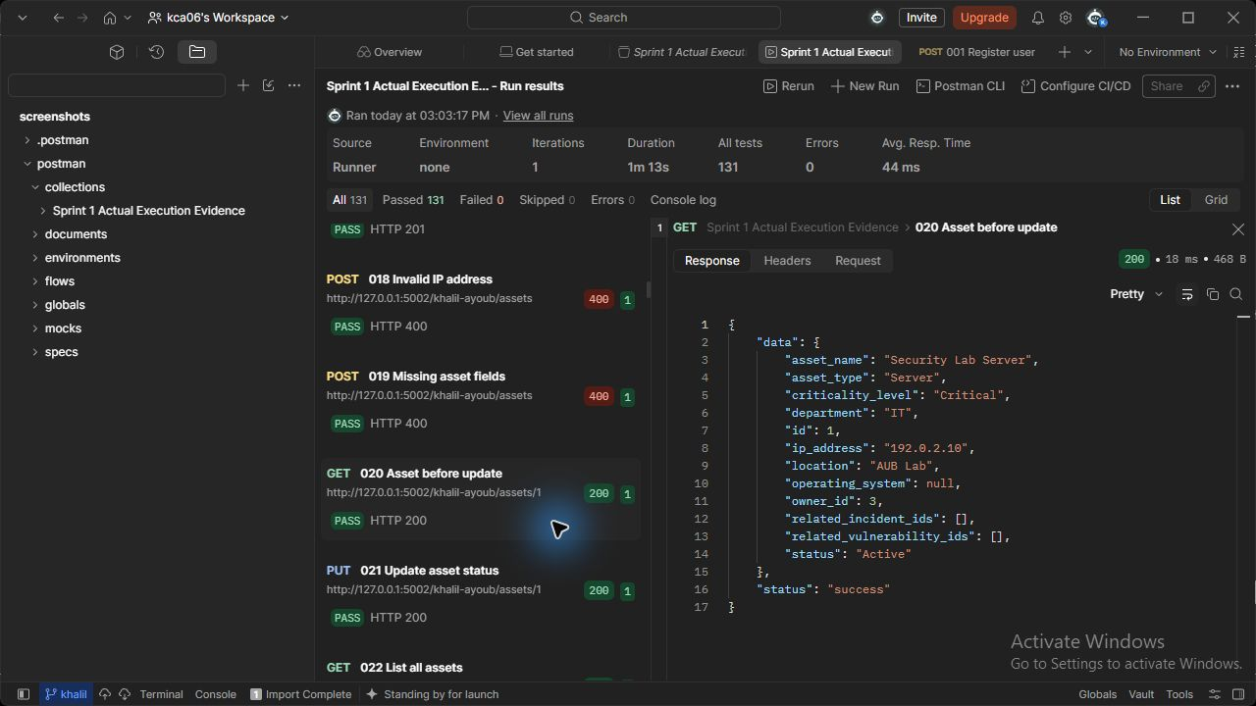
Figure 20 (Khalil Ayoub). assets API - Asset before update. Actual HTTP 200 response; the runner assertion passed.

021 Update asset status (Khalil Ayoub)
PUT http://127.0.0.1:5002/khalil-ayoub/assets/{{asset_id}}
JSON body: {"status": "Under Maintenance", "criticality_level": "High"}
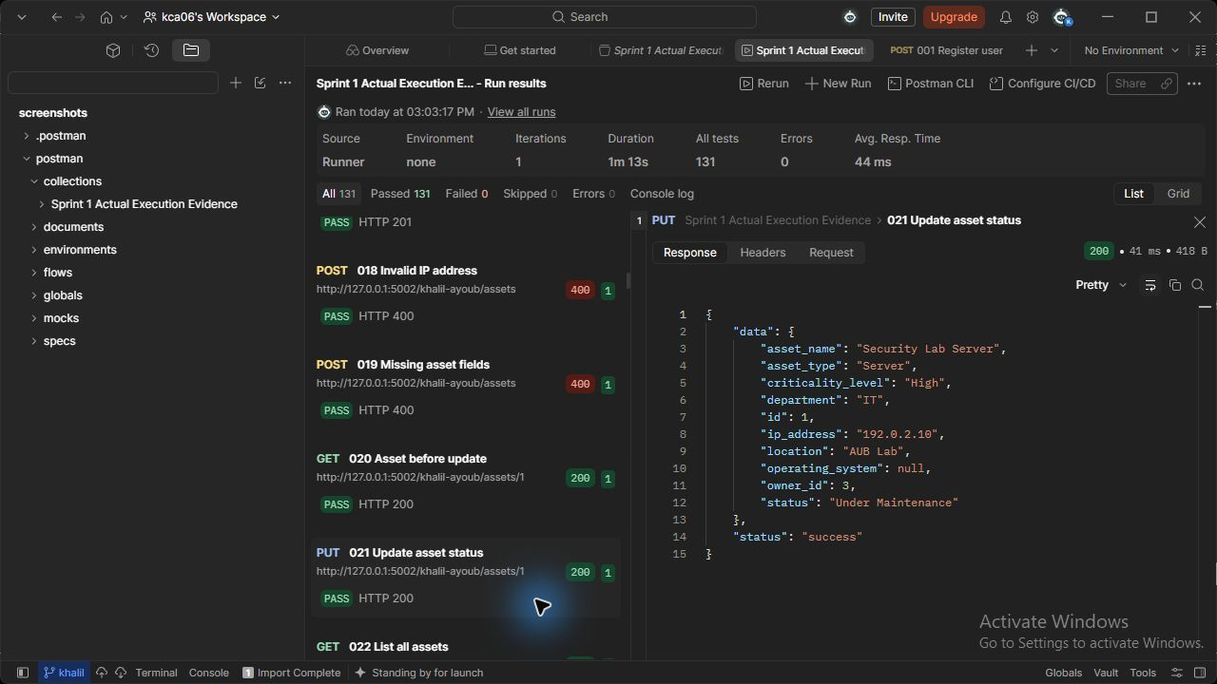
Figure 21 (Khalil Ayoub). assets API - Update asset status. Actual HTTP 200 response; the runner assertion passed.

022 List all assets (Khalil Ayoub)
GET http://127.0.0.1:5002/khalil-ayoub/assets
Request body: none
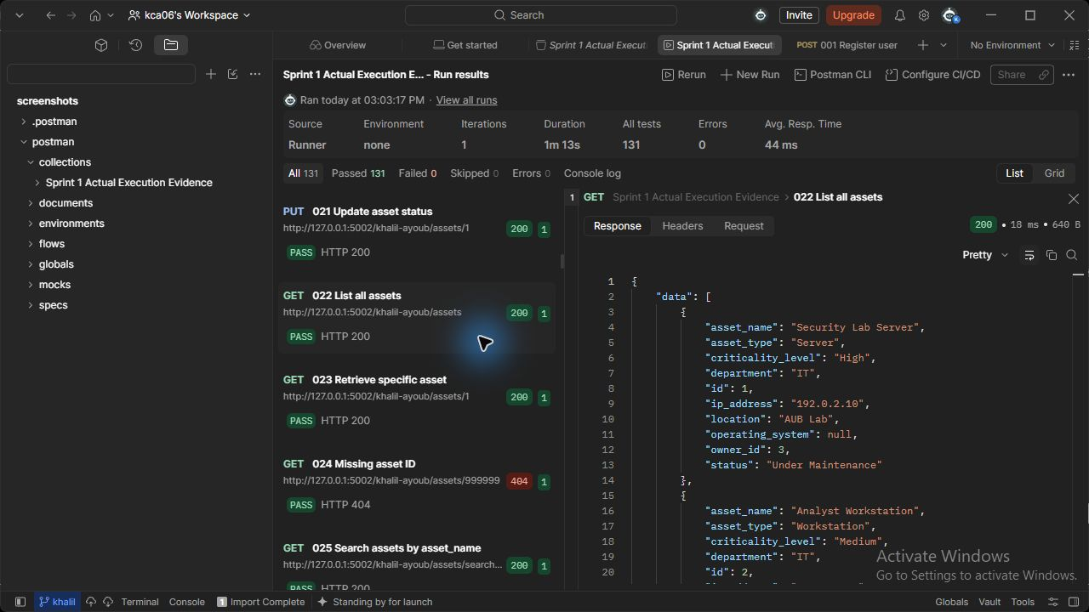
Figure 22 (Khalil Ayoub). assets API - List all assets. Actual HTTP 200 response; the runner assertion passed.

023 Retrieve specific asset (Khalil Ayoub)
GET http://127.0.0.1:5002/khalil-ayoub/assets/{{asset_id}}
Request body: none
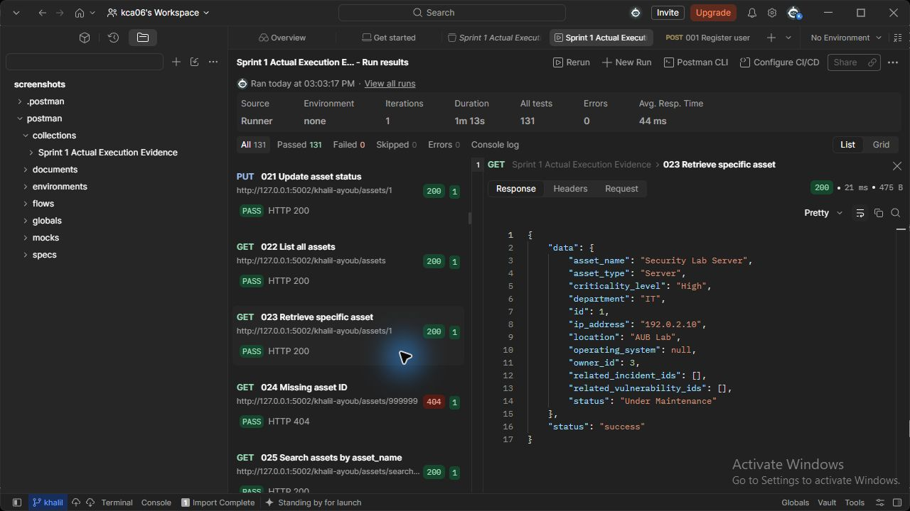
Figure 23 (Khalil Ayoub). assets API - Retrieve specific asset. Actual HTTP 200 response; the runner assertion passed.

025 Search assets by asset_name (Khalil Ayoub)
GET http://127.0.0.1:5002/khalil-ayoub/assets/search?asset_name=Server
Request body: none
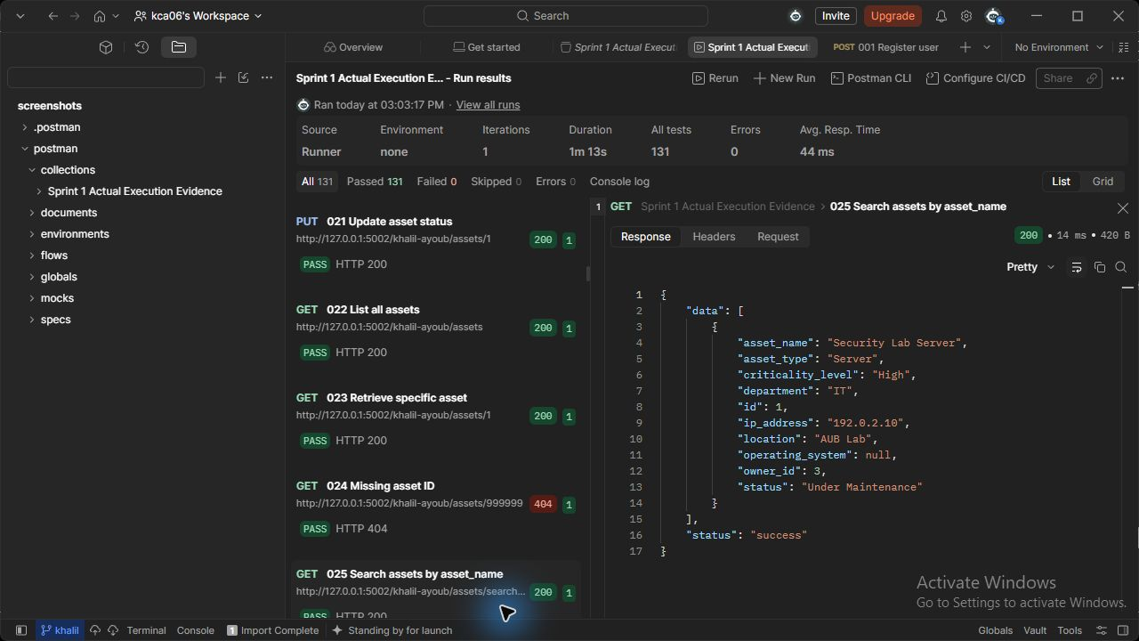
Figure 25 (Khalil Ayoub). assets API - Search assets by asset_name. Actual HTTP 200 response; the runner assertion passed.

026 Search assets by asset_type (Khalil Ayoub)
GET http://127.0.0.1:5002/khalil-ayoub/assets/search?asset_type=Server
Request body: none
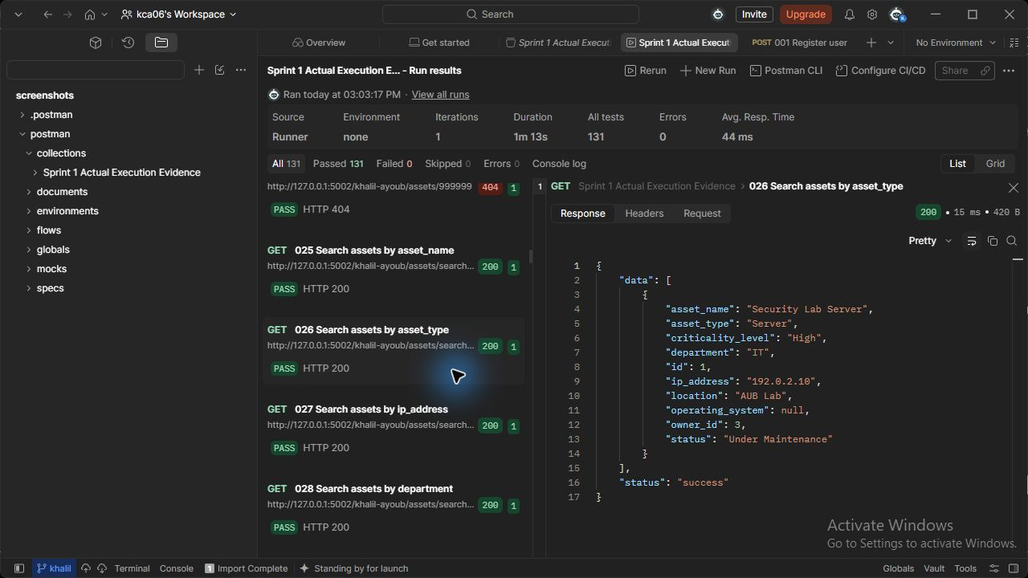
Figure 26 (Khalil Ayoub). assets API - Search assets by asset_type. Actual HTTP 200 response; the runner assertion passed.

027 Search assets by ip_address (Khalil Ayoub)
GET http://127.0.0.1:5002/khalil-ayoub/assets/search?ip_address=192.0.2.10
Request body: none
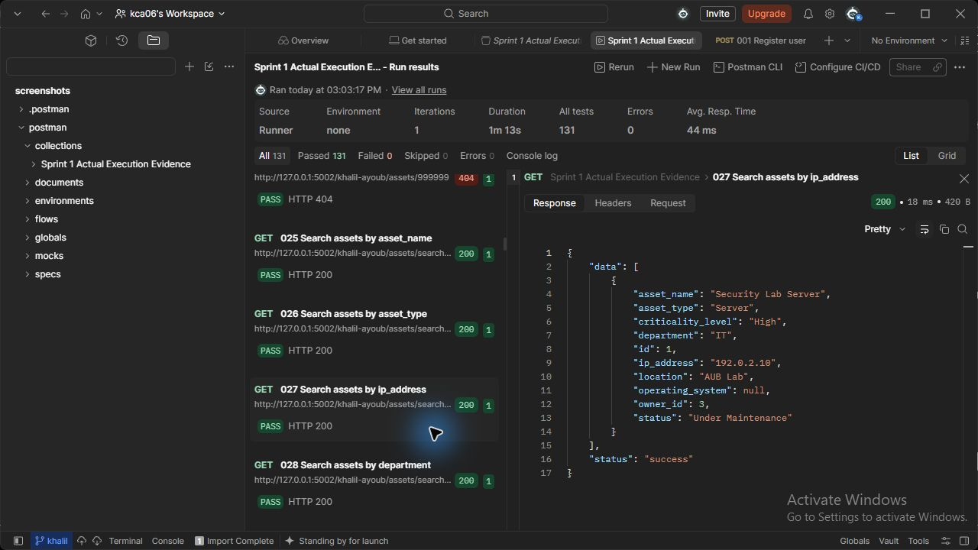
Figure 27 (Khalil Ayoub). assets API - Search assets by ip_address. Actual HTTP 200 response; the runner assertion passed.

028 Search assets by department (Khalil Ayoub)
GET http://127.0.0.1:5002/khalil-ayoub/assets/search?department=IT
Request body: none
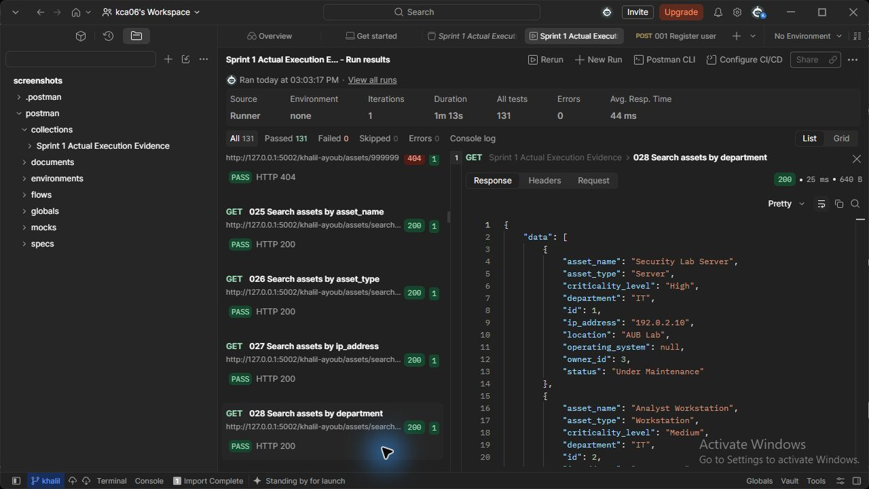
Figure 28 (Khalil Ayoub). assets API - Search assets by department. Actual HTTP 200 response; the runner assertion passed.

029 Search assets by criticality_level (Khalil Ayoub)
GET http://127.0.0.1:5002/khalil-ayoub/assets/search?criticality_level=High
Request body: none
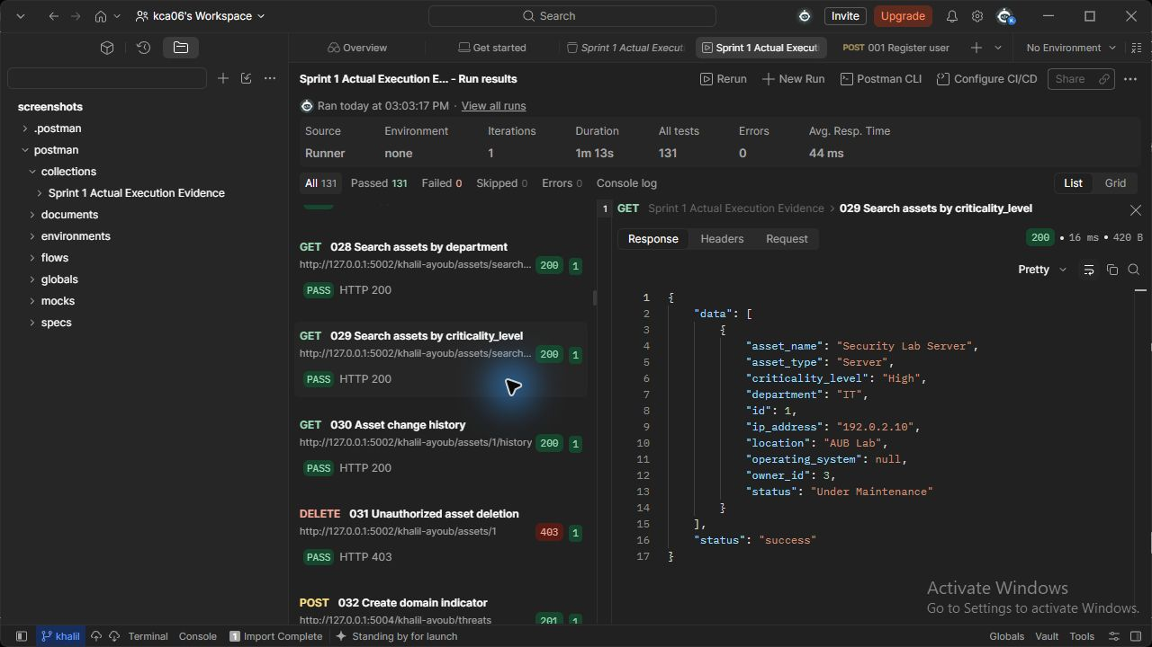
Figure 29 (Khalil Ayoub). assets API - Search assets by criticality_level. Actual HTTP 200 response; the runner assertion passed.

030 Asset change history (Khalil Ayoub)
GET http://127.0.0.1:5002/khalil-ayoub/assets/{{asset_id}}/history
Request body: none
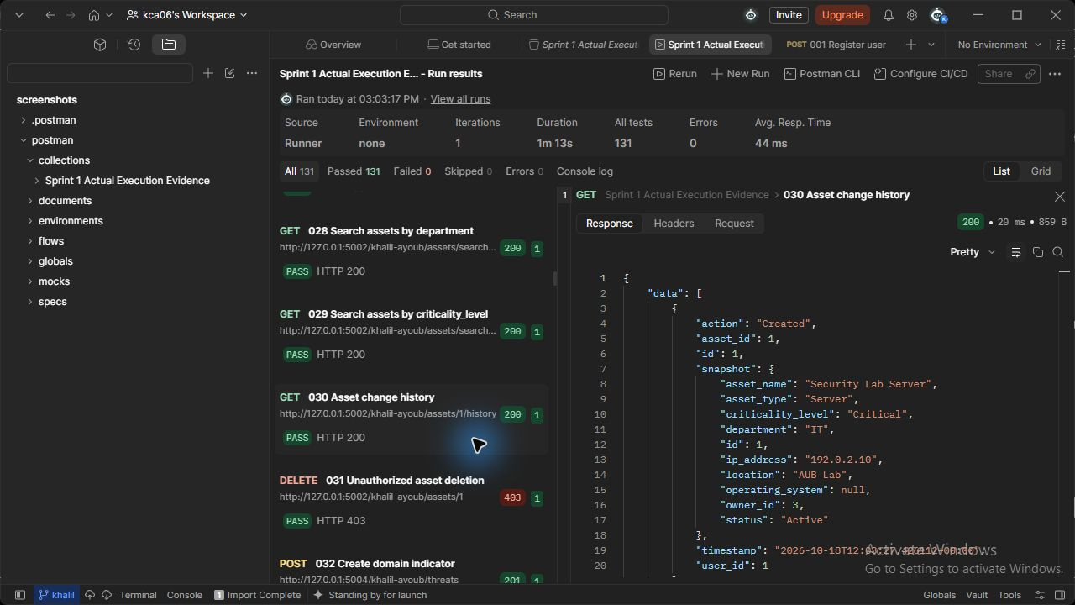
Figure 30 (Khalil Ayoub). assets API - Asset change history. Actual HTTP 200 response; the runner assertion passed.

130 Delete unreferenced asset (Khalil Ayoub)
DELETE http://127.0.0.1:5002/khalil-ayoub/assets/{{asset2_id}}
Request body: none
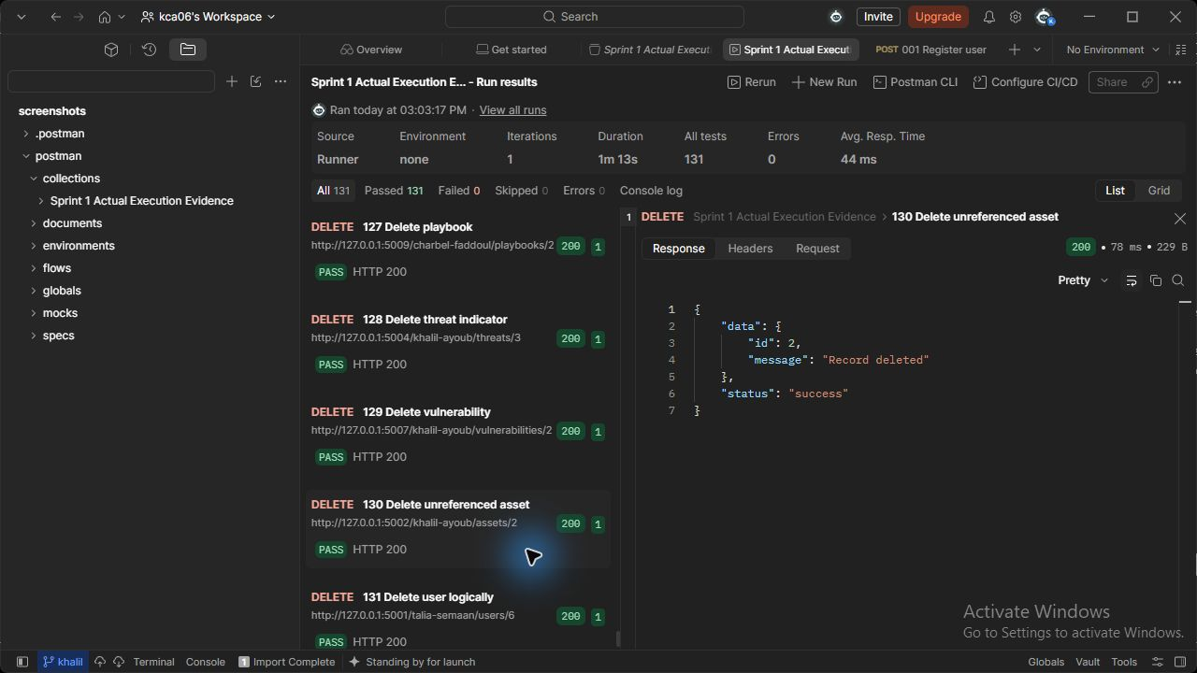
Figure 130 (Khalil Ayoub). assets API - Delete unreferenced asset. Actual HTTP 200 response; the runner assertion passed.

032 Create domain indicator (Khalil Ayoub)
POST http://127.0.0.1:5004/khalil-ayoub/threats
JSON body: {"threat_type": "Domain", "threat_value": "malicious.example.test", "description": "Lab phishing indicator", "severity": "High", "source": "Local analysis"}
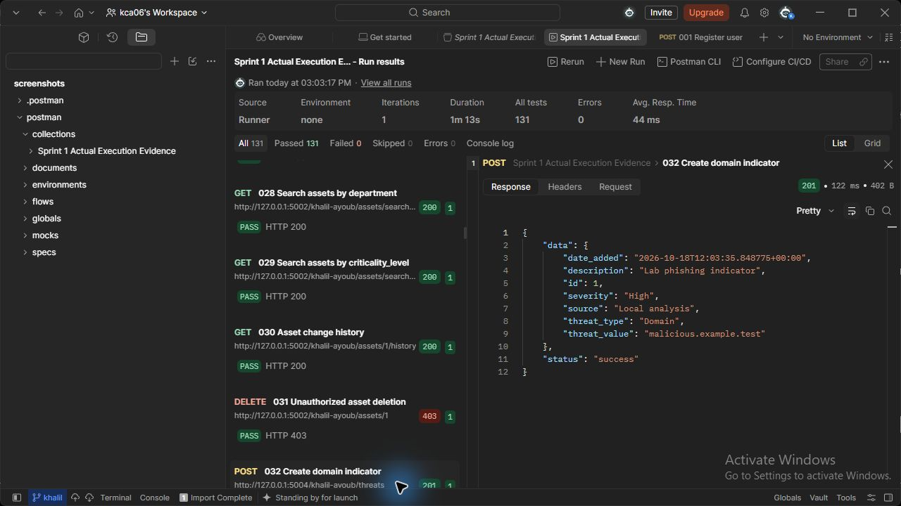
Figure 32 (Khalil Ayoub). threats API - Create domain indicator. Actual HTTP 201 response; the runner assertion passed.

033 Create IP indicator (Khalil Ayoub)
POST http://127.0.0.1:5004/khalil-ayoub/threats
JSON body: {"threat_type": "IP Address", "threat_value": "198.51.100.22", "description": "Lab phishing indicator", "severity": "Critical", "source": "Local analysis"}
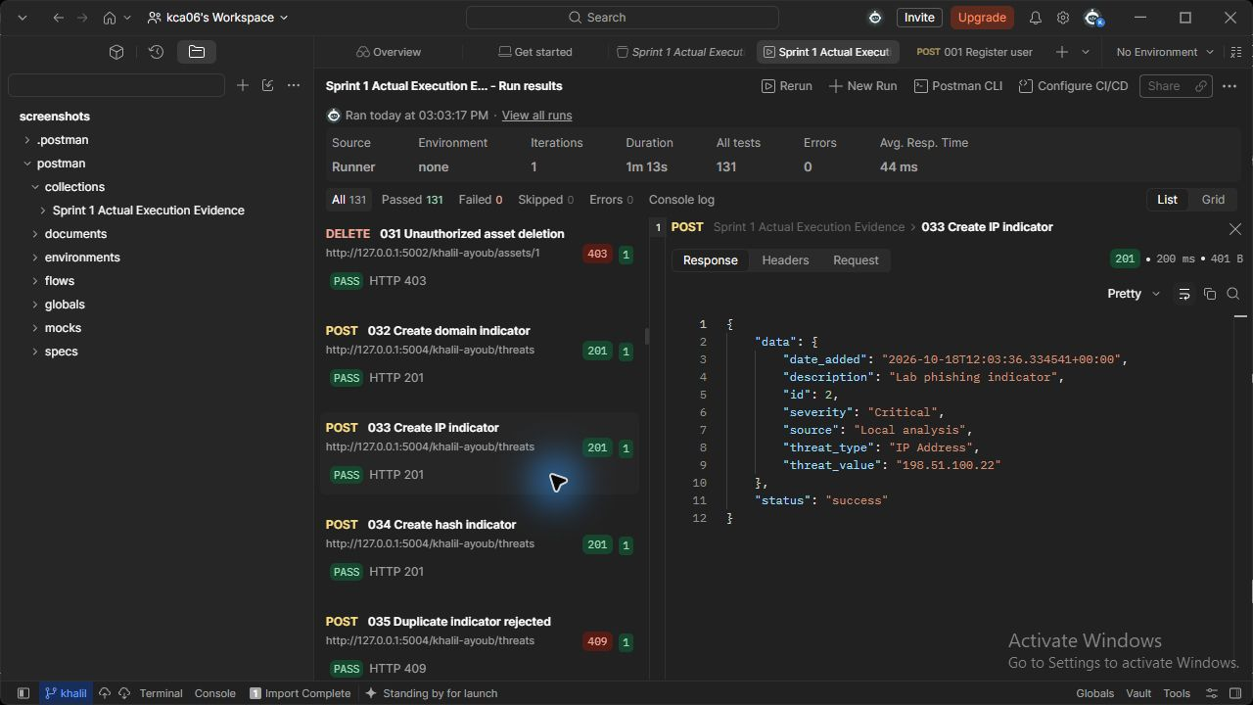
Figure 33 (Khalil Ayoub). threats API - Create IP indicator. Actual HTTP 201 response; the runner assertion passed.

034 Create hash indicator (Khalil Ayoub)
POST http://127.0.0.1:5004/khalil-ayoub/threats
JSON body: {"threat_type": "File Hash", "threat_value": "aaaaaaaaaaaaaaaaaaaaaaaaaaaaaaaaaaaaaaaaaaaaaaaaaaaaaaaaaaaaaaaa", "description": "Lab phishing indicator", "severity": "Medium", "source": "Local analysis"}
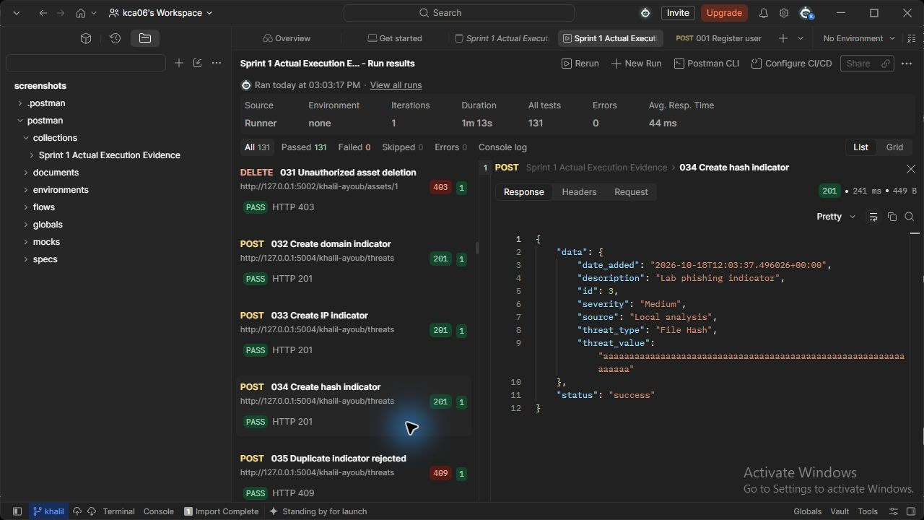
Figure 34 (Khalil Ayoub). threats API - Create hash indicator. Actual HTTP 201 response; the runner assertion passed.

037 List threat indicators (Khalil Ayoub)
GET http://127.0.0.1:5004/khalil-ayoub/threats
Request body: none
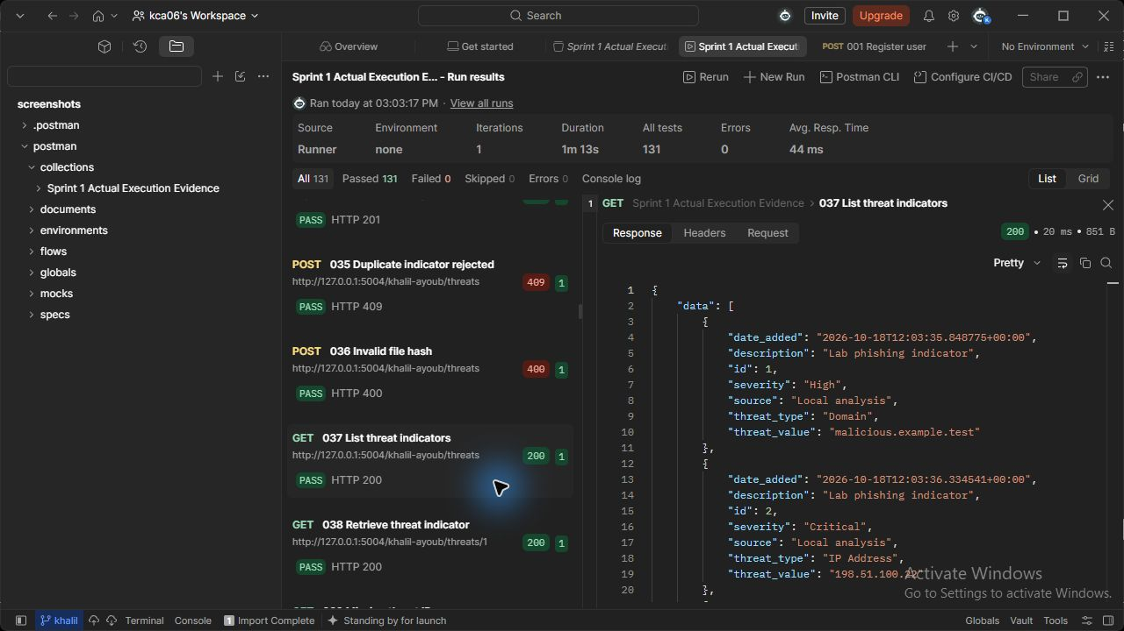
Figure 37 (Khalil Ayoub). threats API - List threat indicators. Actual HTTP 200 response; the runner assertion passed.

038 Retrieve threat indicator (Khalil Ayoub)
GET http://127.0.0.1:5004/khalil-ayoub/threats/{{threat_id}}
Request body: none
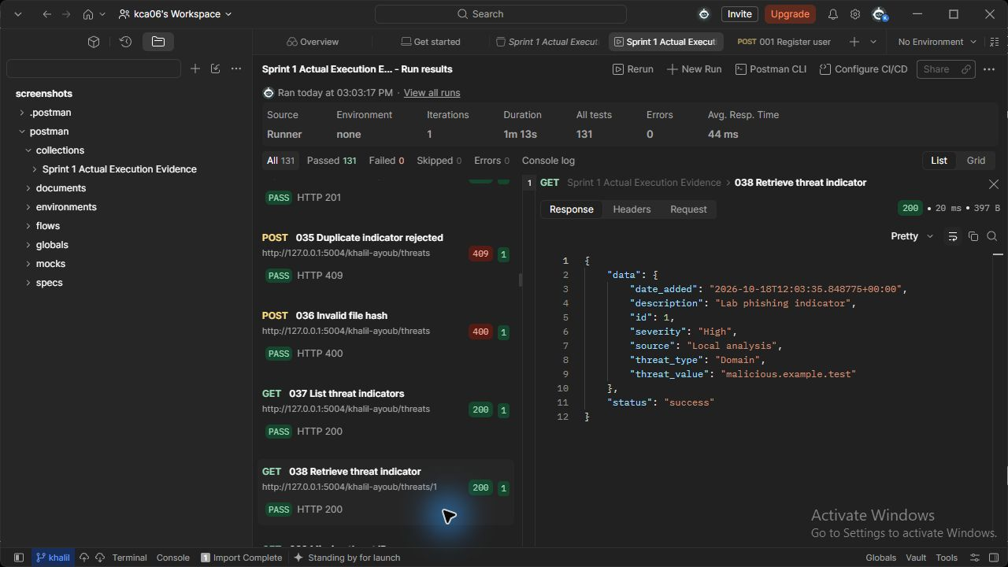
Figure 38 (Khalil Ayoub). threats API - Retrieve threat indicator. Actual HTTP 200 response; the runner assertion passed.

040 Search threats by threat_type (Khalil Ayoub)
GET http://127.0.0.1:5004/khalil-ayoub/threats/search?threat_type=Domain
Request body: none
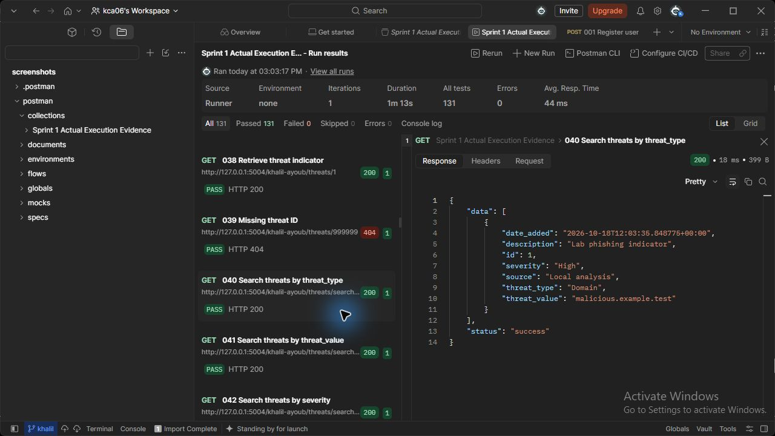
Figure 40 (Khalil Ayoub). threats API - Search threats by threat_type. Actual HTTP 200 response; the runner assertion passed.

041 Search threats by threat_value (Khalil Ayoub)
GET http://127.0.0.1:5004/khalil-ayoub/threats/search?threat_value=malicious
Request body: none
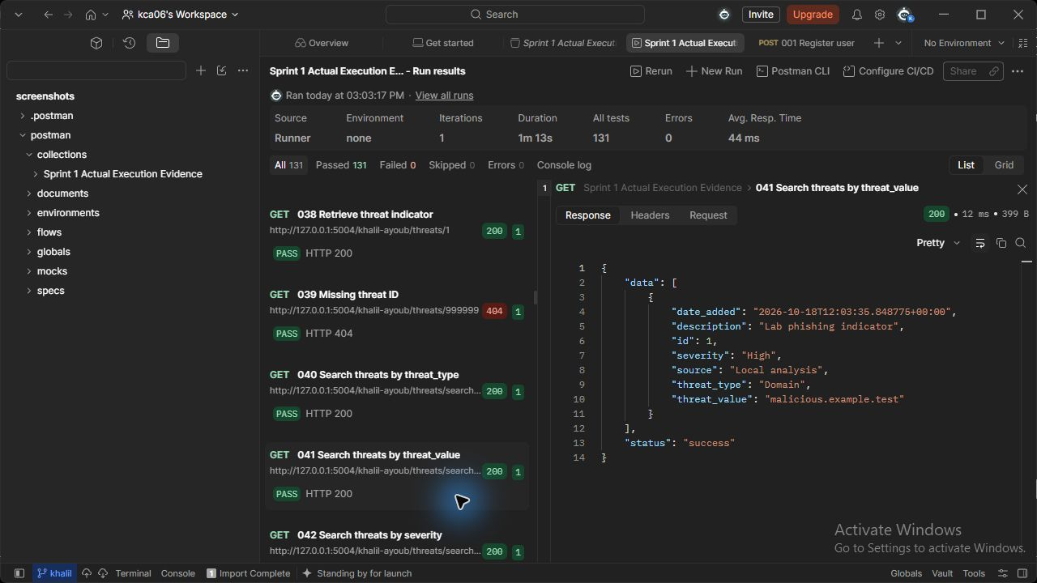
Figure 41 (Khalil Ayoub). threats API - Search threats by threat_value. Actual HTTP 200 response; the runner assertion passed.

042 Search threats by severity (Khalil Ayoub)
GET http://127.0.0.1:5004/khalil-ayoub/threats/search?severity=High
Request body: none
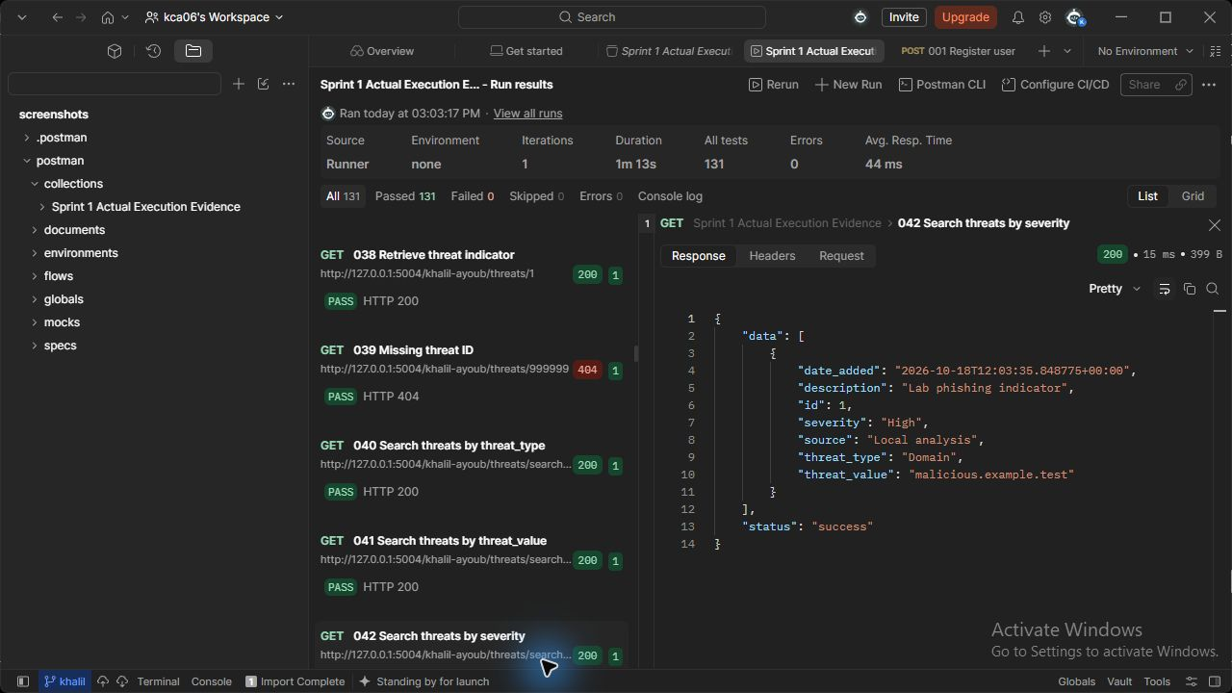
Figure 42 (Khalil Ayoub). threats API - Search threats by severity. Actual HTTP 200 response; the runner assertion passed.

043 Search threats by source (Khalil Ayoub)
GET http://127.0.0.1:5004/khalil-ayoub/threats/search?source=Local
Request body: none
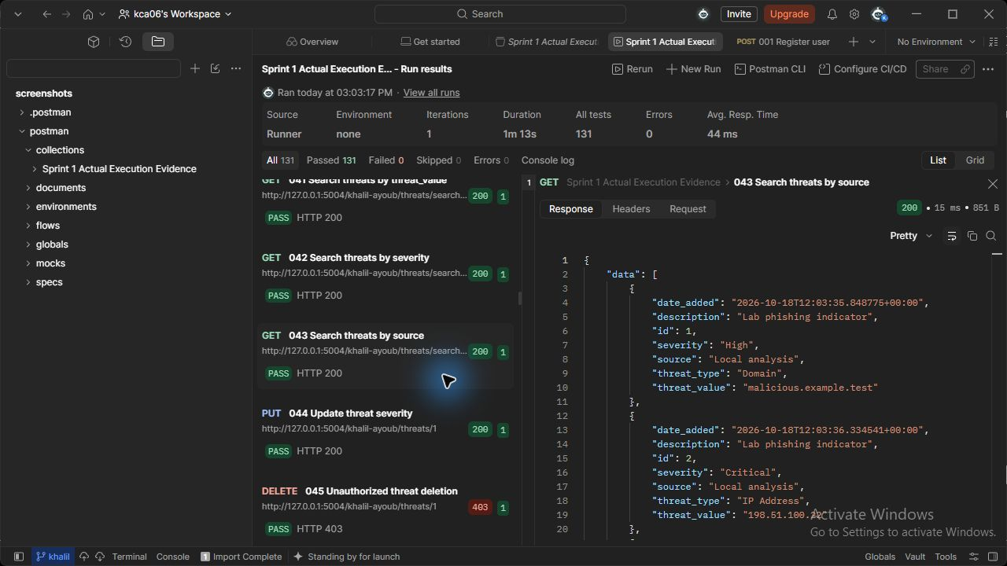
Figure 43 (Khalil Ayoub). threats API - Search threats by source. Actual HTTP 200 response; the runner assertion passed.

044 Update threat severity (Khalil Ayoub)
PUT http://127.0.0.1:5004/khalil-ayoub/threats/{{threat_id}}
JSON body: {"severity": "Critical", "description": "Confirmed phishing domain"}
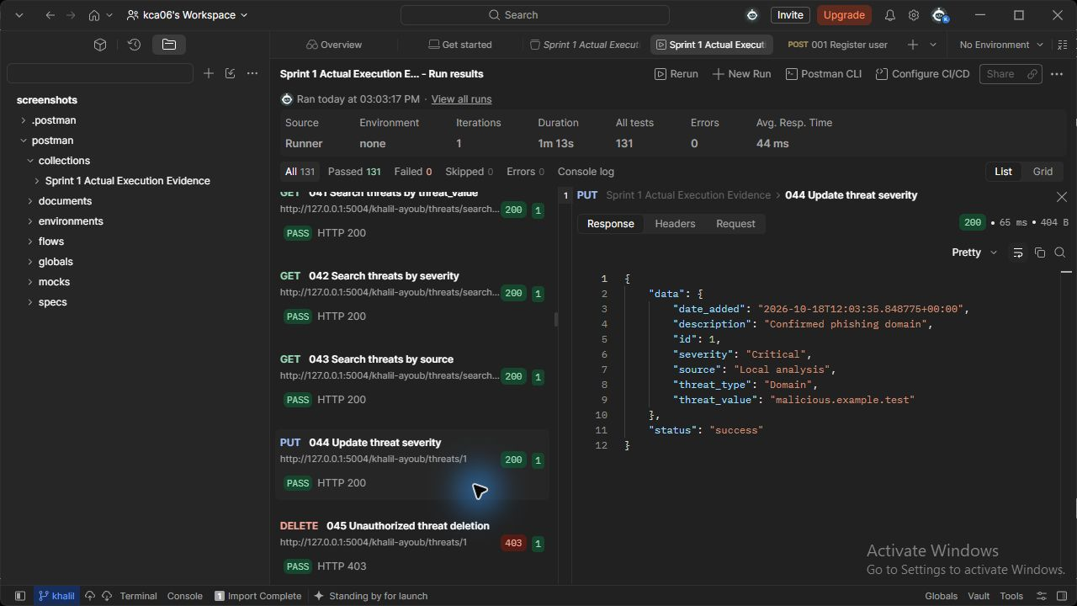
Figure 44 (Khalil Ayoub). threats API - Update threat severity. Actual HTTP 200 response; the runner assertion passed.

128 Delete threat indicator (Khalil Ayoub)
DELETE http://127.0.0.1:5004/khalil-ayoub/threats/{{hash_id}}
Request body: none
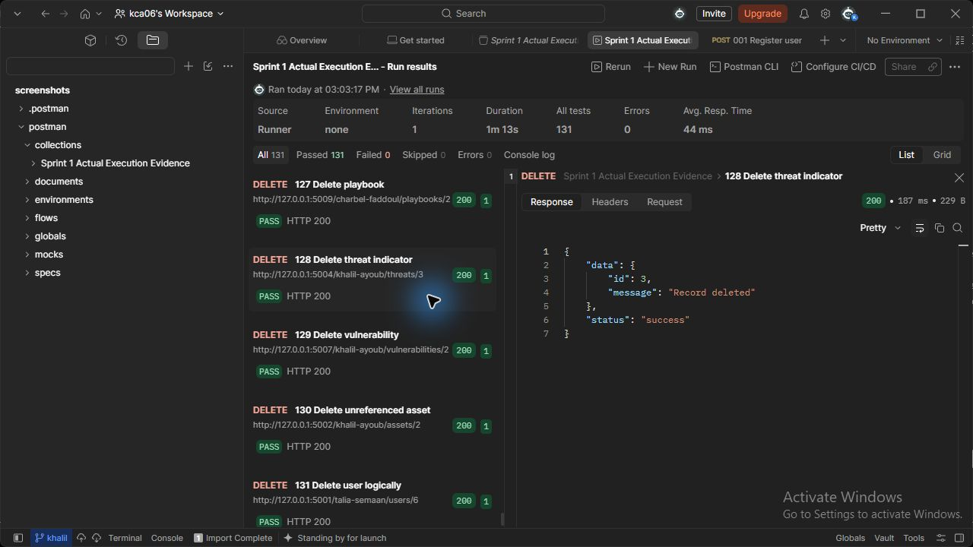
Figure 128 (Khalil Ayoub). threats API - Delete threat indicator. Actual HTTP 200 response; the runner assertion passed.

046 Create vulnerability (Khalil Ayoub)
POST http://127.0.0.1:5007/khalil-ayoub/vulnerabilities
JSON body: { "title": "Unpatched service", "description": "Lab vulnerability affecting the server", "cve_identifier": "CVE-2026-12345", "cvss_score": 9.1, "severity": "Critical", "asset_id": {{asset_id}}, "discovery_source": "Local scan" }
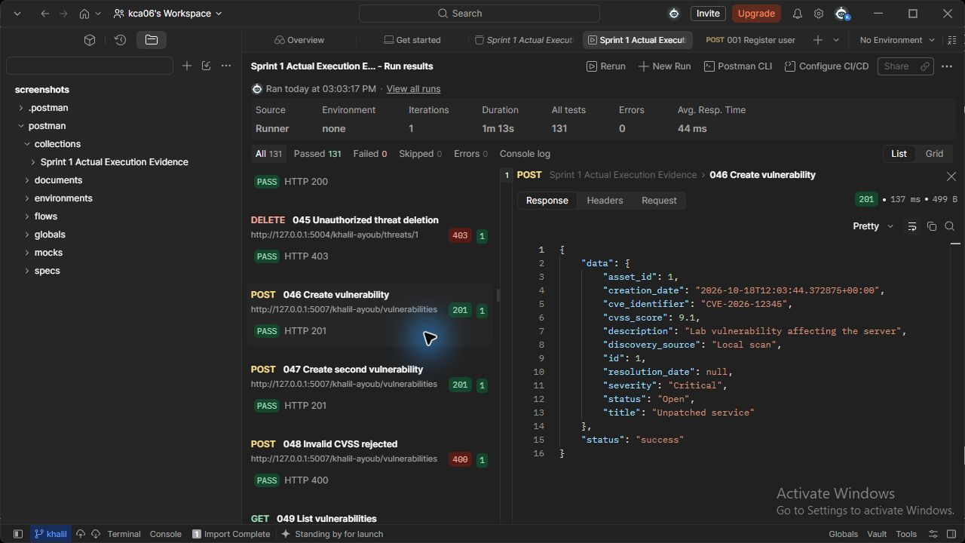
Figure 46 (Khalil Ayoub). vulnerabilities API - Create vulnerability. Actual HTTP 201 response; the runner assertion passed.

047 Create second vulnerability (Khalil Ayoub)
POST http://127.0.0.1:5007/khalil-ayoub/vulnerabilities
JSON body: { "title": "Outdated workstation package", "description": "Lab vulnerability affecting the server", "cve_identifier": "CVE-2026-12346", "cvss_score": 5.5, "severity": "Medium", "asset_id": {{asset2_id}}, "discovery_source": "Local scan" }
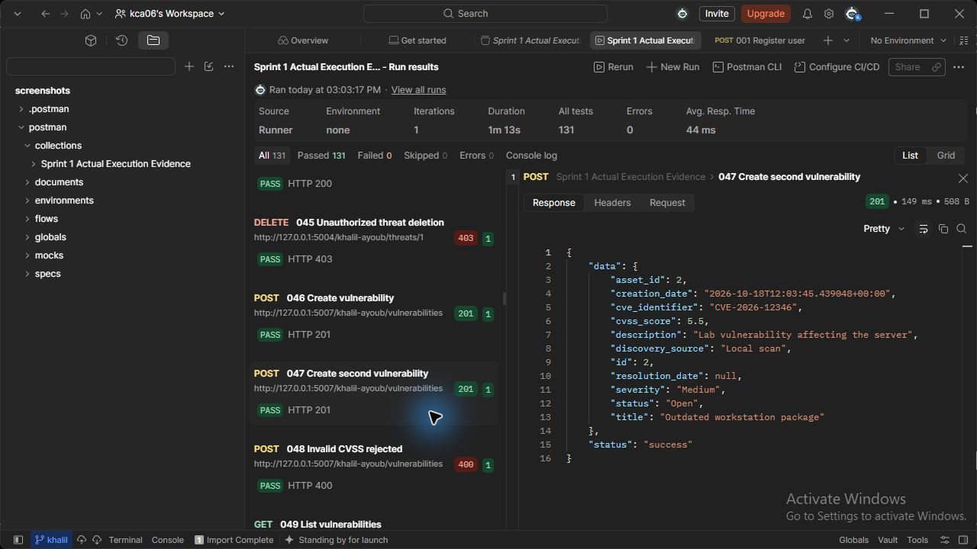
Figure 47 (Khalil Ayoub). vulnerabilities API - Create second vulnerability. Actual HTTP 201 response; the runner assertion passed.

049 List vulnerabilities (Khalil Ayoub)
GET http://127.0.0.1:5007/khalil-ayoub/vulnerabilities
Request body: none
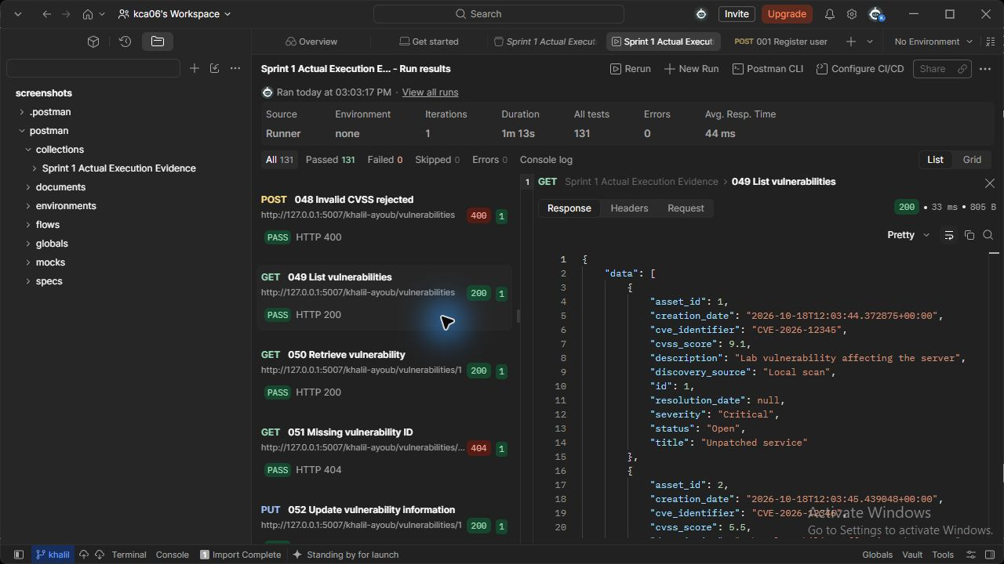
Figure 49 (Khalil Ayoub). vulnerabilities API - List vulnerabilities. Actual HTTP 200 response; the runner assertion passed.

050 Retrieve vulnerability (Khalil Ayoub)
GET http://127.0.0.1:5007/khalil-ayoub/vulnerabilities/{{vulnerability_id}}
Request body: none
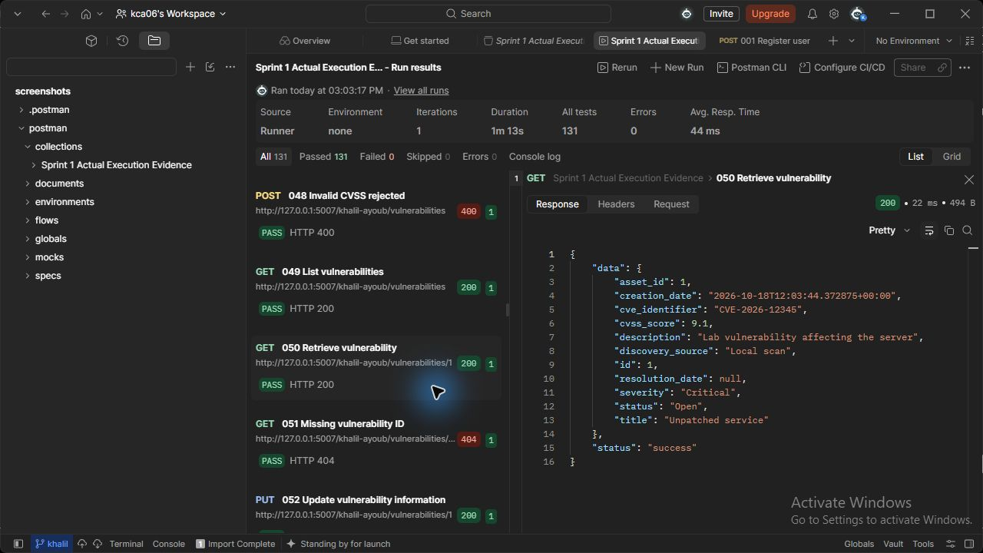
Figure 50 (Khalil Ayoub). vulnerabilities API - Retrieve vulnerability. Actual HTTP 200 response; the runner assertion passed.

052 Update vulnerability information (Khalil Ayoub)
PUT http://127.0.0.1:5007/khalil-ayoub/vulnerabilities/{{vulnerability_id}}
JSON body: {"description": "Remediation investigation started", "cvss_score": 9.2}
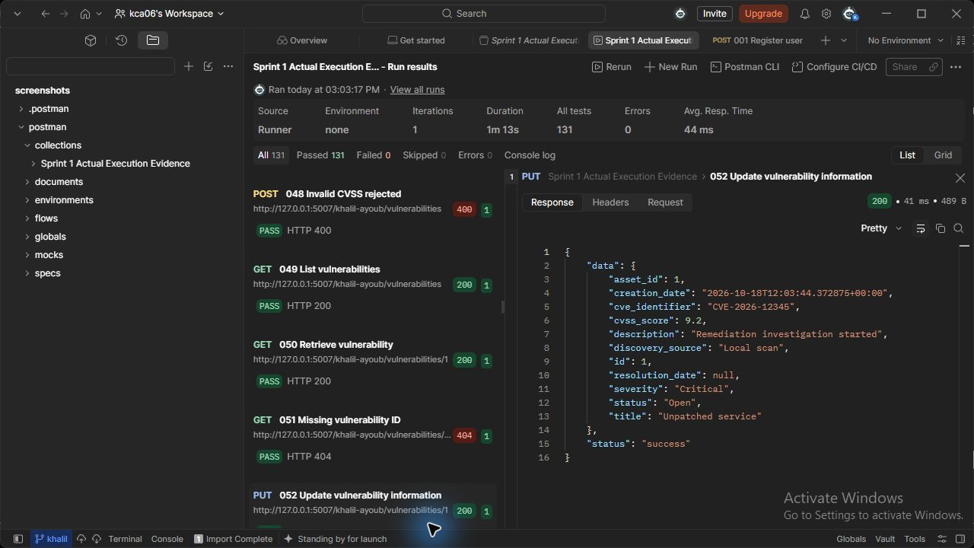
Figure 52 (Khalil Ayoub). vulnerabilities API - Update vulnerability information. Actual HTTP 200 response; the runner assertion passed.

053 Search vulnerabilities by cve_identifier (Khalil Ayoub)
GET http://127.0.0.1:5007/khalil-ayoub/vulnerabilities/search?cve_identifier=CVE-2026-12345
Request body: none
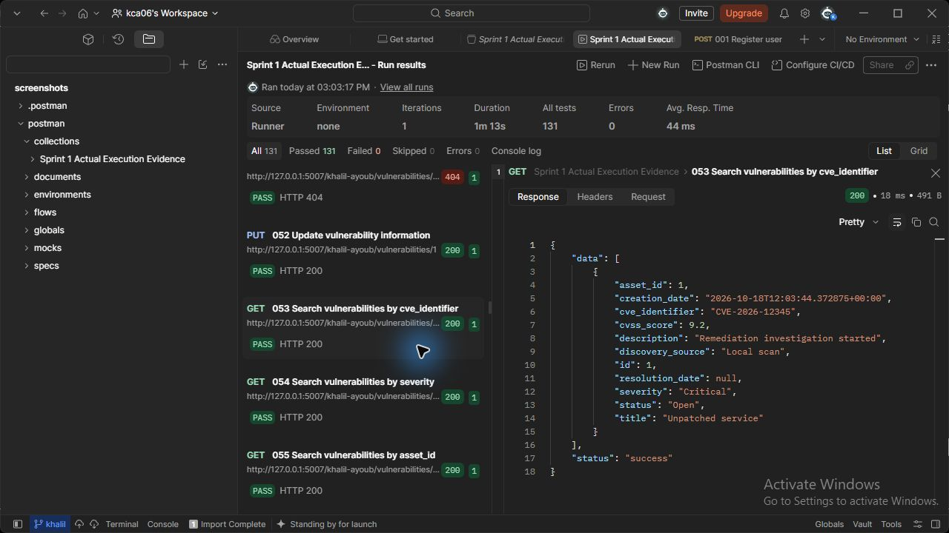
Figure 53 (Khalil Ayoub). vulnerabilities API - Search vulnerabilities by cve_identifier. Actual HTTP 200 response; the runner assertion passed.

054 Search vulnerabilities by severity (Khalil Ayoub)
GET http://127.0.0.1:5007/khalil-ayoub/vulnerabilities/search?severity=Critical
Request body: none
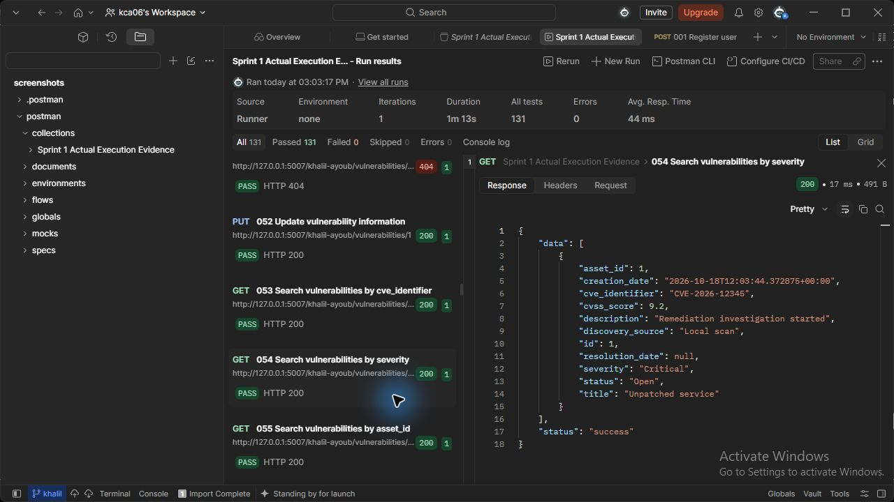
Figure 54 (Khalil Ayoub). vulnerabilities API - Search vulnerabilities by severity. Actual HTTP 200 response; the runner assertion passed.

055 Search vulnerabilities by asset_id (Khalil Ayoub)
GET http://127.0.0.1:5007/khalil-ayoub/vulnerabilities/search?asset_id={{asset_id}}
Request body: none
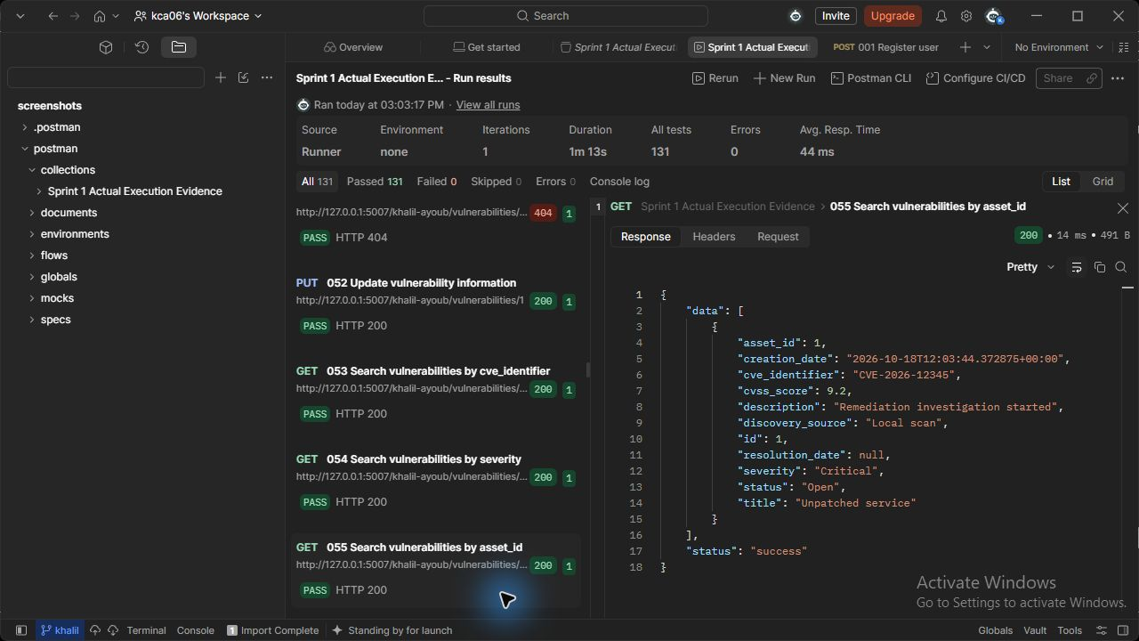
Figure 55 (Khalil Ayoub). vulnerabilities API - Search vulnerabilities by asset_id. Actual HTTP 200 response; the runner assertion passed.

056 Search vulnerabilities by status (Khalil Ayoub)
GET http://127.0.0.1:5007/khalil-ayoub/vulnerabilities/search?status=Open
Request body: none
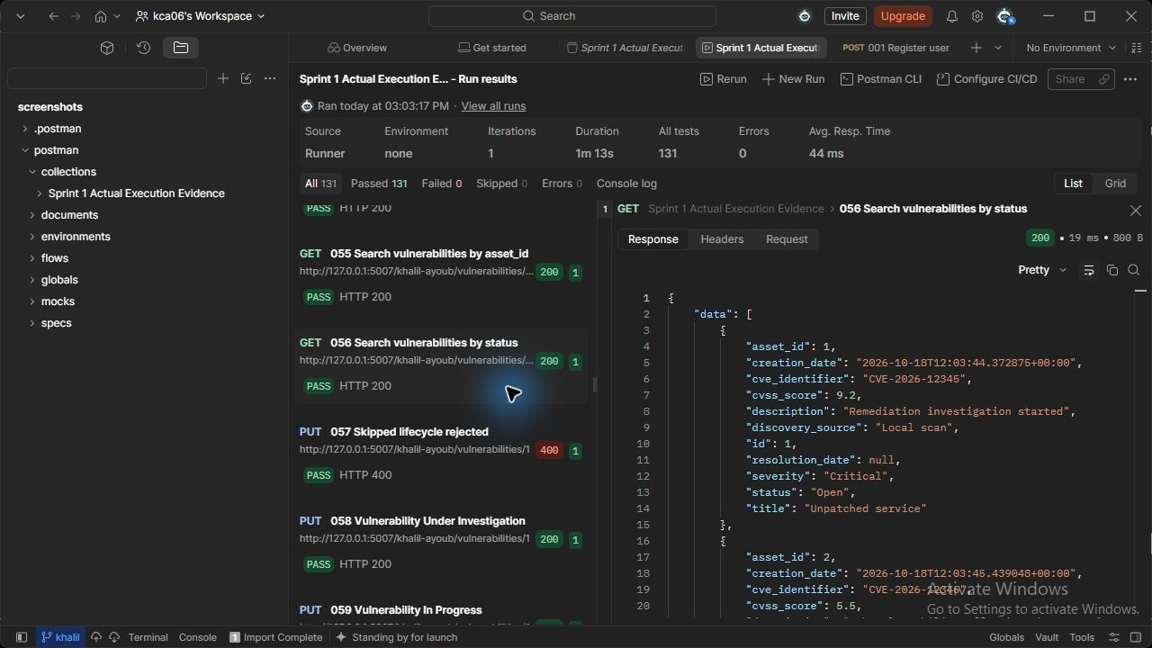
Figure 56 (Khalil Ayoub). vulnerabilities API - Search vulnerabilities by status. Actual HTTP 200 response; the runner assertion passed.

058 Vulnerability Under Investigation (Khalil Ayoub)
PUT http://127.0.0.1:5007/khalil-ayoub/vulnerabilities/{{vulnerability_id}}
JSON body: {"status": "Under Investigation"}
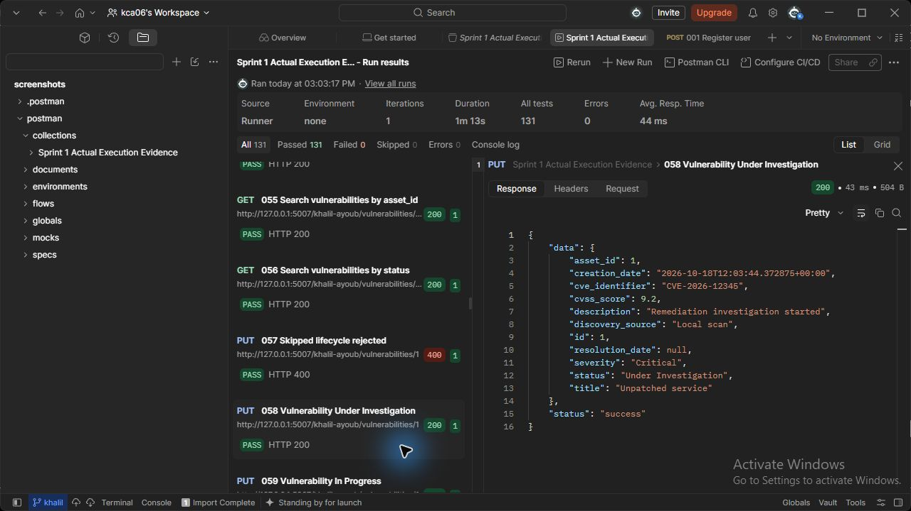
Figure 58 (Khalil Ayoub). vulnerabilities API - Vulnerability Under Investigation. Actual HTTP 200 response; the runner assertion passed.

059 Vulnerability In Progress (Khalil Ayoub)
PUT http://127.0.0.1:5007/khalil-ayoub/vulnerabilities/{{vulnerability_id}}
JSON body: {"status": "In Progress"}
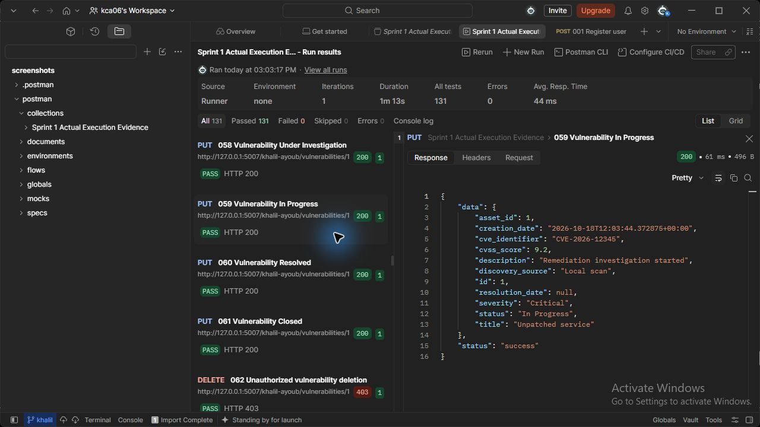
Figure 59 (Khalil Ayoub). vulnerabilities API - Vulnerability In Progress. Actual HTTP 200 response; the runner assertion passed.

060 Vulnerability Resolved (Khalil Ayoub)
PUT http://127.0.0.1:5007/khalil-ayoub/vulnerabilities/{{vulnerability_id}}
JSON body: {"status": "Resolved"}
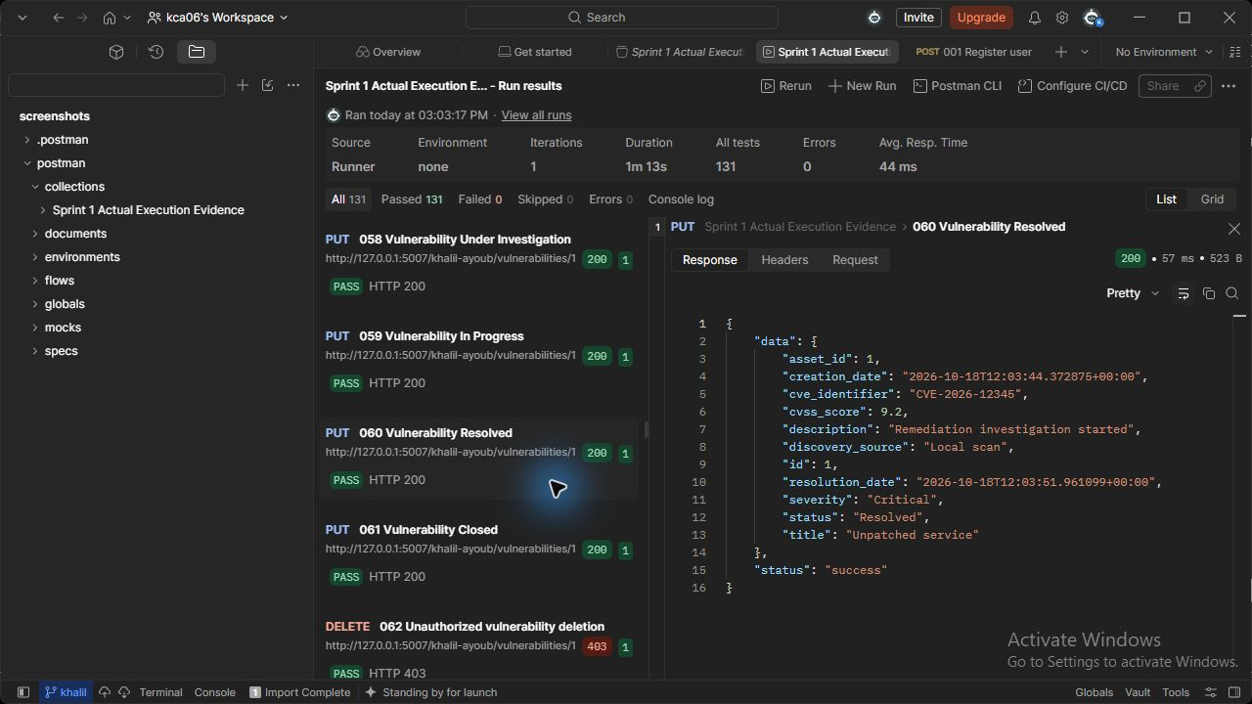
Figure 60 (Khalil Ayoub). vulnerabilities API - Vulnerability Resolved. Actual HTTP 200 response; the runner assertion passed.

061 Vulnerability Closed (Khalil Ayoub)
PUT http://127.0.0.1:5007/khalil-ayoub/vulnerabilities/{{vulnerability_id}}
JSON body: {"status": "Closed"}
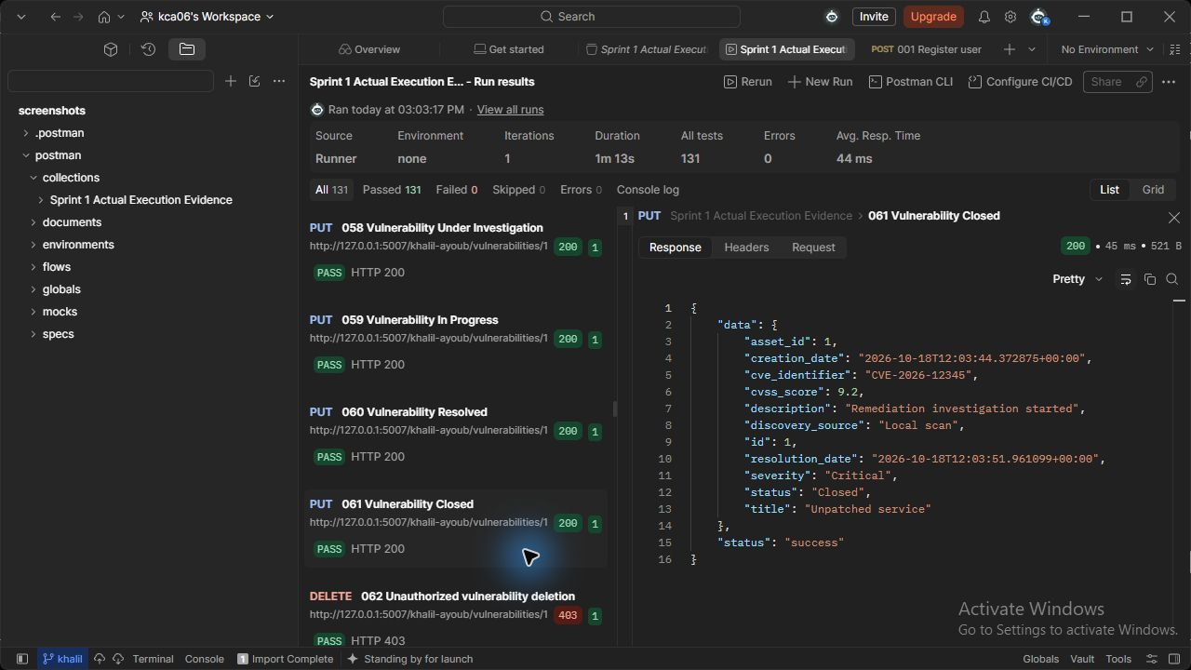
Figure 61 (Khalil Ayoub). vulnerabilities API - Vulnerability Closed. Actual HTTP 200 response; the runner assertion passed.

129 Delete vulnerability (Khalil Ayoub)
DELETE http://127.0.0.1:5007/khalil-ayoub/vulnerabilities/{{vulnerability2_id}}
Request body: none
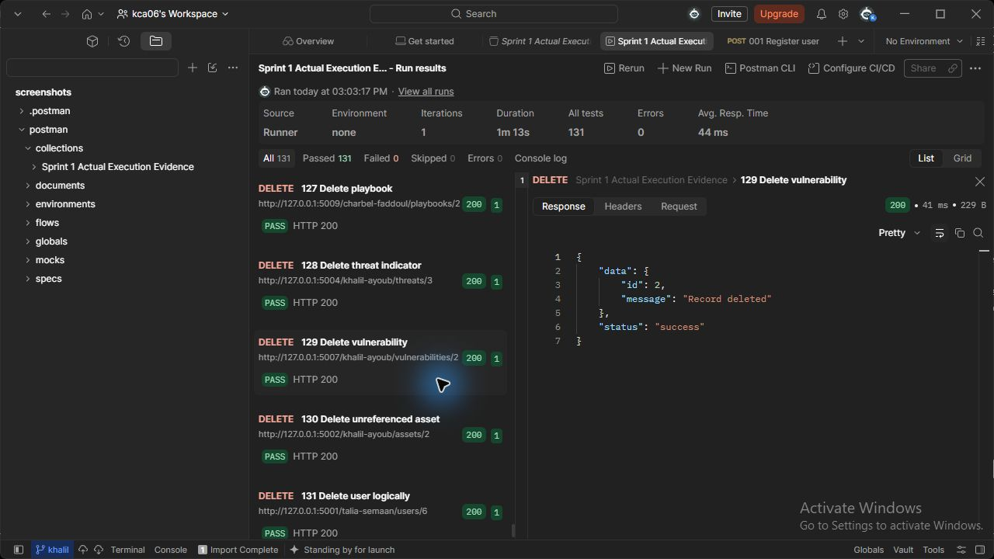
Figure 129 (Khalil Ayoub). vulnerabilities API - Delete vulnerability. Actual HTTP 200 response; the runner assertion passed.

001 Register user (Talia Semaan)
POST http://127.0.0.1:5001/talia-semaan/users/register
JSON body: {"full_name": "New Lab Employee", "username": "evidence_user", "email": "newuser@example.test", "password": "<local test password>", "department": "IT", "role": "Regular Employee/User"}
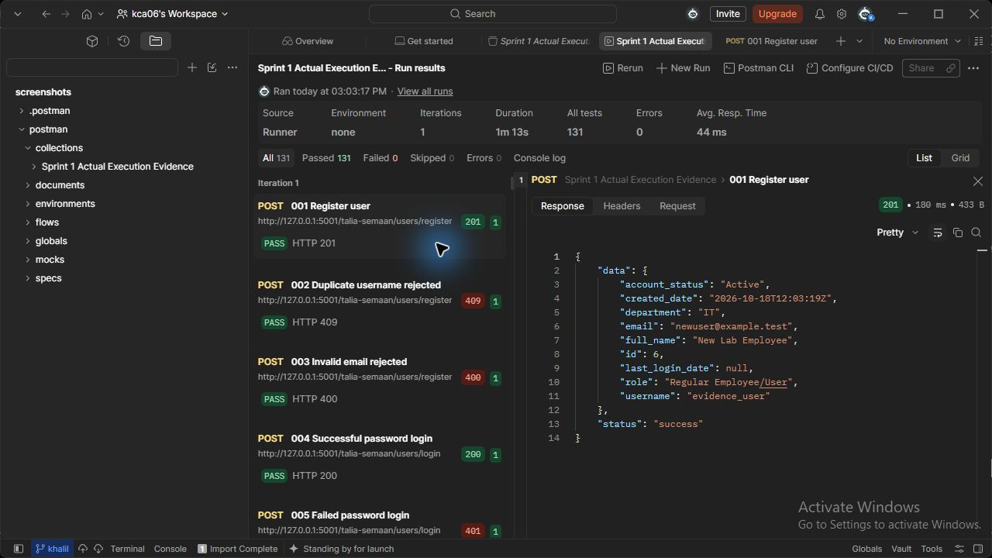
Figure 1 (Talia Semaan). users API - Register user. Actual HTTP 201 response; the runner assertion passed.

Registration request input (Talia Semaan)
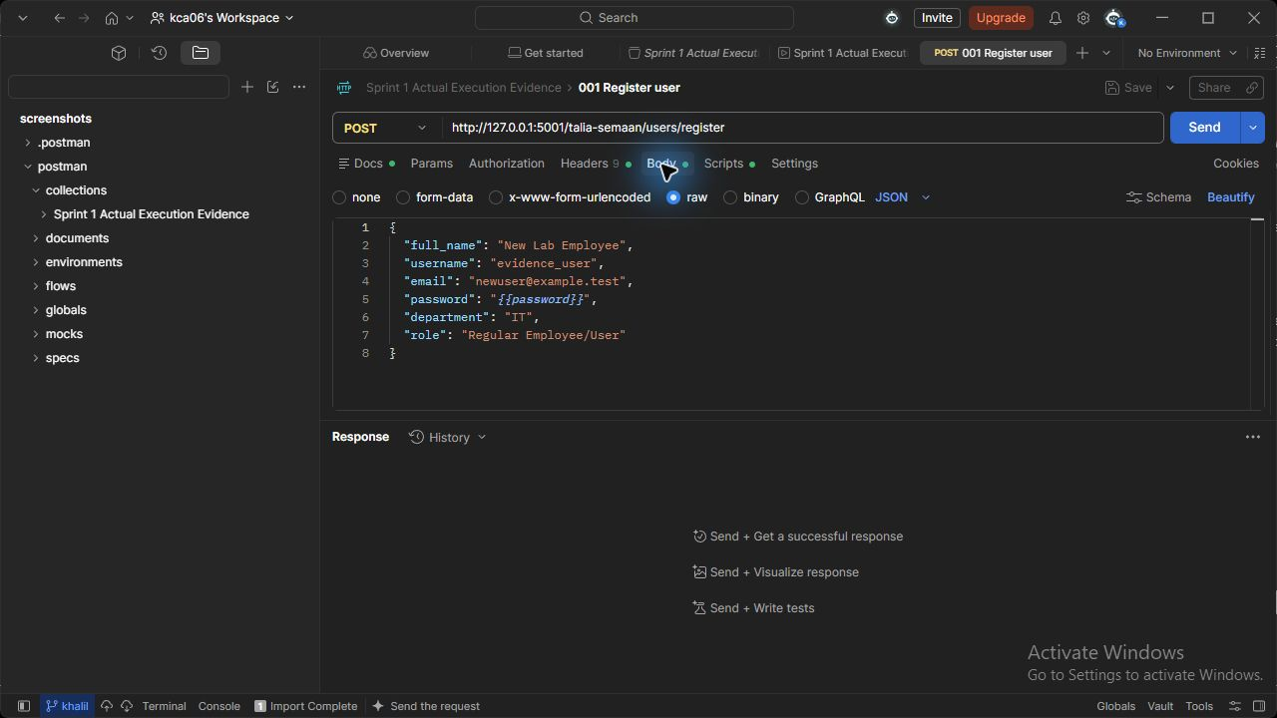
Input figure (Talia Semaan). The actual Postman registration definition uses a password variable. Figure 1 shows its retained execution response.

006 Update user profile (Talia Semaan)
PUT http://127.0.0.1:5001/talia-semaan/users/{{new_user_id}}
JSON body: {"department": "Engineering"}
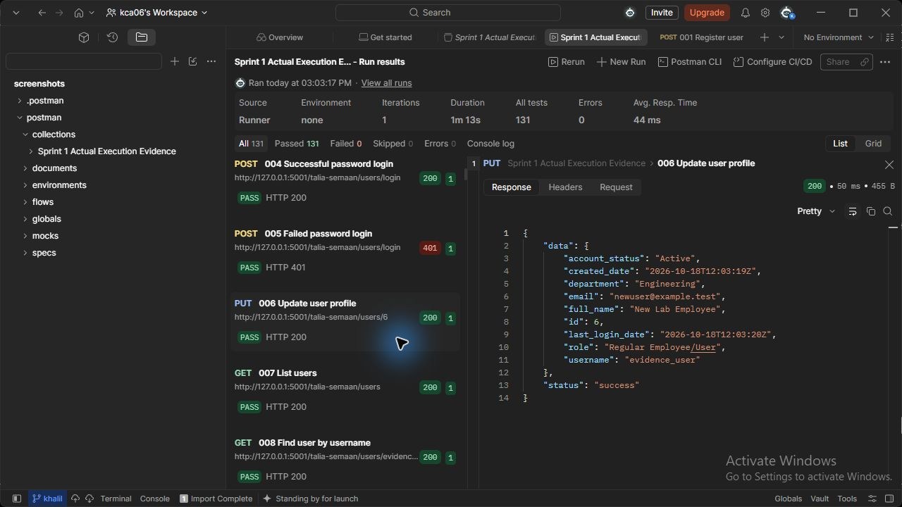
Figure 6 (Talia Semaan). users API - Update user profile. Actual HTTP 200 response; the runner assertion passed.

007 List users (Talia Semaan)
GET http://127.0.0.1:5001/talia-semaan/users
Request body: none
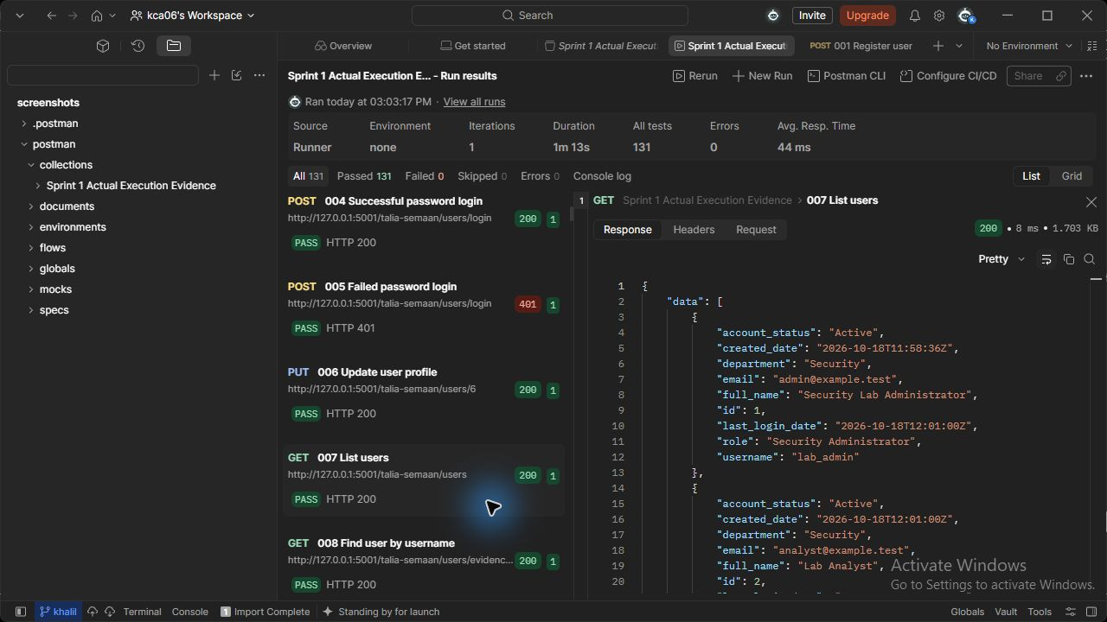
Figure 7 (Talia Semaan). users API - List users. Actual HTTP 200 response; the runner assertion passed.

008 Find user by username (Talia Semaan)
GET http://127.0.0.1:5001/talia-semaan/users/evidence_user
Request body: none
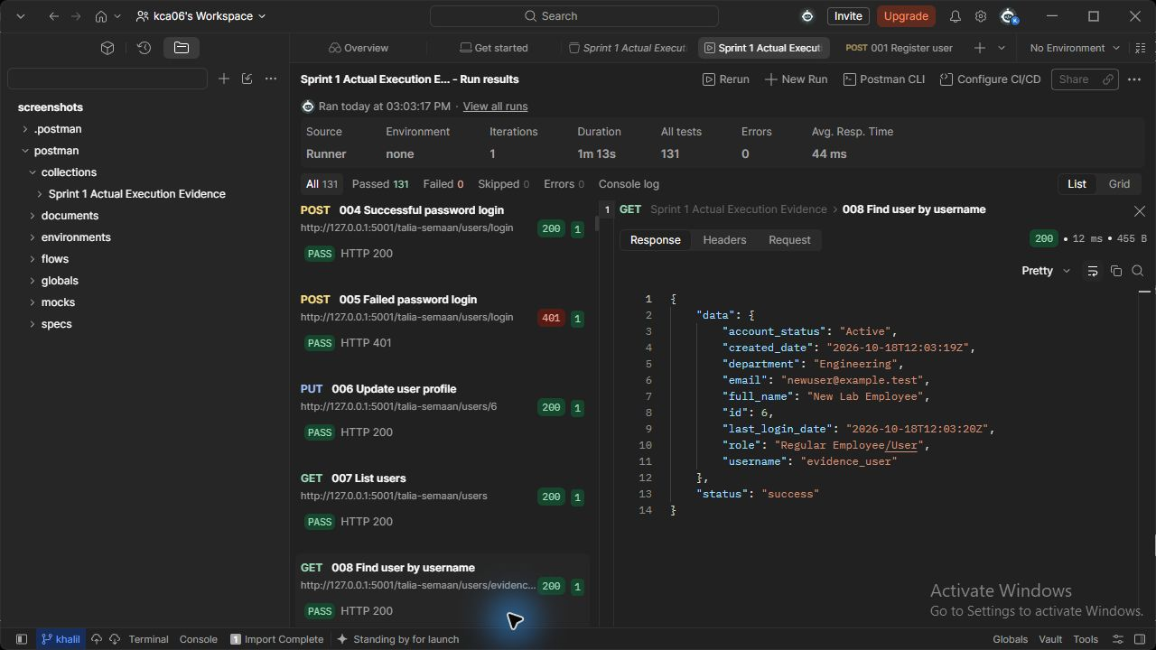
Figure 8 (Talia Semaan). users API - Find user by username. Actual HTTP 200 response; the runner assertion passed.

011 Assign user role (Talia Semaan)
PUT http://127.0.0.1:5001/talia-semaan/users/{{new_user_id}}/role
JSON body: {"role": "Security Analyst"}
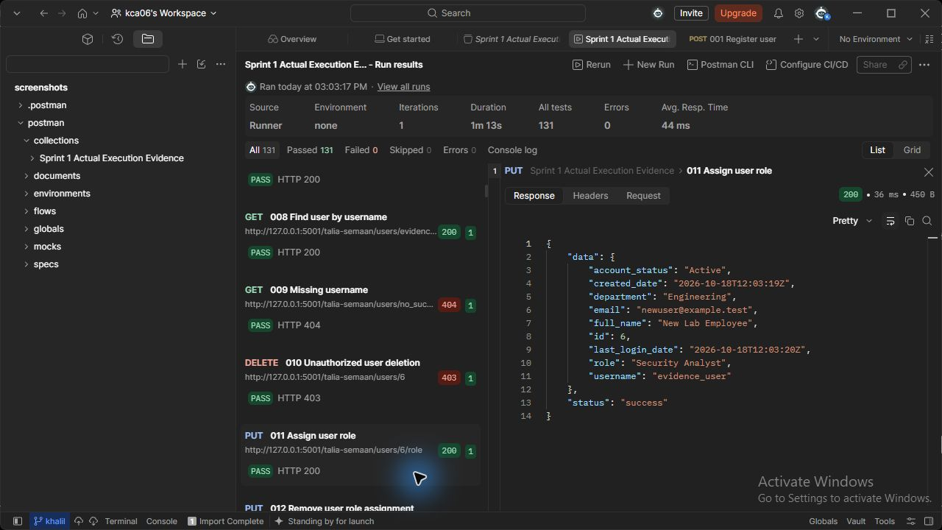
Figure 11 (Talia Semaan). users API - Assign user role. Actual HTTP 200 response; the runner assertion passed.

012 Remove user role assignment (Talia Semaan)
PUT http://127.0.0.1:5001/talia-semaan/users/{{new_user_id}}/role
JSON body: {"role": "Regular Employee/User"}
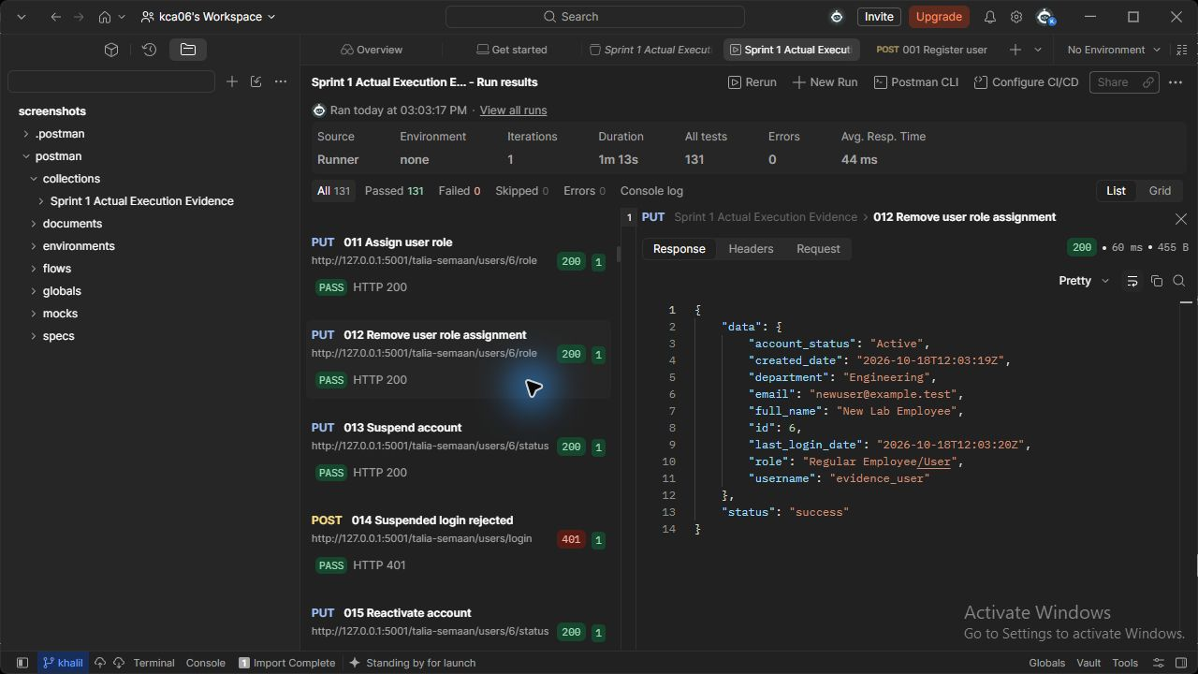
Figure 12 (Talia Semaan). users API - Remove user role assignment. Actual HTTP 200 response; the runner assertion passed.

013 Suspend account (Talia Semaan)
PUT http://127.0.0.1:5001/talia-semaan/users/{{new_user_id}}/status
JSON body: {"account_status": "Suspended"}
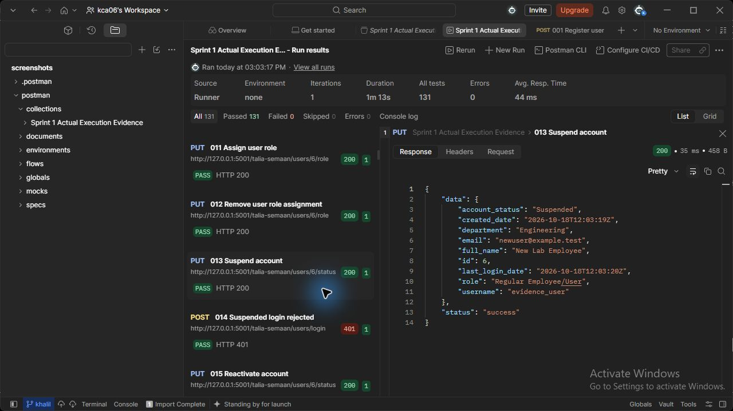
Figure 13 (Talia Semaan). users API - Suspend account. Actual HTTP 200 response; the runner assertion passed.

015 Reactivate account (Talia Semaan)
PUT http://127.0.0.1:5001/talia-semaan/users/{{new_user_id}}/status
JSON body: {"account_status": "Active"}
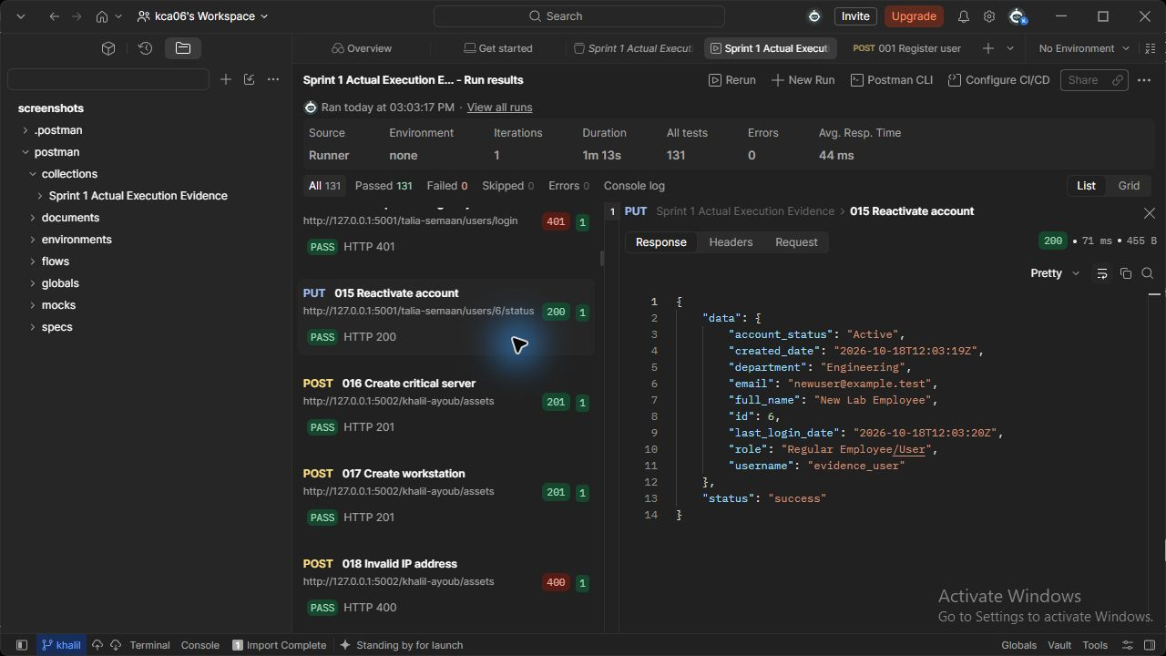
Figure 15 (Talia Semaan). users API - Reactivate account. Actual HTTP 200 response; the runner assertion passed.

131 Delete user logically (Talia Semaan)
DELETE http://127.0.0.1:5001/talia-semaan/users/{{new_user_id}}
Request body: none
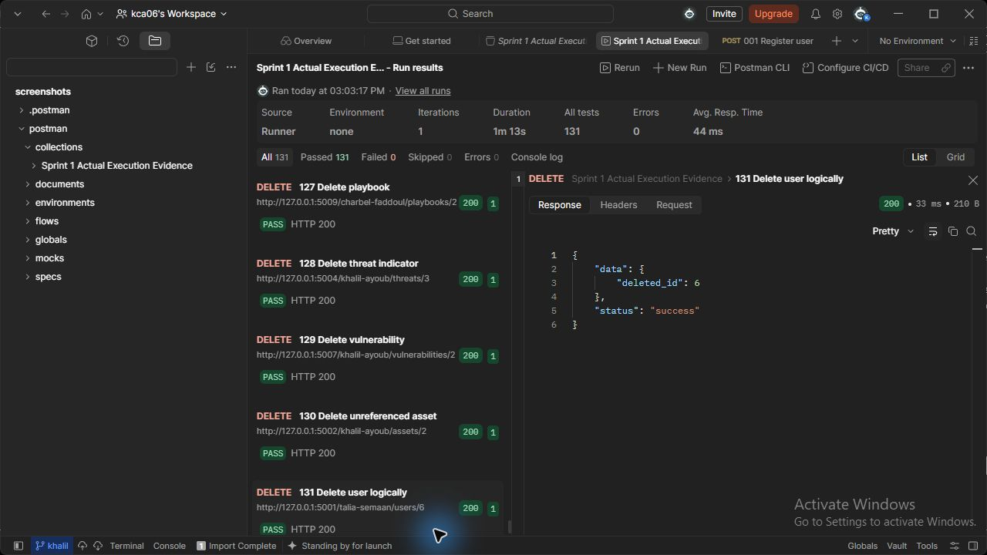
Figure 131 (Talia Semaan). users API - Delete user logically. Actual HTTP 200 response; the runner assertion passed.

103 Create security log (Talia Semaan)
POST http://127.0.0.1:5005/talia-semaan/logs
JSON body: { "user_id": {{employee_id}}, "action": "lab_review", "description": "Security review performed in lab", "severity": "Information", "related_service": "incidents" }
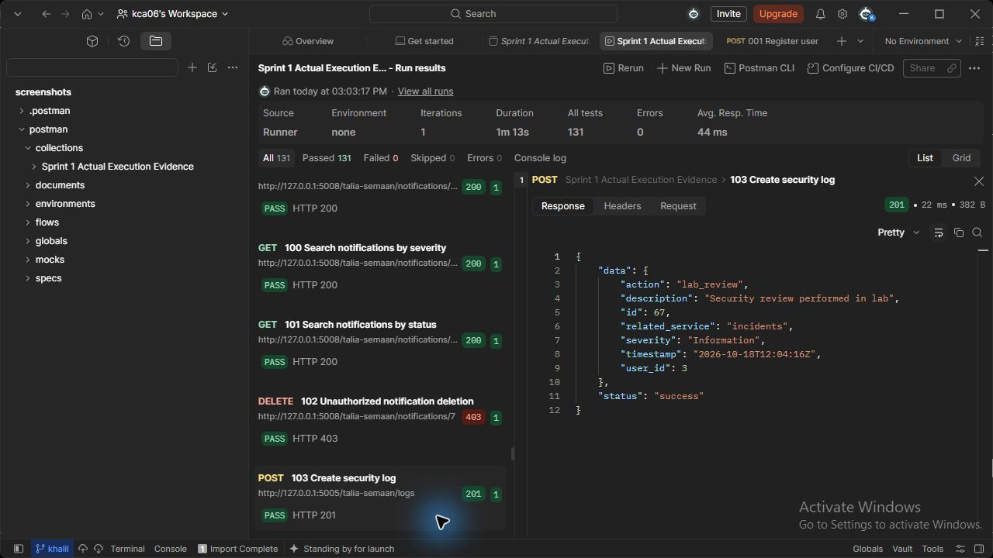
Figure 103 (Talia Semaan). logs API - Create security log. Actual HTTP 201 response; the runner assertion passed.

104 List security logs (Talia Semaan)
GET http://127.0.0.1:5005/talia-semaan/logs
Request body: none
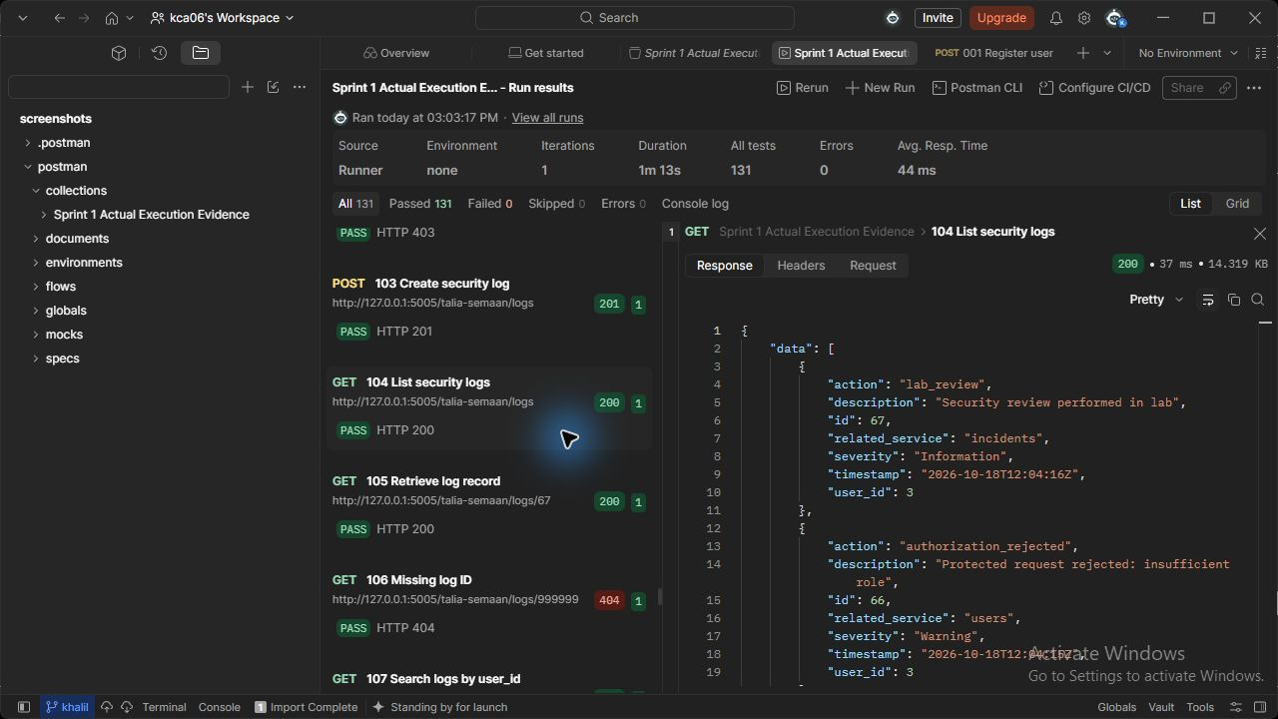
Figure 104 (Talia Semaan). logs API - List security logs. Actual HTTP 200 response; the runner assertion passed.

105 Retrieve log record (Talia Semaan)
GET http://127.0.0.1:5005/talia-semaan/logs/{{log_id}}
Request body: none
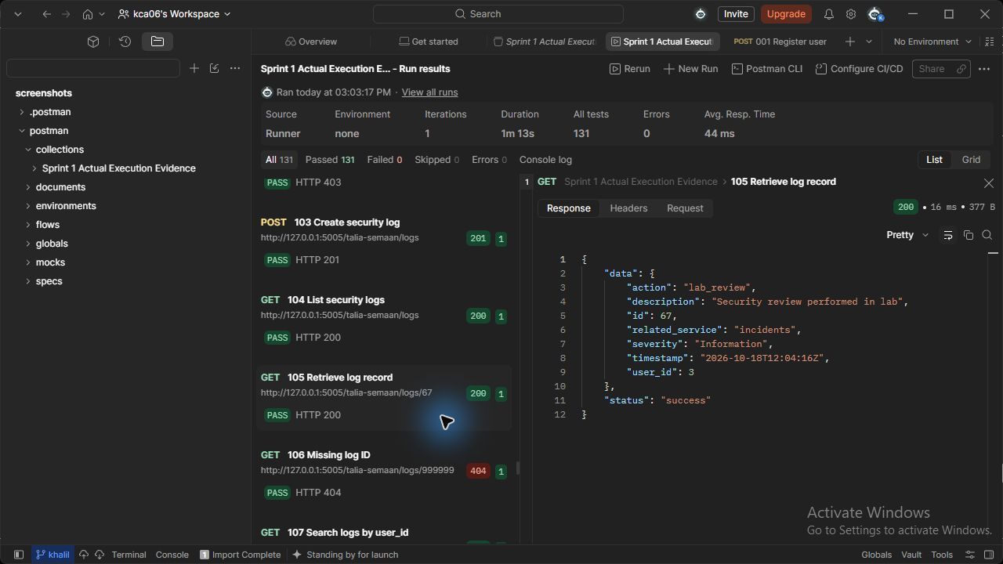
Figure 105 (Talia Semaan). logs API - Retrieve log record. Actual HTTP 200 response; the runner assertion passed.

107 Search logs by user_id (Talia Semaan)
GET http://127.0.0.1:5005/talia-semaan/logs/search?user_id={{employee_id}}
Request body: none
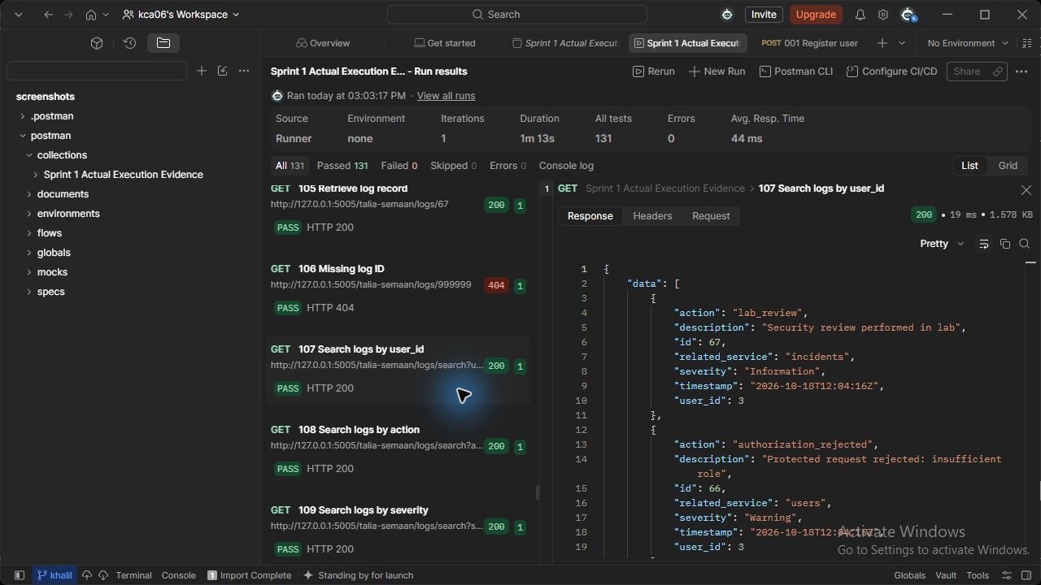
Figure 107 (Talia Semaan). logs API - Search logs by user_id. Actual HTTP 200 response; the runner assertion passed.

108 Search logs by action (Talia Semaan)
GET http://127.0.0.1:5005/talia-semaan/logs/search?action=lab_review
Request body: none
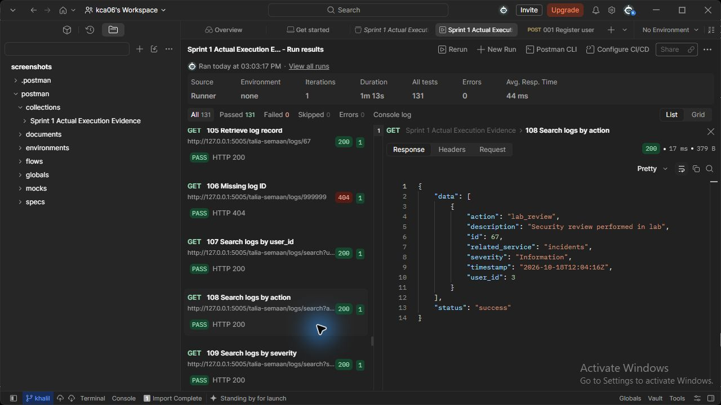
Figure 108 (Talia Semaan). logs API - Search logs by action. Actual HTTP 200 response; the runner assertion passed.

109 Search logs by severity (Talia Semaan)
GET http://127.0.0.1:5005/talia-semaan/logs/search?severity=Warning
Request body: none
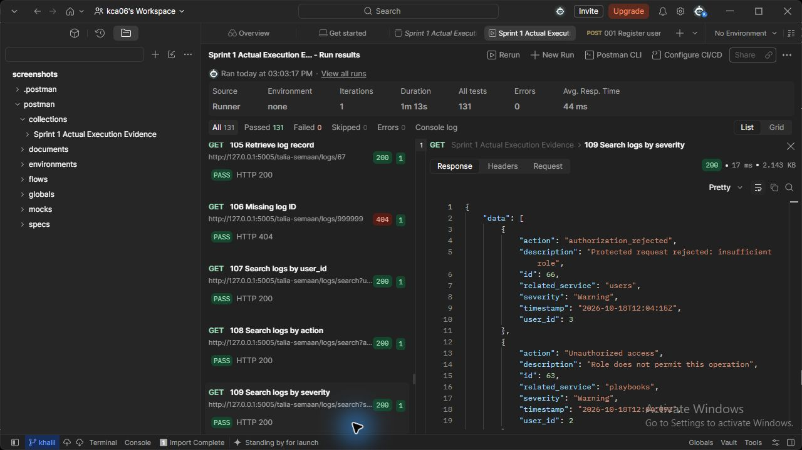
Figure 109 (Talia Semaan). logs API - Search logs by severity. Actual HTTP 200 response; the runner assertion passed.

110 Search logs by related_service (Talia Semaan)
GET http://127.0.0.1:5005/talia-semaan/logs/search?related_service=incidents
Request body: none
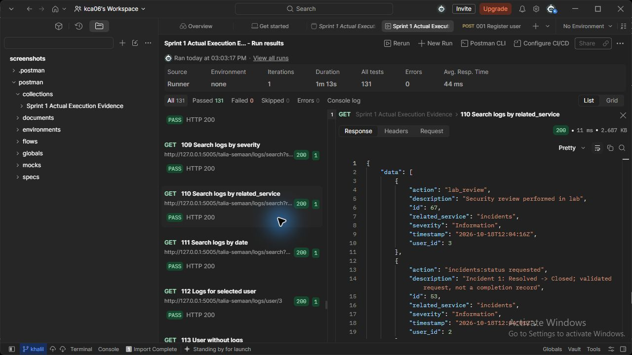
Figure 110 (Talia Semaan). logs API - Search logs by related_service. Actual HTTP 200 response; the runner assertion passed.

111 Search logs by date (Talia Semaan)
GET http://127.0.0.1:5005/talia-semaan/logs/search?date=2026-10-18
Request body: none
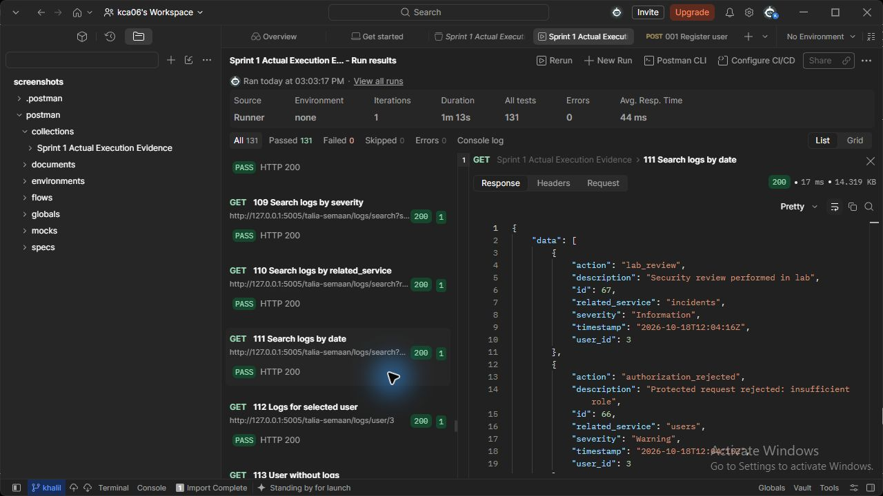
Figure 111 (Talia Semaan). logs API - Search logs by date. Actual HTTP 200 response; the runner assertion passed.

112 Logs for selected user (Talia Semaan)
GET http://127.0.0.1:5005/talia-semaan/logs/user/{{employee_id}}
Request body: none
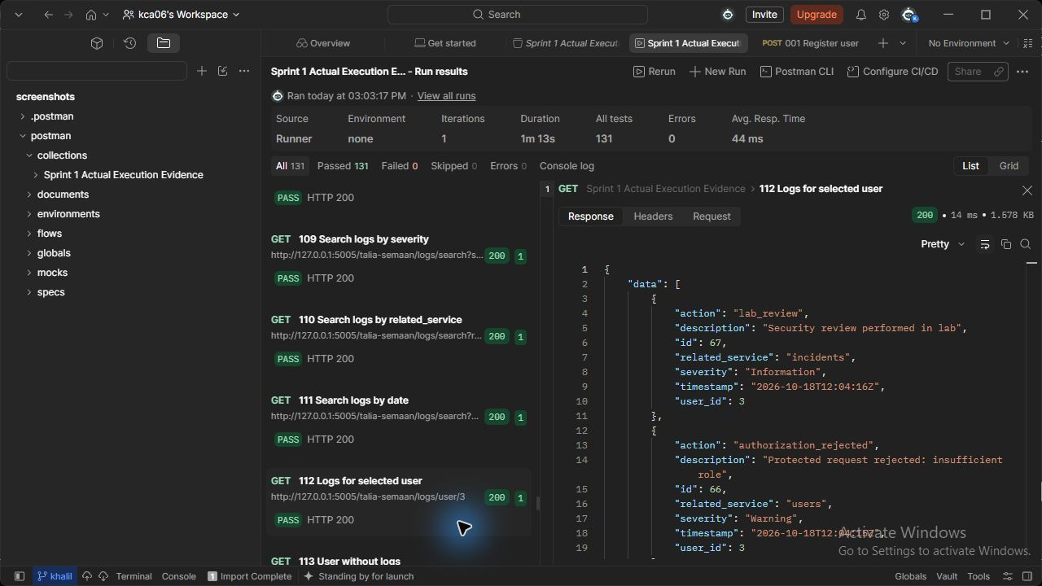
Figure 112 (Talia Semaan). logs API - Logs for selected user. Actual HTTP 200 response; the runner assertion passed.

113 User without logs (Talia Semaan)
GET http://127.0.0.1:5005/talia-semaan/logs/user/999999
Request body: none
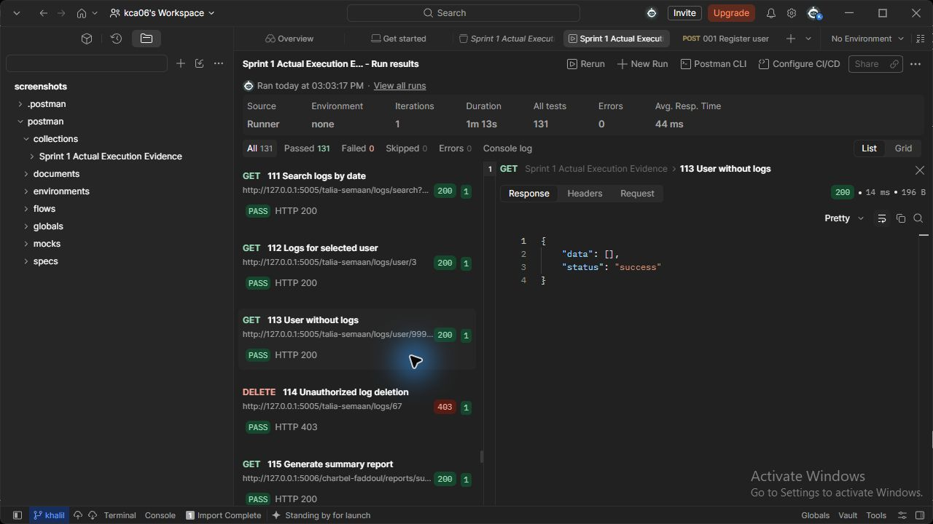
Figure 113 (Talia Semaan). logs API - User without logs. Actual HTTP 200 response; the runner assertion passed.

126 Delete security log (Talia Semaan)
DELETE http://127.0.0.1:5005/talia-semaan/logs/{{log_id}}
Request body: none
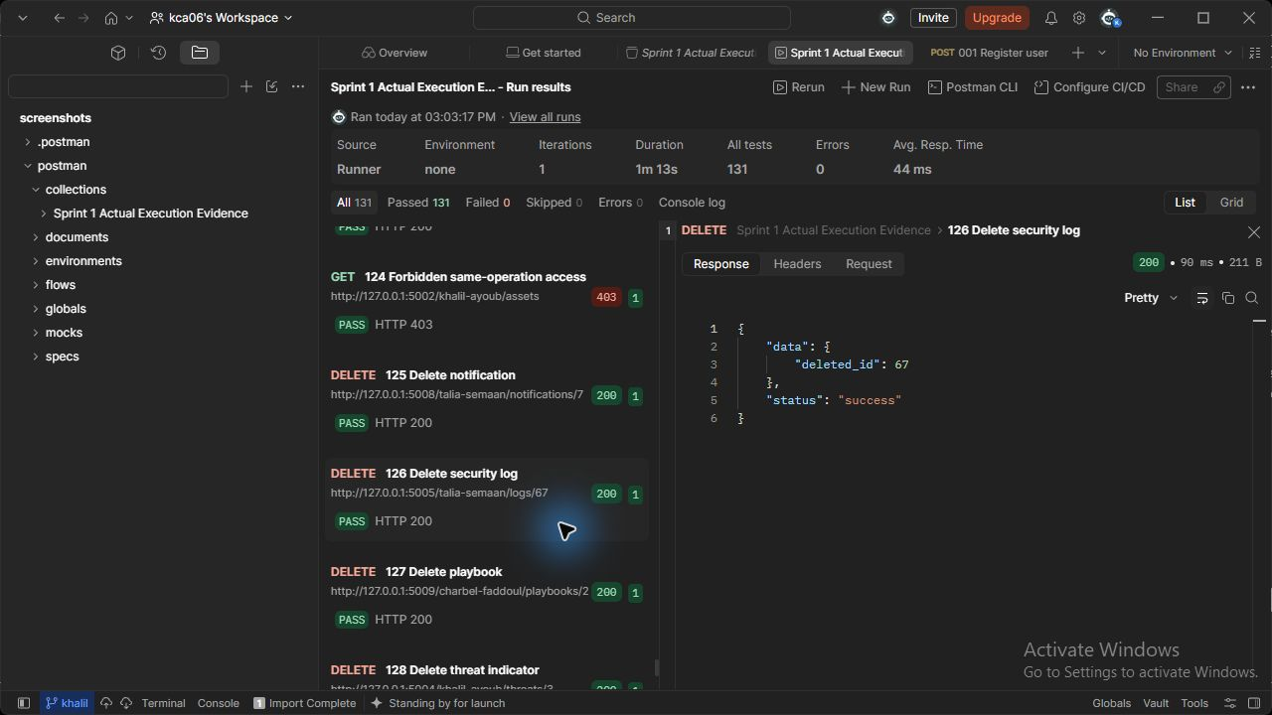
Figure 126 (Talia Semaan). logs API - Delete security log. Actual HTTP 200 response; the runner assertion passed.

092 Create notification (Talia Semaan)
POST http://127.0.0.1:5008/talia-semaan/notifications
JSON body: { "user_id": {{employee_id}}, "title": "Security review", "message": "Please review the lab security event", "notification_type": "System Notification", "severity": "Medium" }
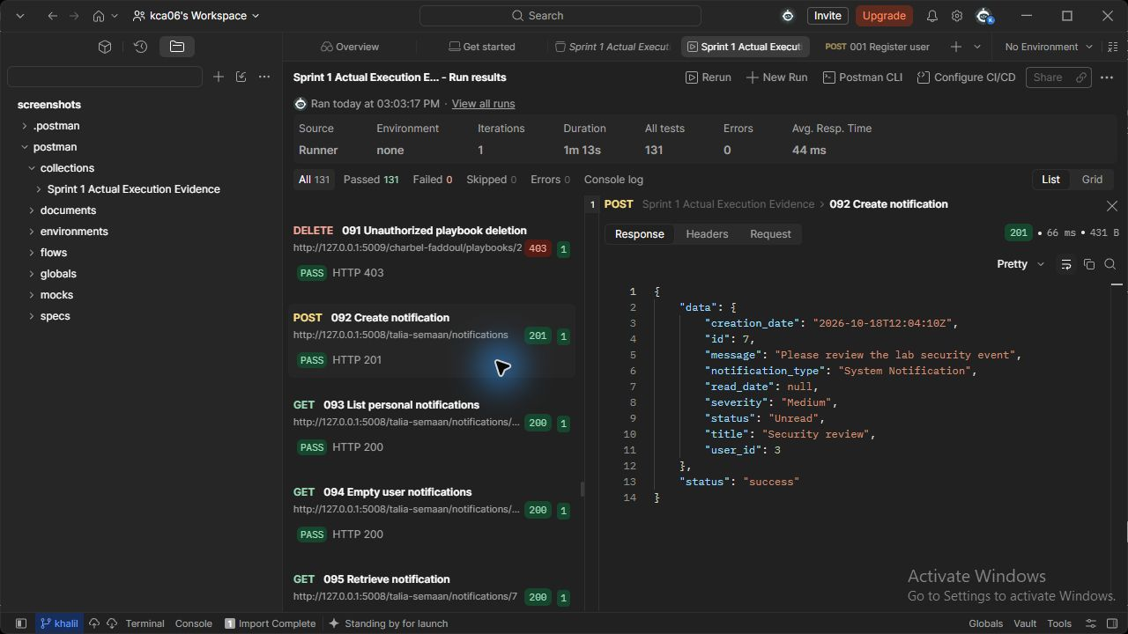
Figure 92 (Talia Semaan). notifications API - Create notification. Actual HTTP 201 response; the runner assertion passed.

093 List personal notifications (Talia Semaan)
GET http://127.0.0.1:5008/talia-semaan/notifications/user/{{employee_id}}
Request body: none
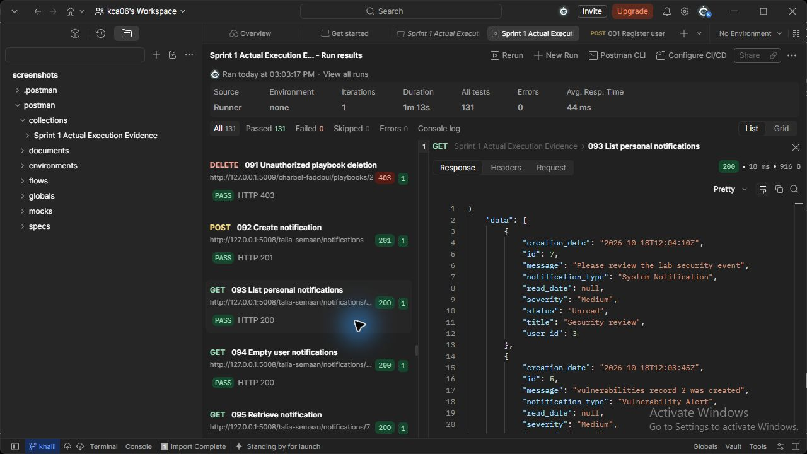
Figure 93 (Talia Semaan). notifications API - List personal notifications. Actual HTTP 200 response; the runner assertion passed.

094 Empty user notifications (Talia Semaan)
GET http://127.0.0.1:5008/talia-semaan/notifications/user/{{other_id}}
Request body: none
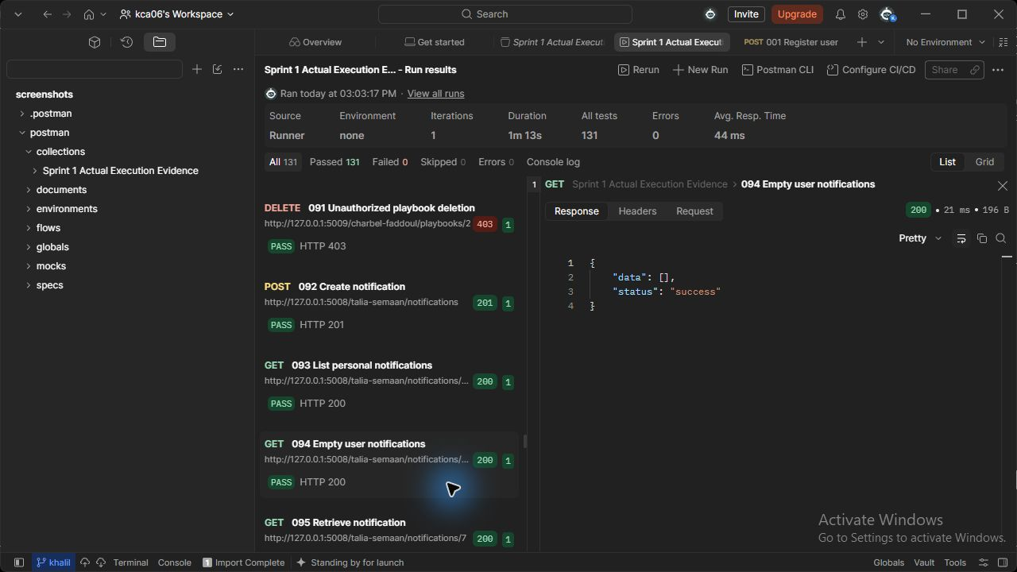
Figure 94 (Talia Semaan). notifications API - Empty user notifications. Actual HTTP 200 response; the runner assertion passed.

095 Retrieve notification (Talia Semaan)
GET http://127.0.0.1:5008/talia-semaan/notifications/{{notification_id}}
Request body: none
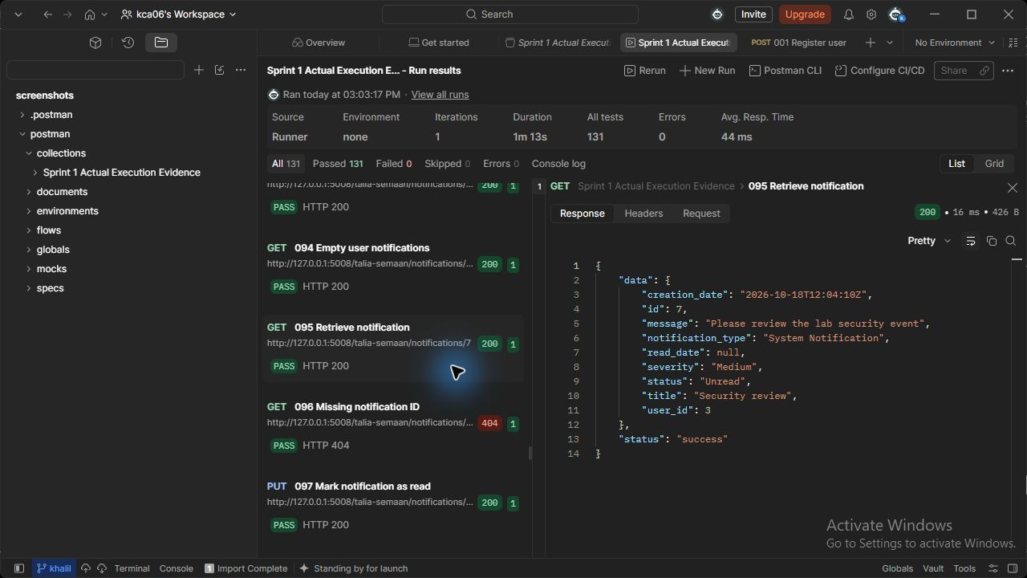
Figure 95 (Talia Semaan). notifications API - Retrieve notification. Actual HTTP 200 response; the runner assertion passed.

097 Mark notification as read (Talia Semaan)
PUT http://127.0.0.1:5008/talia-semaan/notifications/{{notification_id}}/read
Request body: none
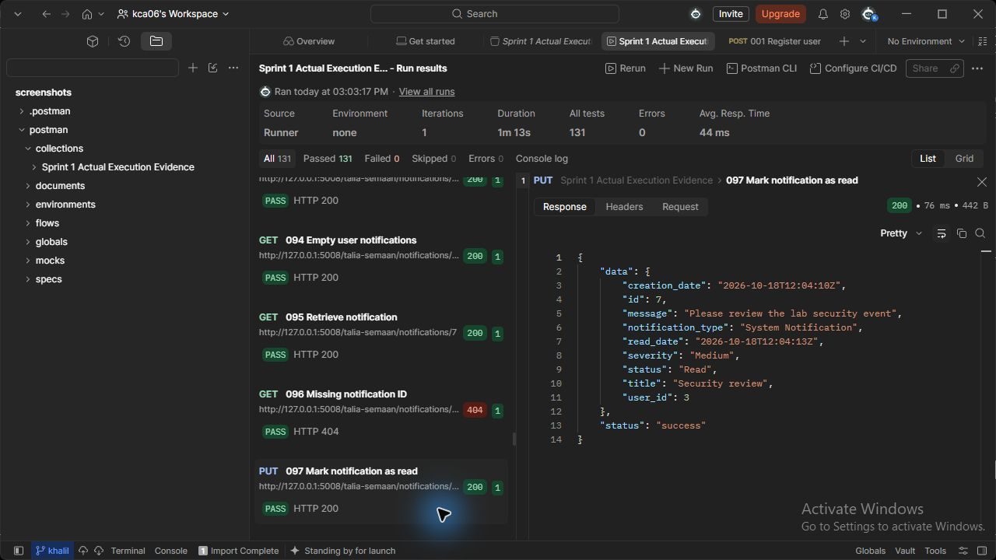
Figure 97 (Talia Semaan). notifications API - Mark notification as read. Actual HTTP 200 response; the runner assertion passed.

098 Search notifications by user_id (Talia Semaan)
GET http://127.0.0.1:5008/talia-semaan/notifications/search?user_id={{employee_id}}
Request body: none
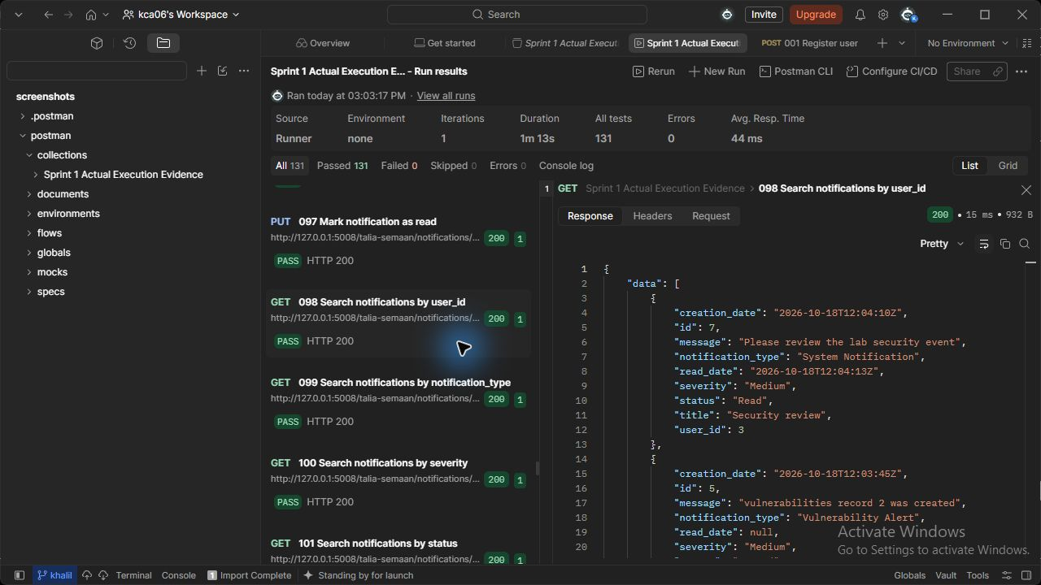
Figure 98 (Talia Semaan). notifications API - Search notifications by user_id. Actual HTTP 200 response; the runner assertion passed.

099 Search notifications by notification_type (Talia Semaan)
GET http://127.0.0.1:5008/talia-semaan/notifications/search?notification_type=System%20Notification
Request body: none
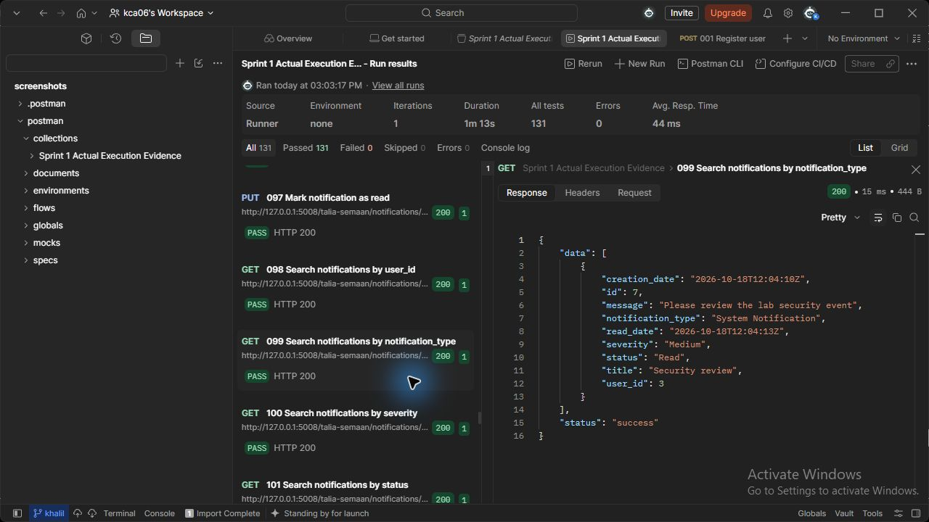
Figure 99 (Talia Semaan). notifications API - Search notifications by notification_type. Actual HTTP 200 response; the runner assertion passed.

100 Search notifications by severity (Talia Semaan)
GET http://127.0.0.1:5008/talia-semaan/notifications/search?severity=Medium
Request body: none
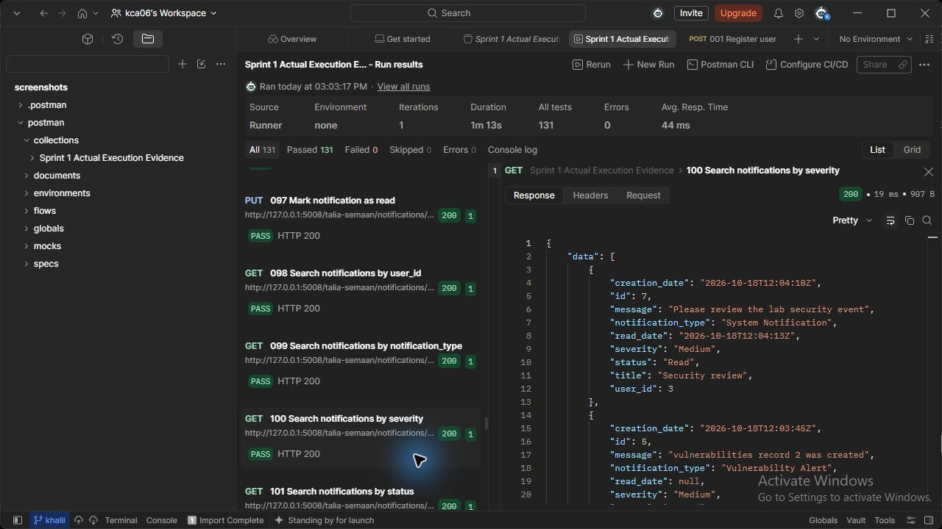
Figure 100 (Talia Semaan). notifications API - Search notifications by severity. Actual HTTP 200 response; the runner assertion passed.

101 Search notifications by status (Talia Semaan)
GET http://127.0.0.1:5008/talia-semaan/notifications/search?status=Read
Request body: none
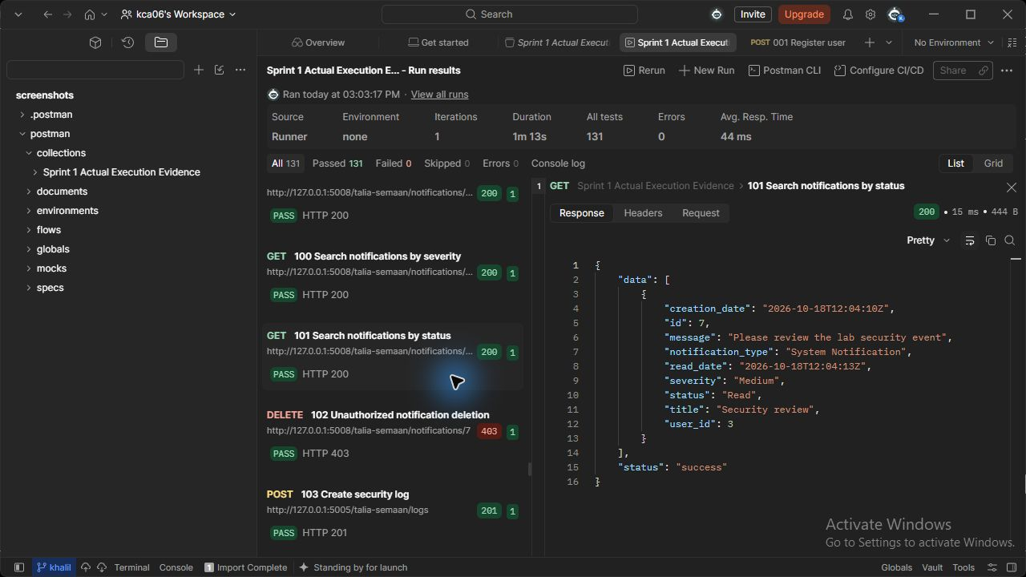
Figure 101 (Talia Semaan). notifications API - Search notifications by status. Actual HTTP 200 response; the runner assertion passed.

125 Delete notification (Talia Semaan)
DELETE http://127.0.0.1:5008/talia-semaan/notifications/{{notification_id}}
Request body: none
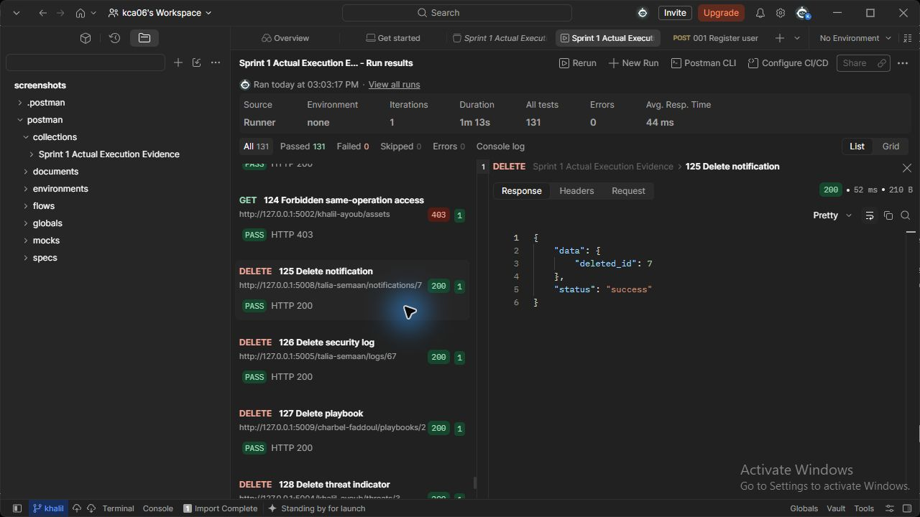
Figure 125 (Talia Semaan). notifications API - Delete notification. Actual HTTP 200 response; the runner assertion passed.

063 Report employee incident (Charbel Faddoul)
POST http://127.0.0.1:5003/charbel-faddoul/incidents
JSON body: { "title": "Suspicious access", "description": "Unexpected authentication on security lab server", "category": "Unauthorized access", "severity": "High", "asset_id": {{asset_id}} }
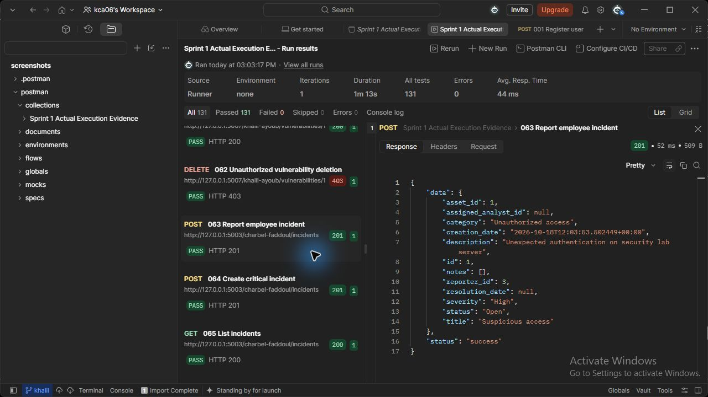
Figure 63 (Charbel Faddoul). incidents API - Report employee incident. Actual HTTP 201 response; the runner assertion passed.

064 Create critical incident (Charbel Faddoul)
POST http://127.0.0.1:5003/charbel-faddoul/incidents
JSON body: { "title": "Lab malware incident", "description": "Unexpected authentication on security lab server", "category": "Malware", "severity": "Critical", "asset_id": {{asset_id}} }
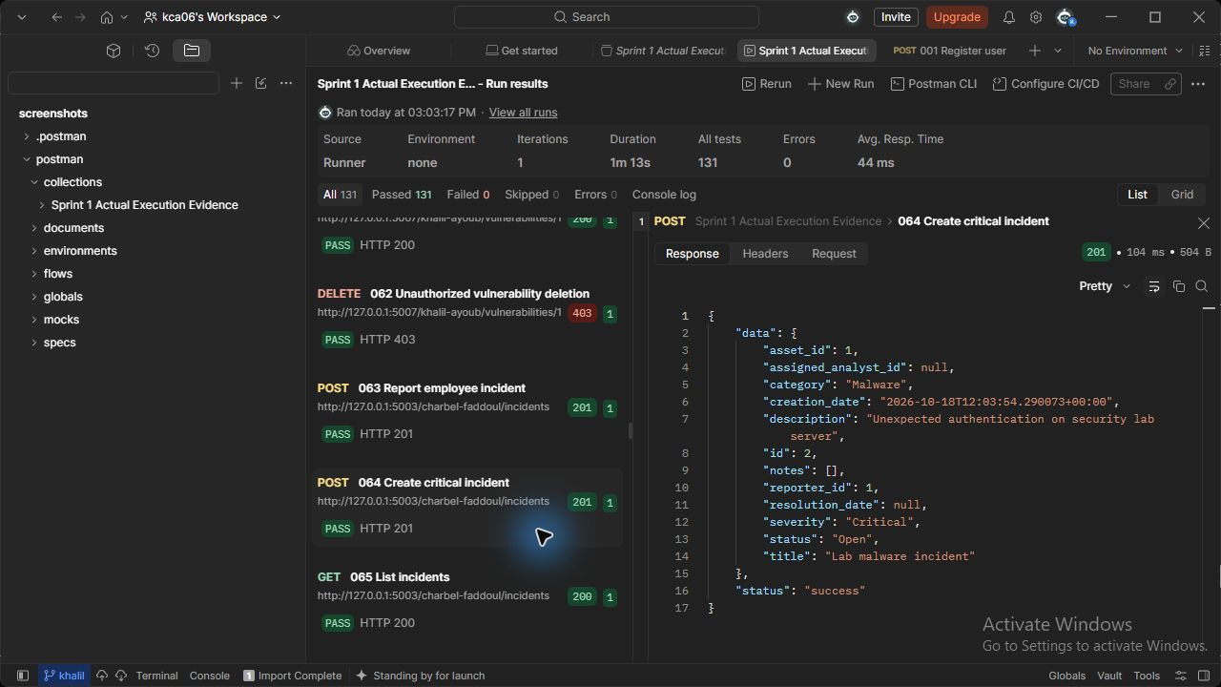
Figure 64 (Charbel Faddoul). incidents API - Create critical incident. Actual HTTP 201 response; the runner assertion passed.

065 List incidents (Charbel Faddoul)
GET http://127.0.0.1:5003/charbel-faddoul/incidents
Request body: none
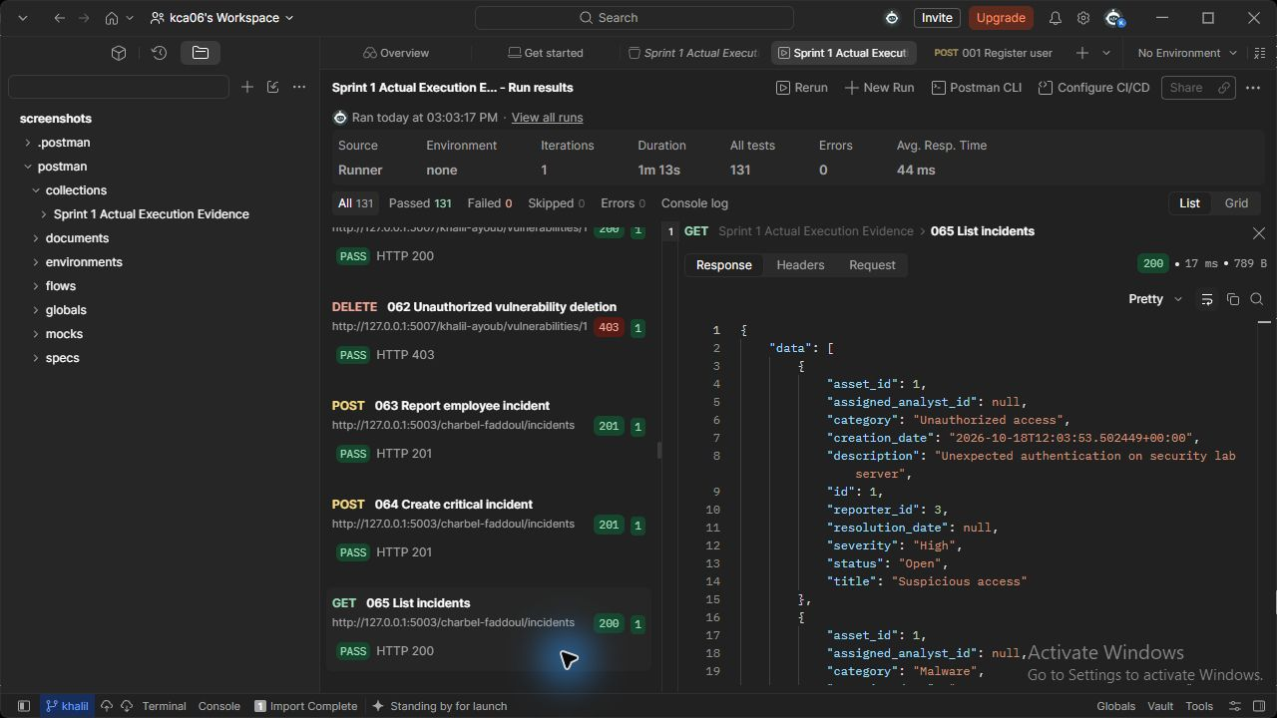
Figure 65 (Charbel Faddoul). incidents API - List incidents. Actual HTTP 200 response; the runner assertion passed.

066 Retrieve incident (Charbel Faddoul)
GET http://127.0.0.1:5003/charbel-faddoul/incidents/{{incident_id}}
Request body: none
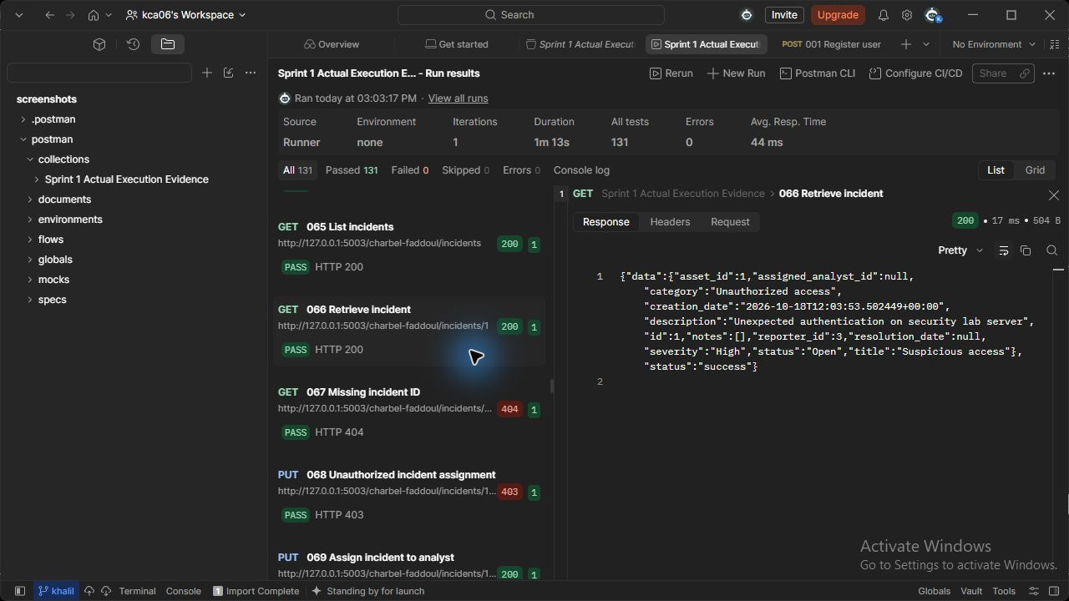
Figure 66 (Charbel Faddoul). incidents API - Retrieve incident. Actual HTTP 200 response; the runner assertion passed.

069 Assign incident to analyst (Charbel Faddoul)
PUT http://127.0.0.1:5003/charbel-faddoul/incidents/{{incident_id}}/assign
JSON body: { "assigned_analyst_id": {{analyst_id}} }
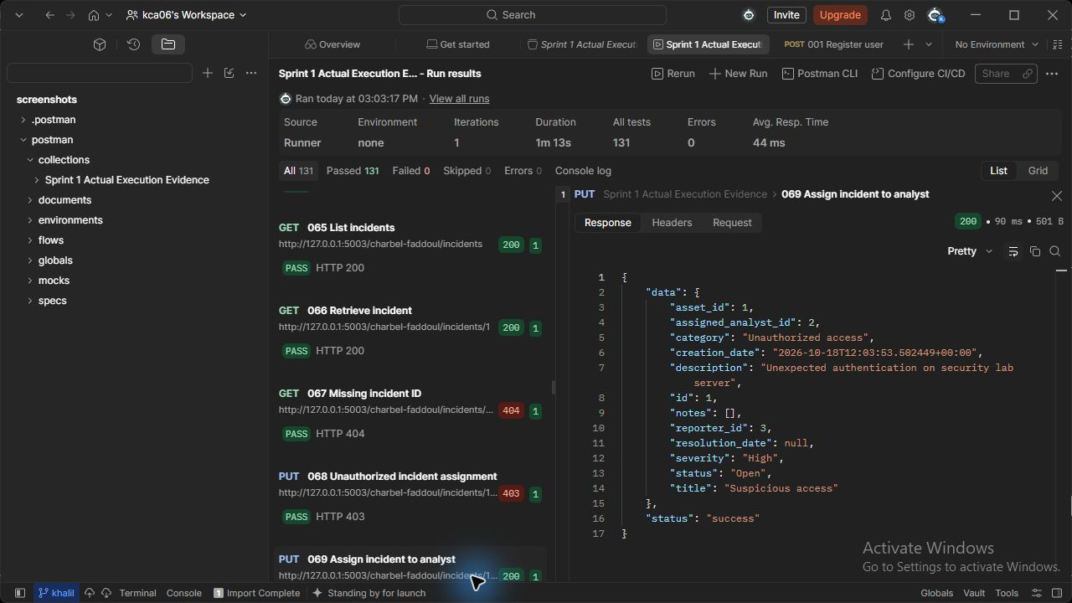
Figure 69 (Charbel Faddoul). incidents API - Assign incident to analyst. Actual HTTP 200 response; the runner assertion passed.

070 List assigned incidents (Charbel Faddoul)
GET http://127.0.0.1:5003/charbel-faddoul/incidents/assigned
Request body: none
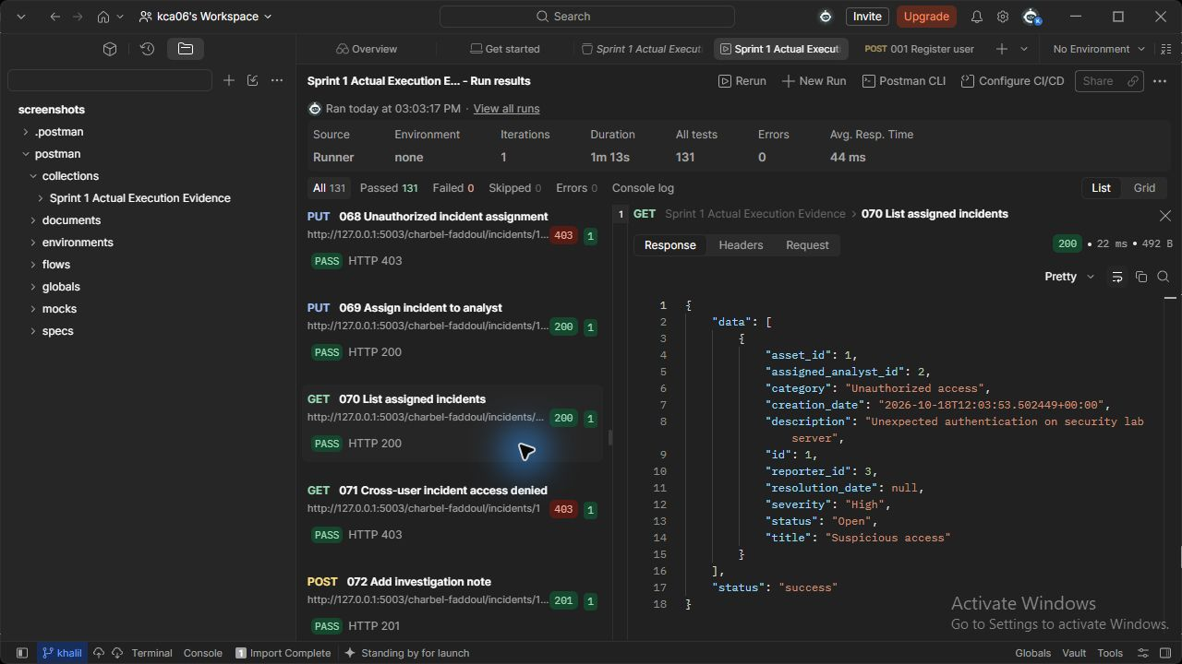
Figure 70 (Charbel Faddoul). incidents API - List assigned incidents. Actual HTTP 200 response; the runner assertion passed.

072 Add investigation note (Charbel Faddoul)
POST http://127.0.0.1:5003/charbel-faddoul/incidents/{{incident_id}}/notes
JSON body: {"note_content": "Reviewed security logs and isolated affected service"}
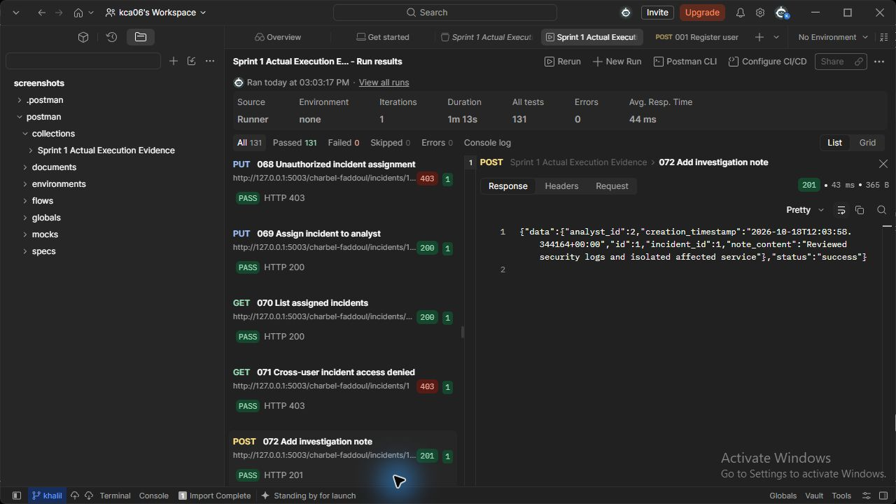
Figure 72 (Charbel Faddoul). incidents API - Add investigation note. Actual HTTP 201 response; the runner assertion passed.

073 Retrieve incident with notes (Charbel Faddoul)
GET http://127.0.0.1:5003/charbel-faddoul/incidents/{{incident_id}}
Request body: none
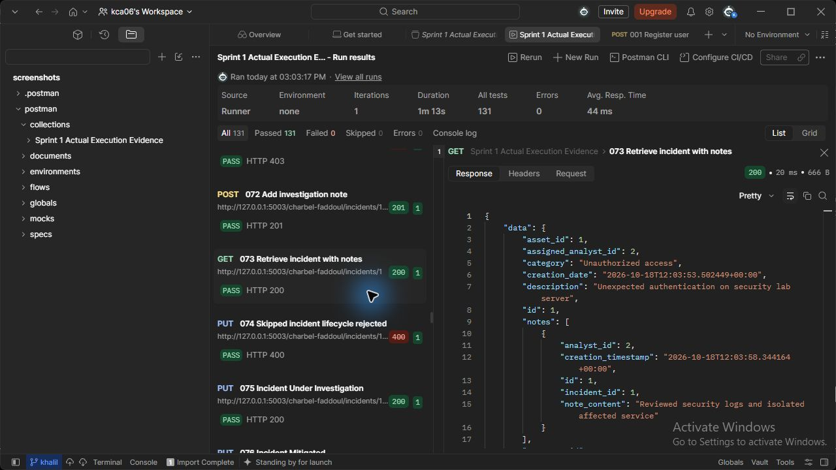
Figure 73 (Charbel Faddoul). incidents API - Retrieve incident with notes. Actual HTTP 200 response; the runner assertion passed.

075 Incident Under Investigation (Charbel Faddoul)
PUT http://127.0.0.1:5003/charbel-faddoul/incidents/{{incident_id}}/status
JSON body: {"status": "Under Investigation"}
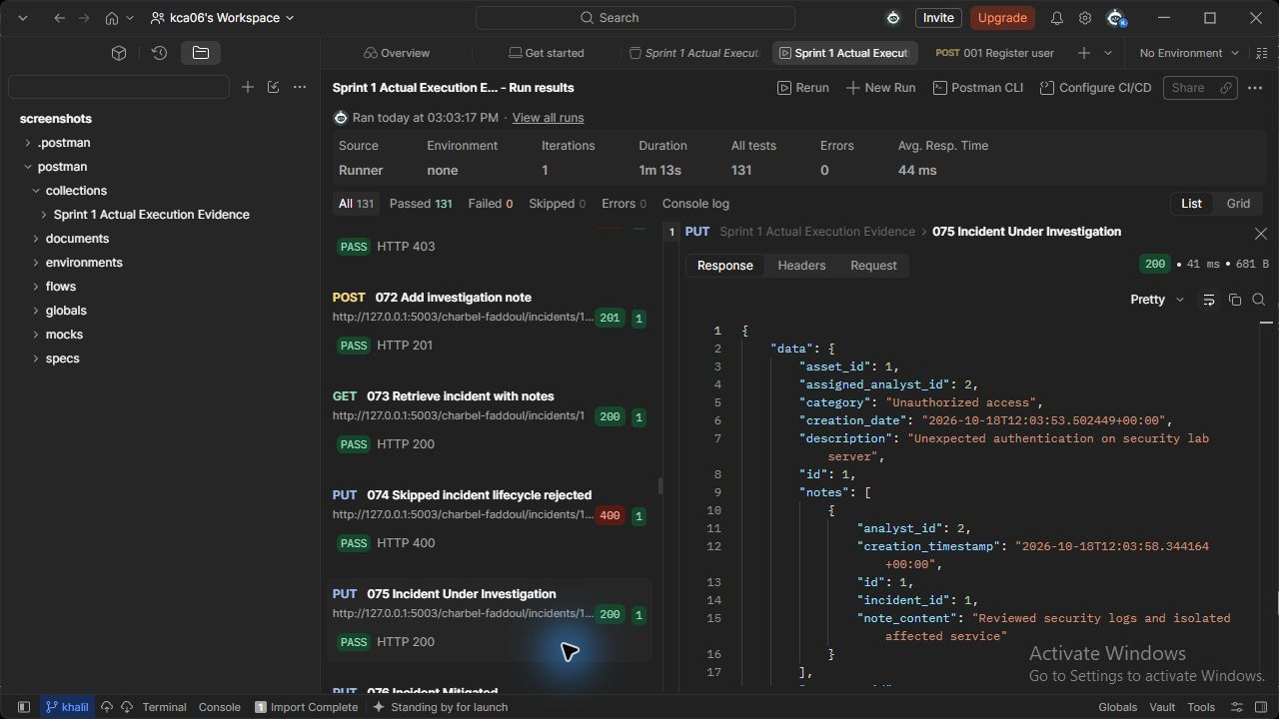
Figure 75 (Charbel Faddoul). incidents API - Incident Under Investigation. Actual HTTP 200 response; the runner assertion passed.

076 Incident Mitigated (Charbel Faddoul)
PUT http://127.0.0.1:5003/charbel-faddoul/incidents/{{incident_id}}/status
JSON body: {"status": "Mitigated"}
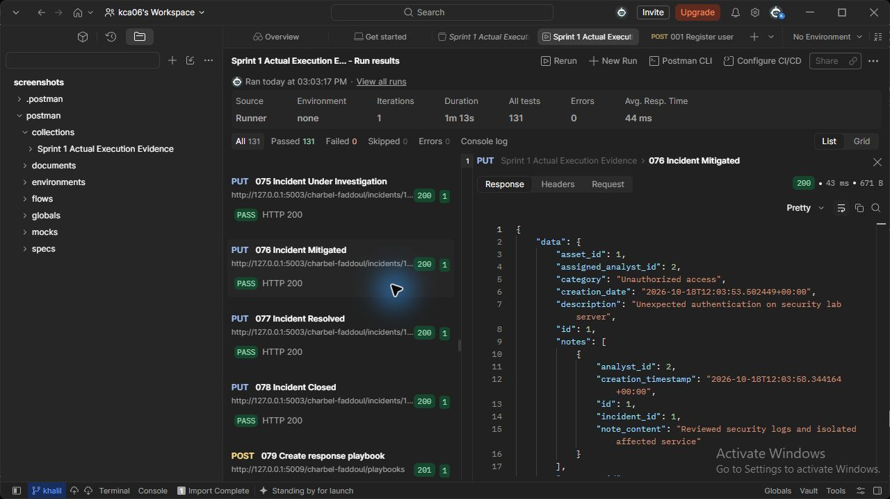
Figure 76 (Charbel Faddoul). incidents API - Incident Mitigated. Actual HTTP 200 response; the runner assertion passed.

077 Incident Resolved (Charbel Faddoul)
PUT http://127.0.0.1:5003/charbel-faddoul/incidents/{{incident_id}}/status
JSON body: {"status": "Resolved"}
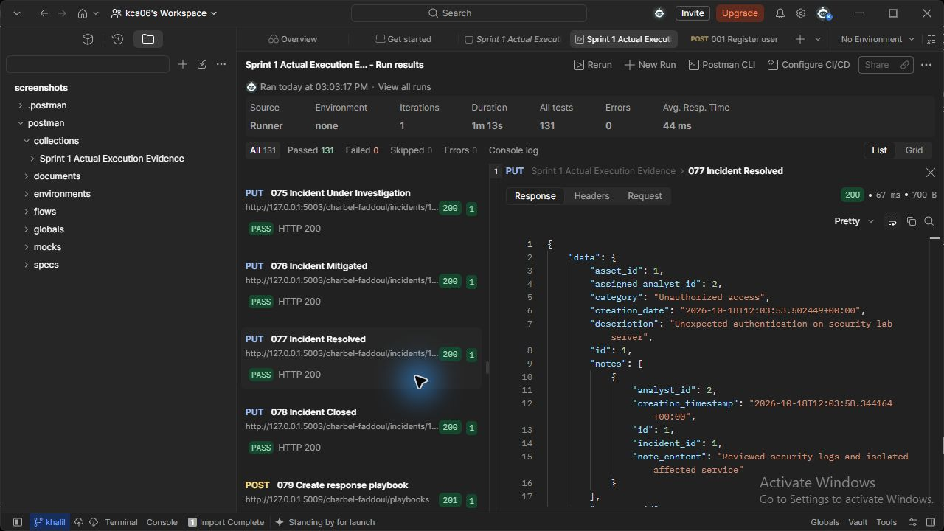
Figure 77 (Charbel Faddoul). incidents API - Incident Resolved. Actual HTTP 200 response; the runner assertion passed.

078 Incident Closed (Charbel Faddoul)
PUT http://127.0.0.1:5003/charbel-faddoul/incidents/{{incident_id}}/status
JSON body: {"status": "Closed"}
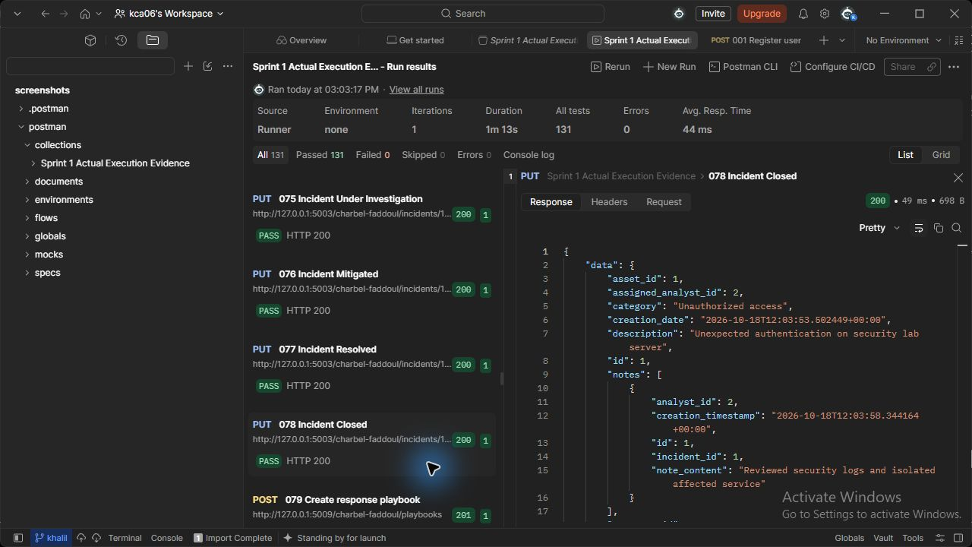
Figure 78 (Charbel Faddoul). incidents API - Incident Closed. Actual HTTP 200 response; the runner assertion passed.

115 Generate summary report (Charbel Faddoul)
GET http://127.0.0.1:5006/charbel-faddoul/reports/summary
Request body: none
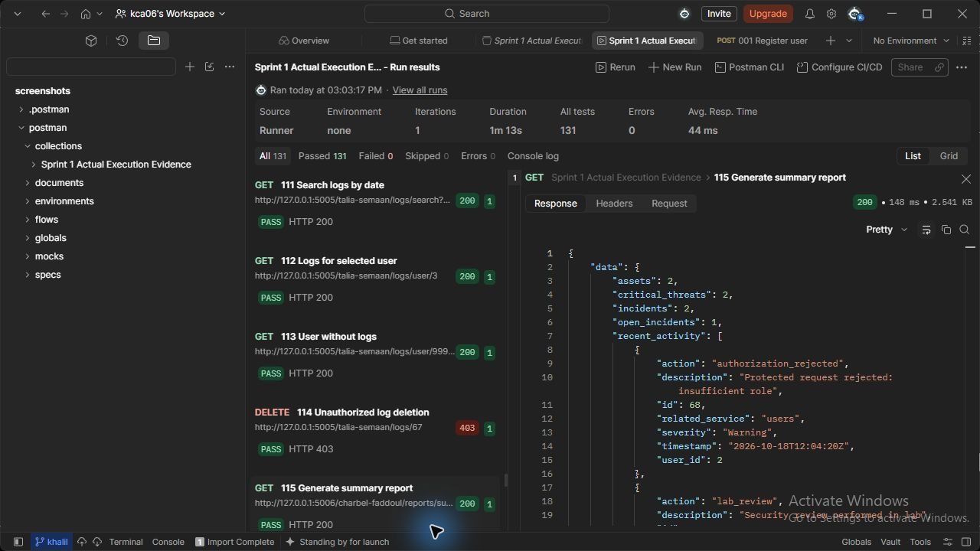
Figure 115 (Charbel Faddoul). reports API - Generate summary report. Actual HTTP 200 response; the runner assertion passed.

116 Generate incidents report (Charbel Faddoul)
GET http://127.0.0.1:5006/charbel-faddoul/reports/incidents
Request body: none
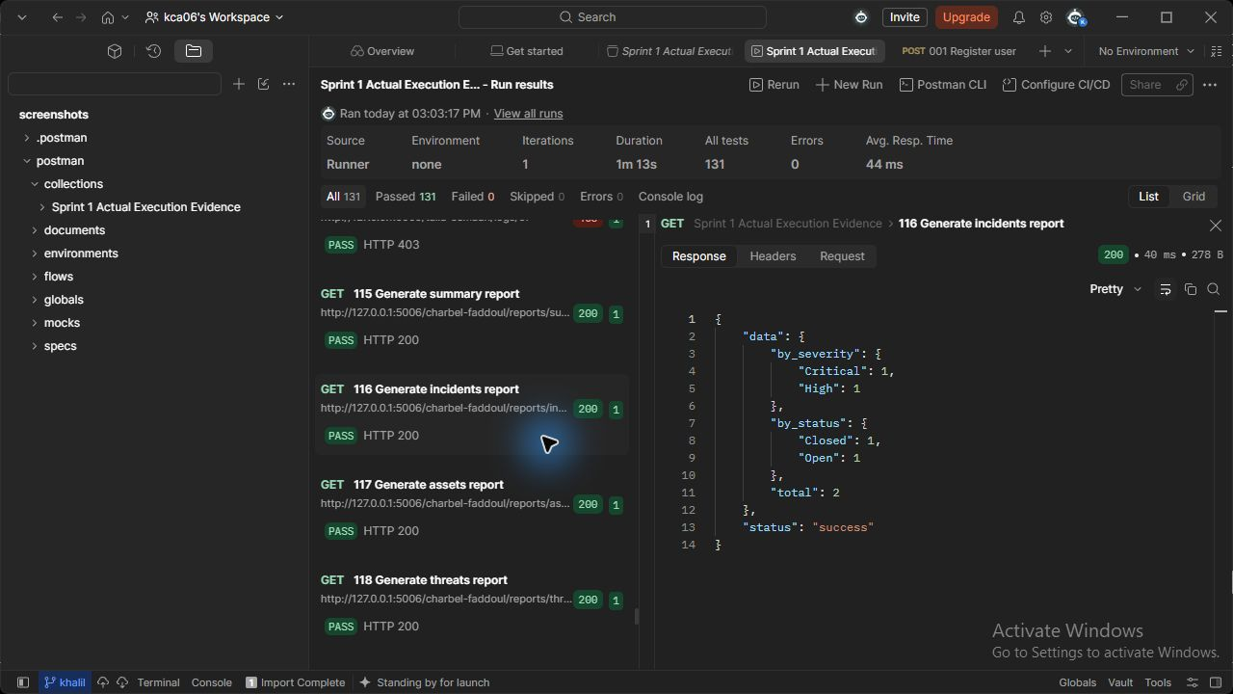
Figure 116 (Charbel Faddoul). reports API - Generate incidents report. Actual HTTP 200 response; the runner assertion passed.

117 Generate assets report (Charbel Faddoul)
GET http://127.0.0.1:5006/charbel-faddoul/reports/assets
Request body: none
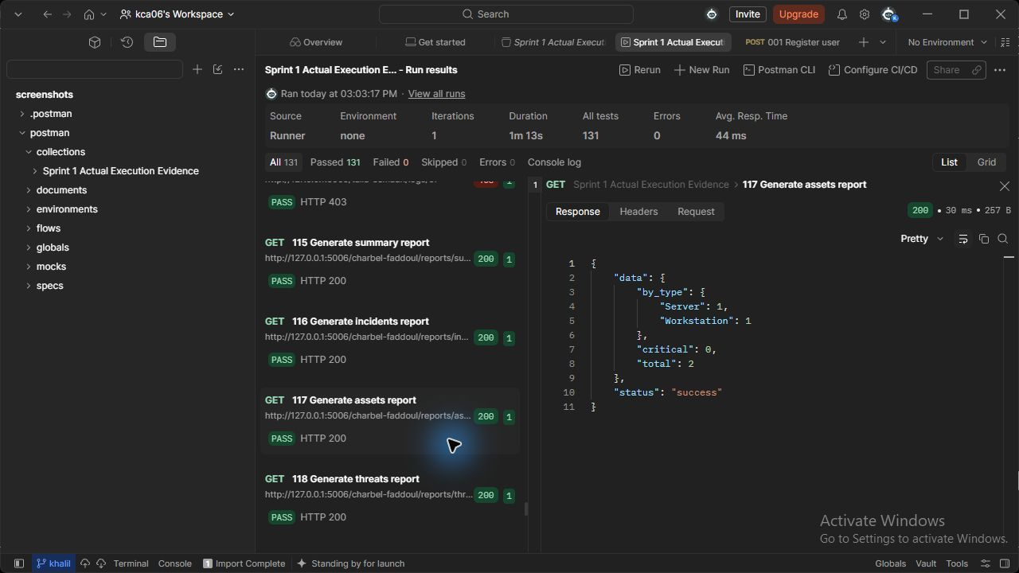
Figure 117 (Charbel Faddoul). reports API - Generate assets report. Actual HTTP 200 response; the runner assertion passed.

118 Generate threats report (Charbel Faddoul)
GET http://127.0.0.1:5006/charbel-faddoul/reports/threats
Request body: none
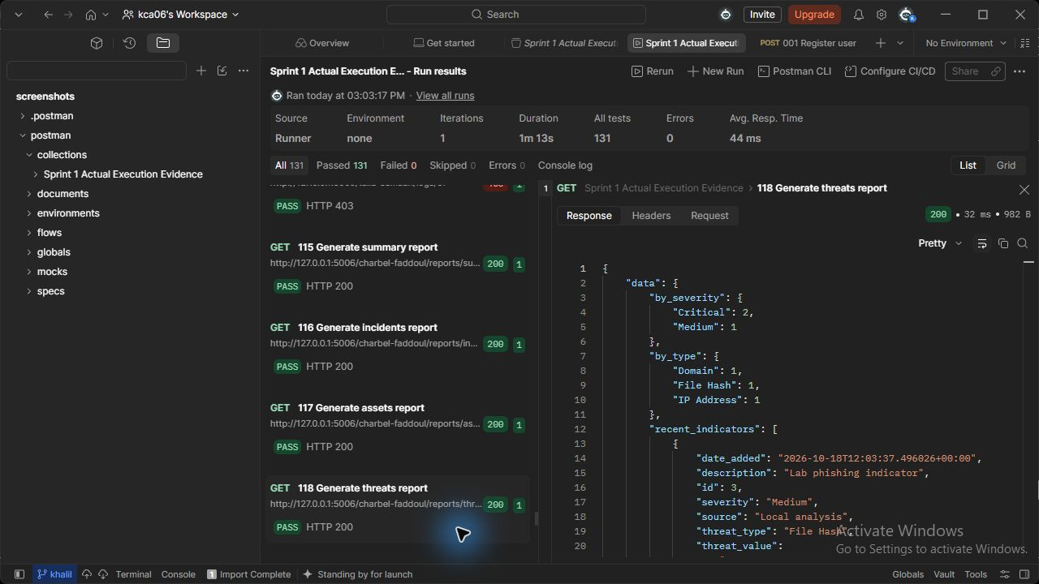
Figure 118 (Charbel Faddoul). reports API - Generate threats report. Actual HTTP 200 response; the runner assertion passed.

119 Generate vulnerabilities report (Charbel Faddoul)
GET http://127.0.0.1:5006/charbel-faddoul/reports/vulnerabilities
Request body: none
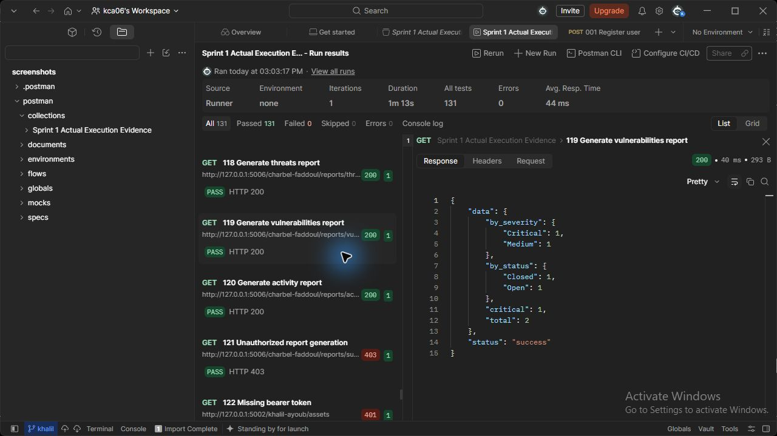
Figure 119 (Charbel Faddoul). reports API - Generate vulnerabilities report. Actual HTTP 200 response; the runner assertion passed.

120 Generate activity report (Charbel Faddoul)
GET http://127.0.0.1:5006/charbel-faddoul/reports/activity
Request body: none
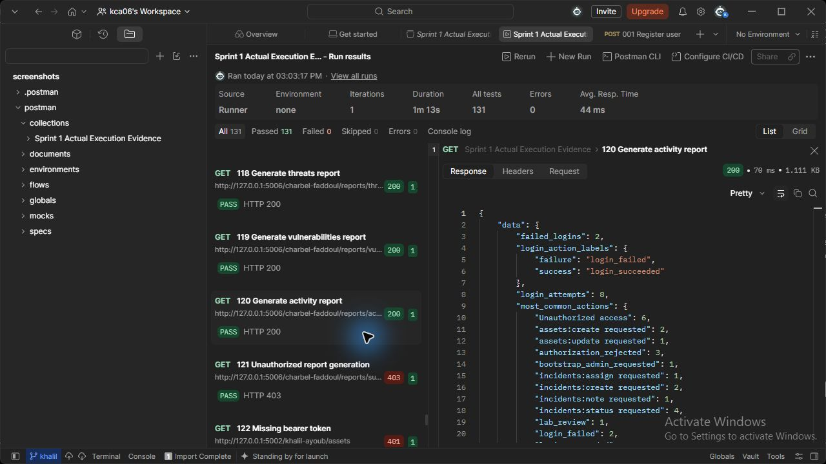
Figure 120 (Charbel Faddoul). reports API - Generate activity report. Actual HTTP 200 response; the runner assertion passed.

079 Create response playbook (Charbel Faddoul)
POST http://127.0.0.1:5009/charbel-faddoul/playbooks
JSON body: {"name": "Unauthorized access response", "description": "Collect evidence and contain access", "incident_category": "Unauthorized access", "severity": "High"}
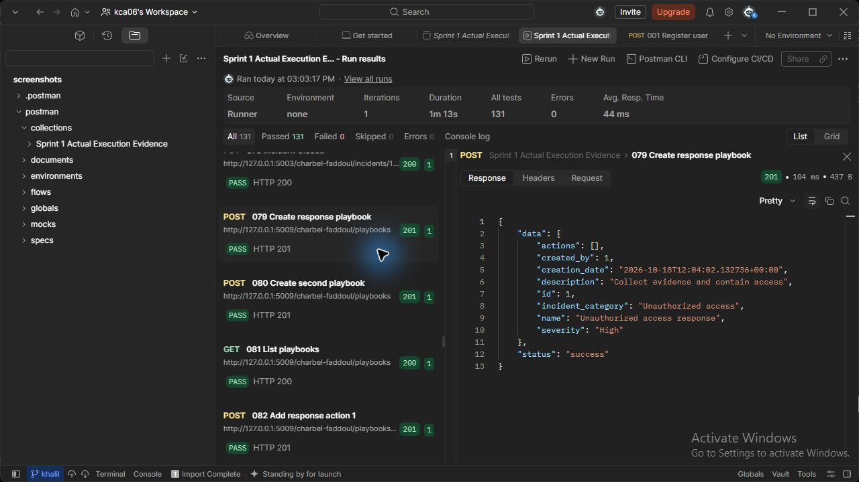
Figure 79 (Charbel Faddoul). playbooks API - Create response playbook. Actual HTTP 201 response; the runner assertion passed.

080 Create second playbook (Charbel Faddoul)
POST http://127.0.0.1:5009/charbel-faddoul/playbooks
JSON body: {"name": "Malware response", "description": "Collect evidence and contain access", "incident_category": "Malware", "severity": "Critical"}
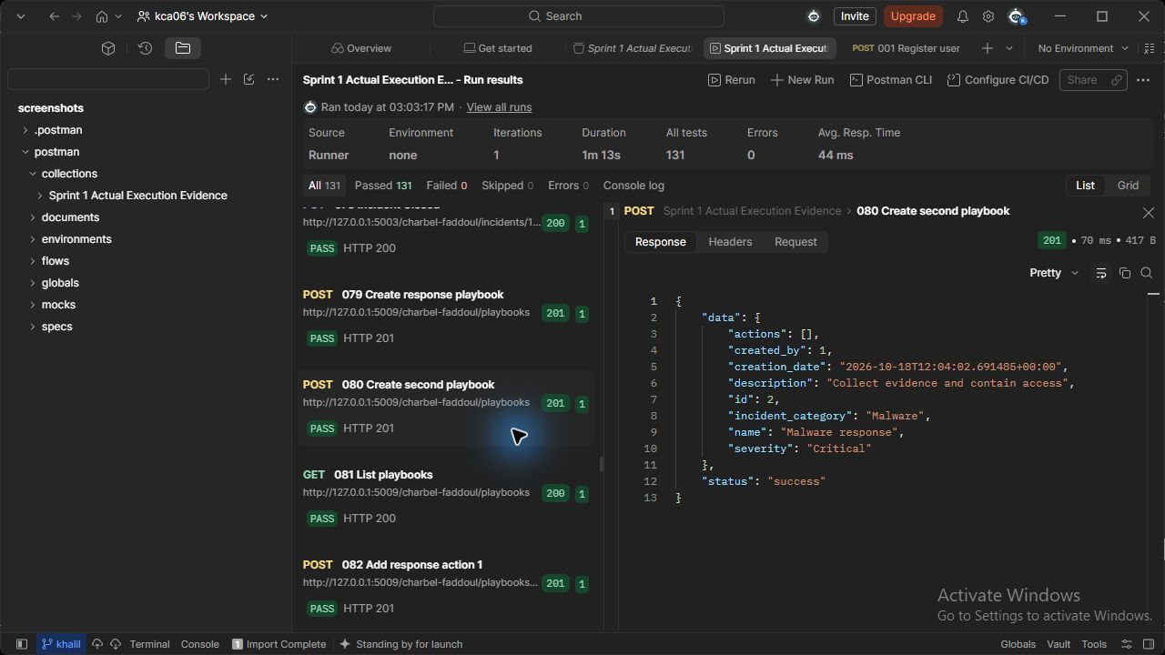
Figure 80 (Charbel Faddoul). playbooks API - Create second playbook. Actual HTTP 201 response; the runner assertion passed.

081 List playbooks (Charbel Faddoul)
GET http://127.0.0.1:5009/charbel-faddoul/playbooks
Request body: none
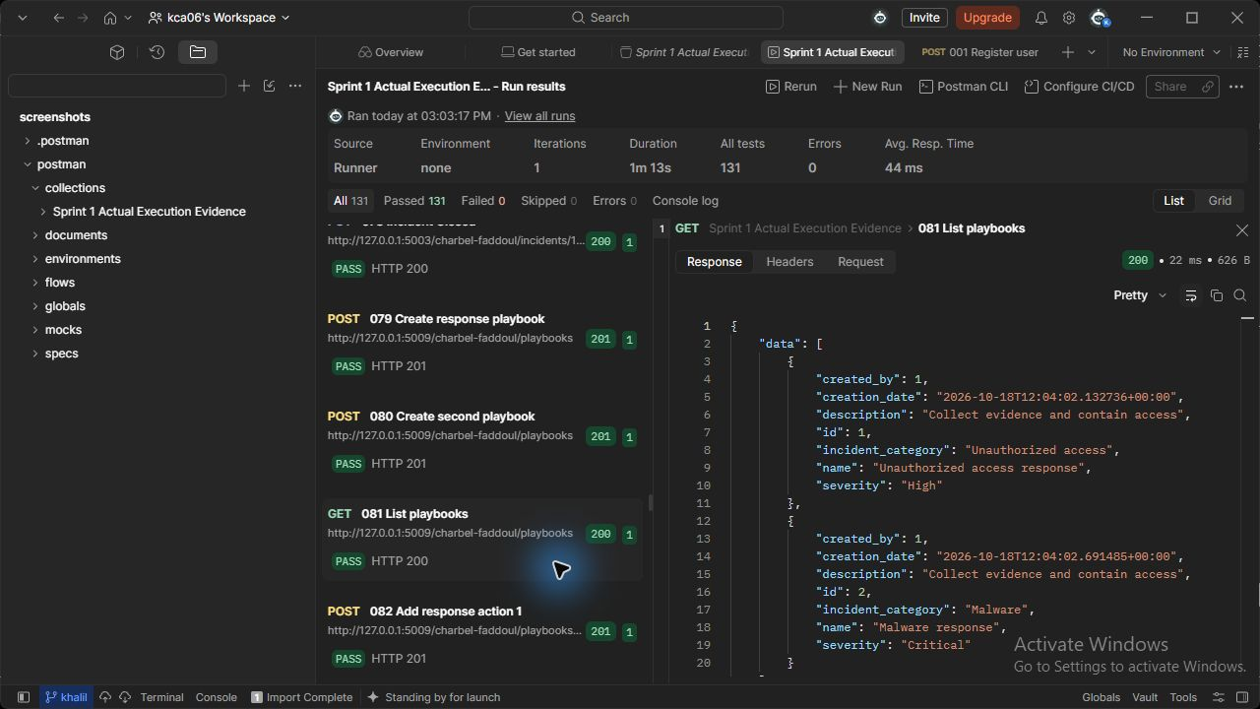
Figure 81 (Charbel Faddoul). playbooks API - List playbooks. Actual HTTP 200 response; the runner assertion passed.

082 Add response action 1 (Charbel Faddoul)
POST http://127.0.0.1:5009/charbel-faddoul/playbooks/{{playbook_id}}/actions
JSON body: { "description": "Collect evidence", "step_number": 1, "assigned_user_id": {{analyst_id}} }
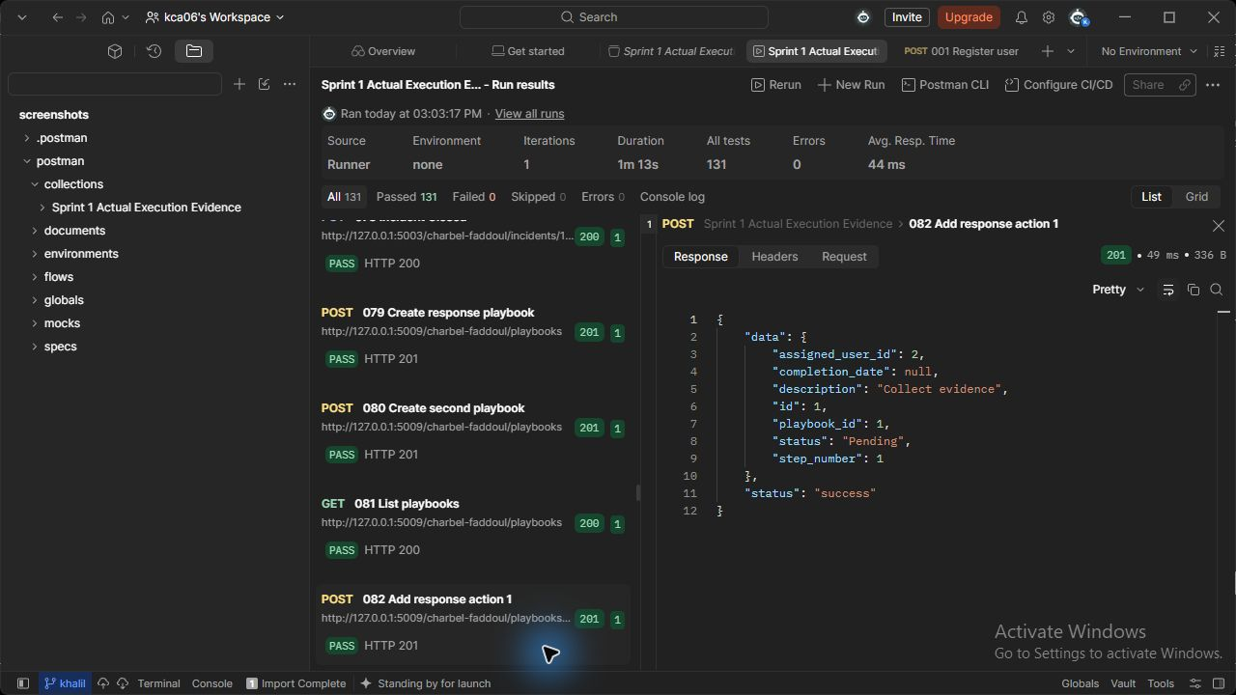
Figure 82 (Charbel Faddoul). playbooks API - Add response action 1. Actual HTTP 201 response; the runner assertion passed.

083 Add response action 2 (Charbel Faddoul)
POST http://127.0.0.1:5009/charbel-faddoul/playbooks/{{playbook_id}}/actions
JSON body: { "description": "Contain affected service", "step_number": 2, "assigned_user_id": {{analyst_id}} }
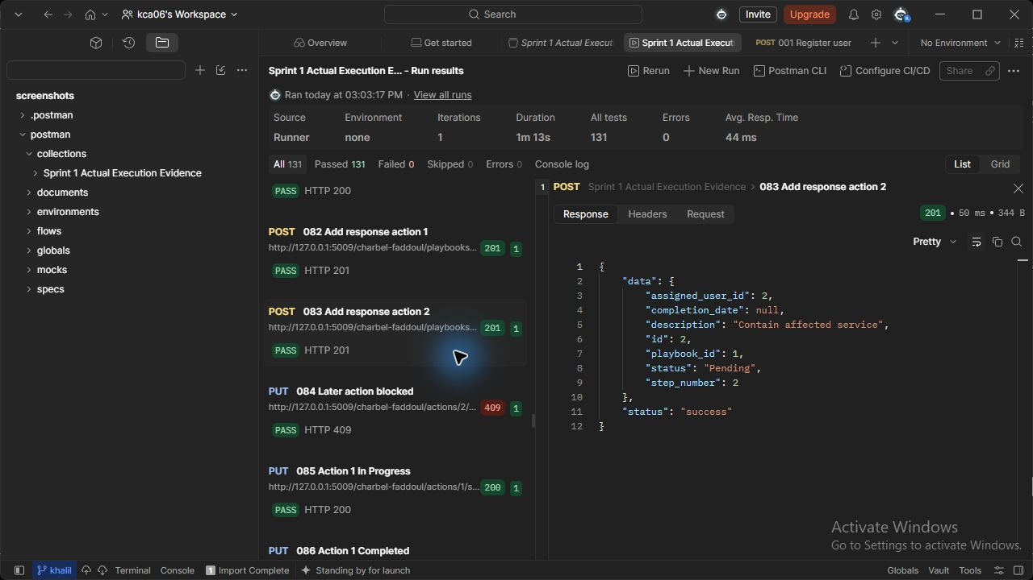
Figure 83 (Charbel Faddoul). playbooks API - Add response action 2. Actual HTTP 201 response; the runner assertion passed.

085 Action 1 In Progress (Charbel Faddoul)
PUT http://127.0.0.1:5009/charbel-faddoul/actions/{{action1_id}}/status
JSON body: {"status": "In Progress"}
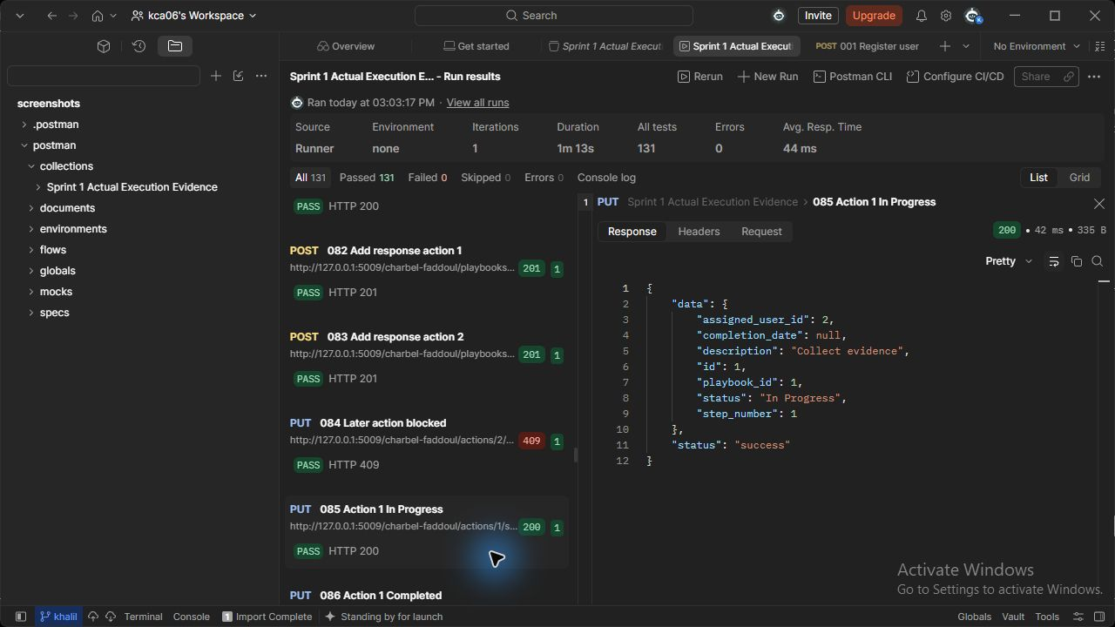
Figure 85 (Charbel Faddoul). playbooks API - Action 1 In Progress. Actual HTTP 200 response; the runner assertion passed.

086 Action 1 Completed (Charbel Faddoul)
PUT http://127.0.0.1:5009/charbel-faddoul/actions/{{action1_id}}/status
JSON body: {"status": "Completed"}
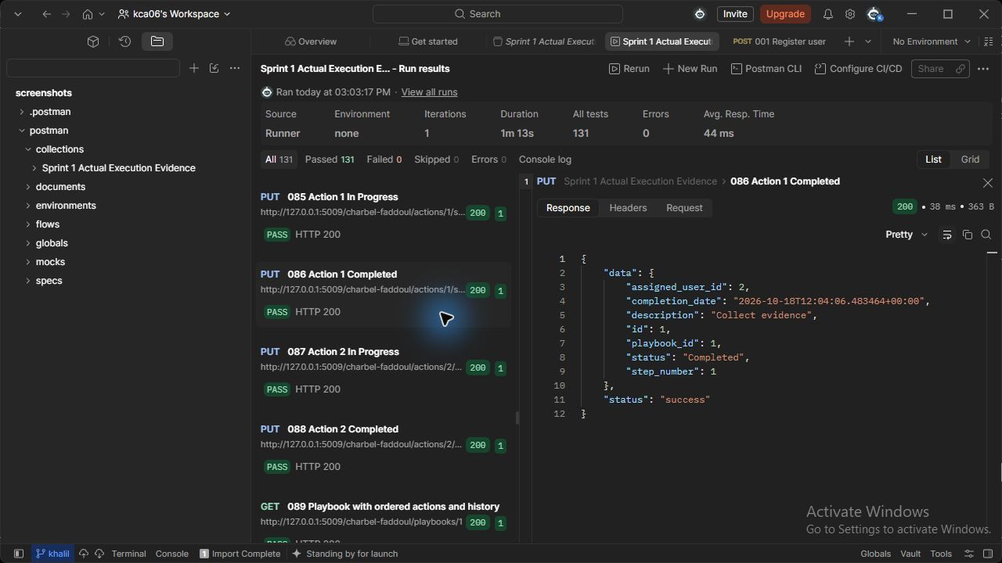
Figure 86 (Charbel Faddoul). playbooks API - Action 1 Completed. Actual HTTP 200 response; the runner assertion passed.

087 Action 2 In Progress (Charbel Faddoul)
PUT http://127.0.0.1:5009/charbel-faddoul/actions/{{action2_id}}/status
JSON body: {"status": "In Progress"}
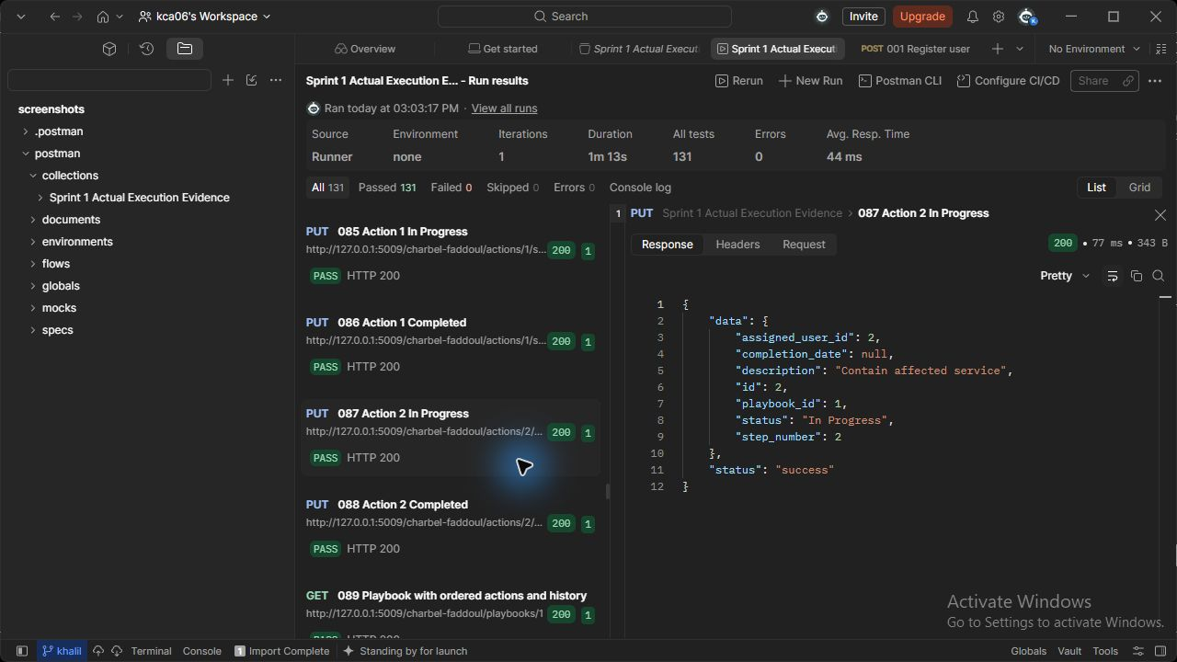
Figure 87 (Charbel Faddoul). playbooks API - Action 2 In Progress. Actual HTTP 200 response; the runner assertion passed.

088 Action 2 Completed (Charbel Faddoul)
PUT http://127.0.0.1:5009/charbel-faddoul/actions/{{action2_id}}/status
JSON body: {"status": "Completed"}
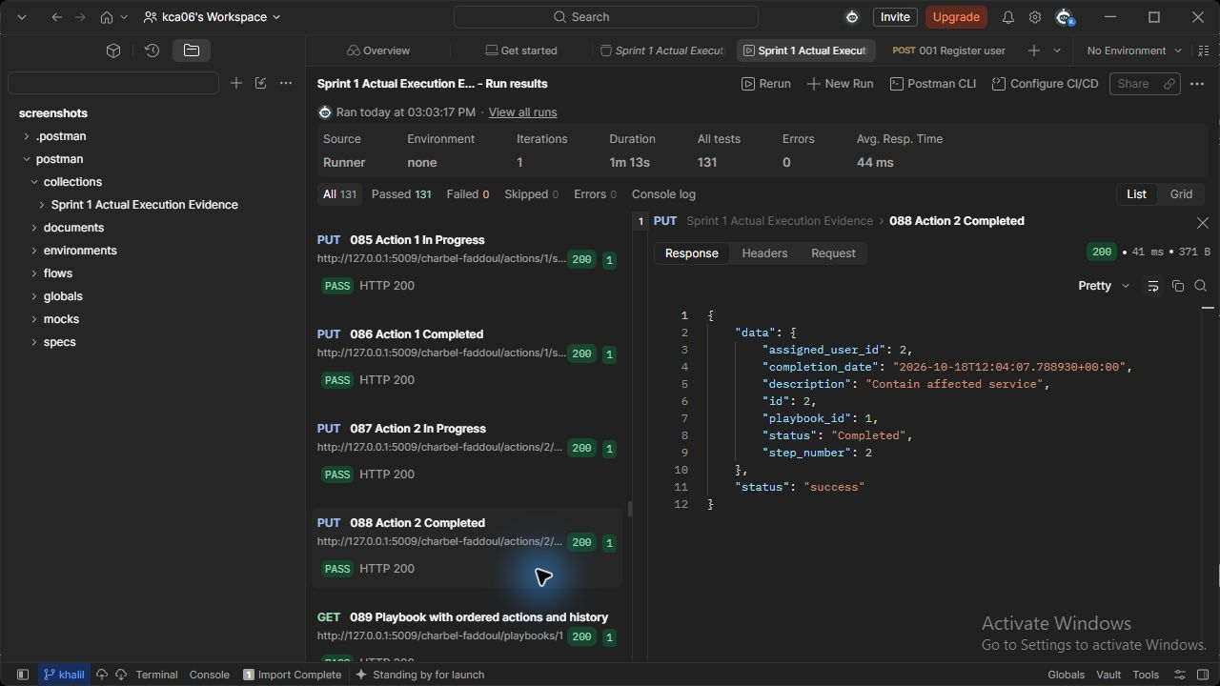
Figure 88 (Charbel Faddoul). playbooks API - Action 2 Completed. Actual HTTP 200 response; the runner assertion passed.

089 Playbook with ordered actions and history (Charbel Faddoul)
GET http://127.0.0.1:5009/charbel-faddoul/playbooks/{{playbook_id}}
Request body: none
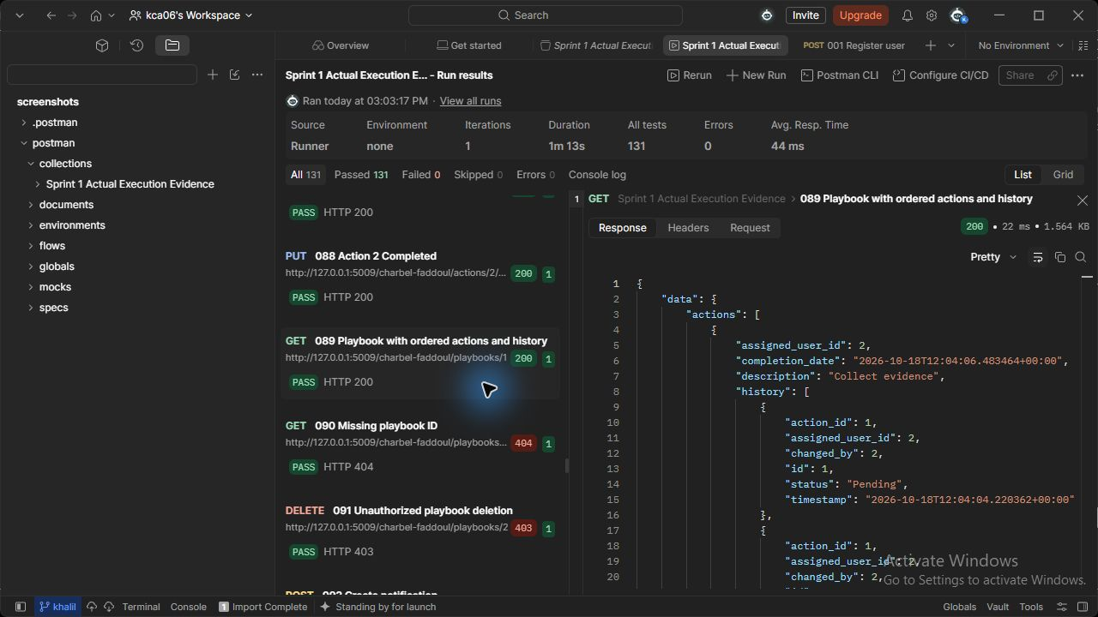
Figure 89 (Charbel Faddoul). playbooks API - Playbook with ordered actions and history. Actual HTTP 200 response; the runner assertion passed.

127 Delete playbook (Charbel Faddoul)
DELETE http://127.0.0.1:5009/charbel-faddoul/playbooks/{{playbook2_id}}
Request body: none
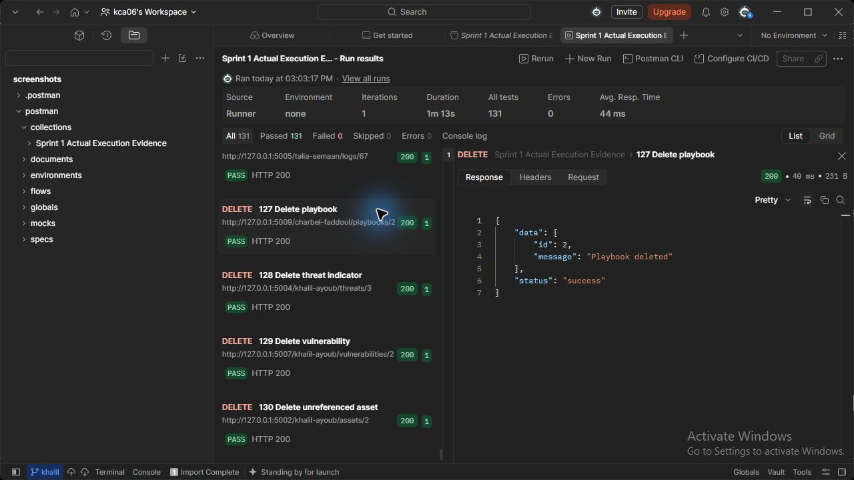
Figure 127 (Charbel Faddoul). playbooks API - Delete playbook. Actual HTTP 200 response; the runner assertion passed.

6 Database Design (Khalil Ayoub, Talia Semaan and Charbel Faddoul)
The database uses integer primary keys, explicit foreign keys and a single canonical schema. Users own assets, report incidents, receive notifications and may be assigned incidents or response actions. Assets relate to incidents and vulnerabilities. Incidents own notes. Playbooks own ordered actions, which preserve execution history.
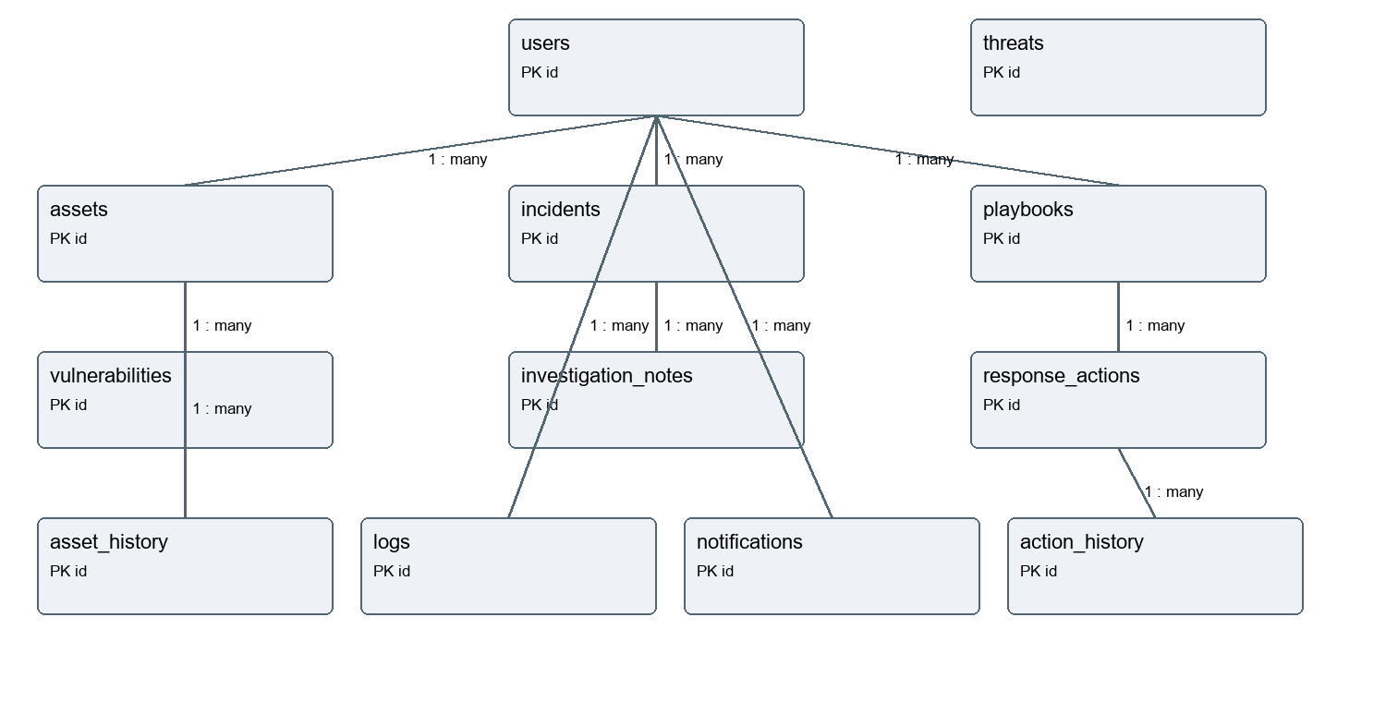
Database relationship overview (Khalil Ayoub, Talia Semaan and Charbel Faddoul). Full foreign keys and fields are listed on the following pages.

Users (Talia Semaan)
Field | SQLite type | Constraint | References
id | INTEGER | Primary key
full_name | TEXT | Required
username | TEXT | Required
email | TEXT | Required
password_hash | TEXT | Required
department | TEXT | Required
role | TEXT | Required
account_status | TEXT | Required
created_date | TEXT | Required
last_login_date | TEXT | Optional
deleted_at | TEXT | Optional
Final stored rows: 6.

Users stored records (Talia Semaan)
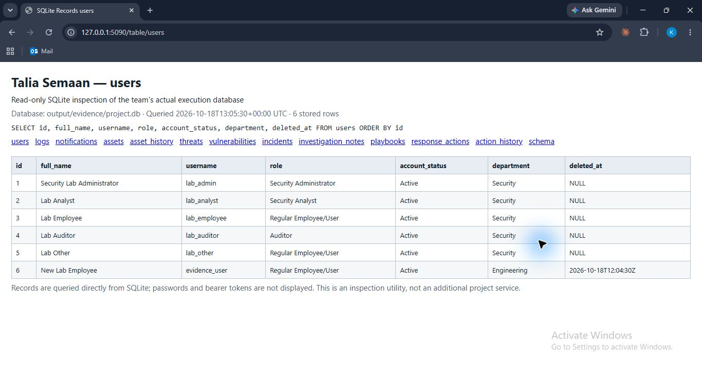
Database figure (Talia Semaan). Actual stored users rows after the Postman run and cleanup, queried read-only from output/evidence/project.db.

Logs (Talia Semaan)
Field | SQLite type | Constraint | References
id | INTEGER | Primary key
user_id | INTEGER | Optional | users.id
action | TEXT | Required
description | TEXT | Required
timestamp | TEXT | Required
severity | TEXT | Required
related_service | TEXT | Required
Final stored rows: 76.

Logs stored records (Talia Semaan)
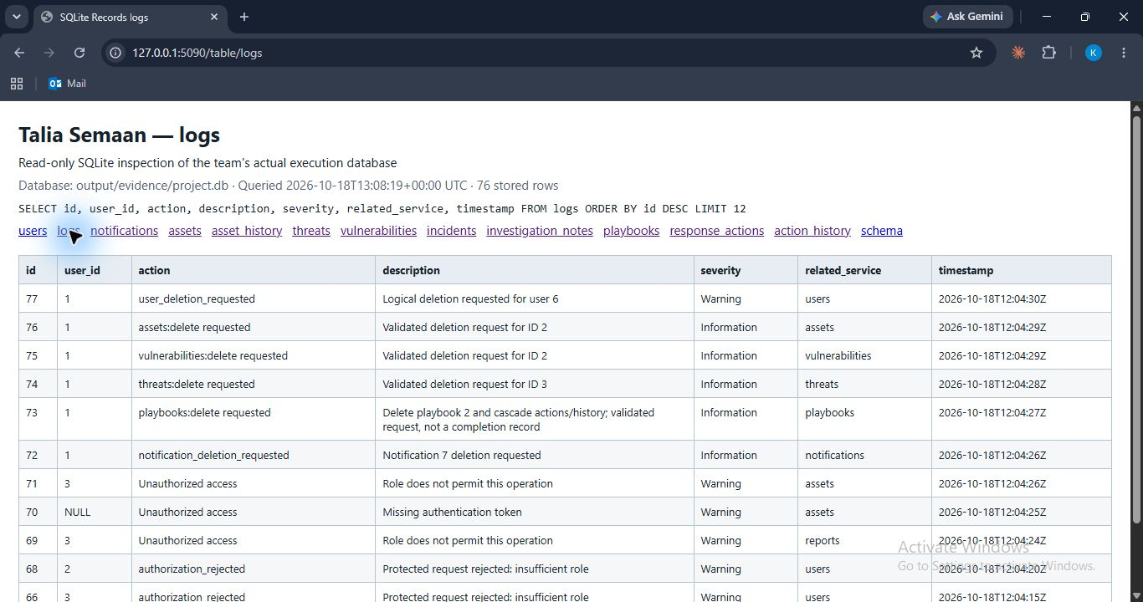
Database figure (Talia Semaan). Actual stored logs rows after the Postman run and cleanup, queried read-only from output/evidence/project.db.

Notifications (Talia Semaan)
Field | SQLite type | Constraint | References
id | INTEGER | Primary key
user_id | INTEGER | Required | users.id
title | TEXT | Required
message | TEXT | Required
notification_type | TEXT | Required
severity | TEXT | Required
status | TEXT | Required
creation_date | TEXT | Required
read_date | TEXT | Optional
Final stored rows: 6.

Notifications stored records (Talia Semaan)
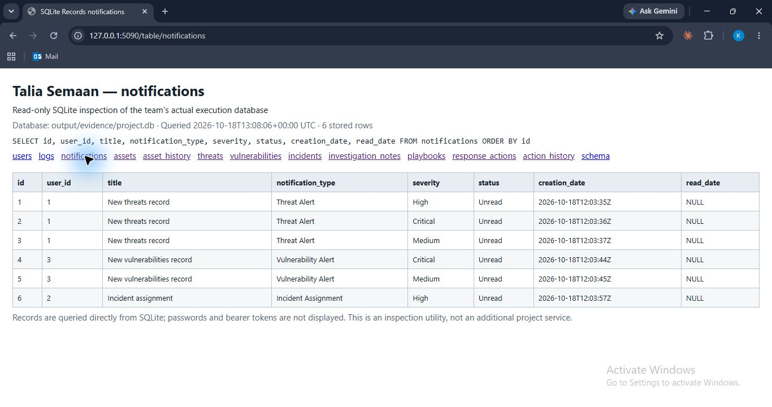
Database figure (Talia Semaan). Actual stored notifications rows after the Postman run and cleanup, queried read-only from output/evidence/project.db.

Assets (Khalil Ayoub)
Field | SQLite type | Constraint | References
id | INTEGER | Primary key
asset_name | TEXT | Required
asset_type | TEXT | Required
ip_address | TEXT | Required
operating_system | TEXT | Optional
owner_id | INTEGER | Required | users.id
department | TEXT | Required
location | TEXT | Optional
criticality_level | TEXT | Required
status | TEXT | Required
Final stored rows: 1.

Assets stored records (Khalil Ayoub)
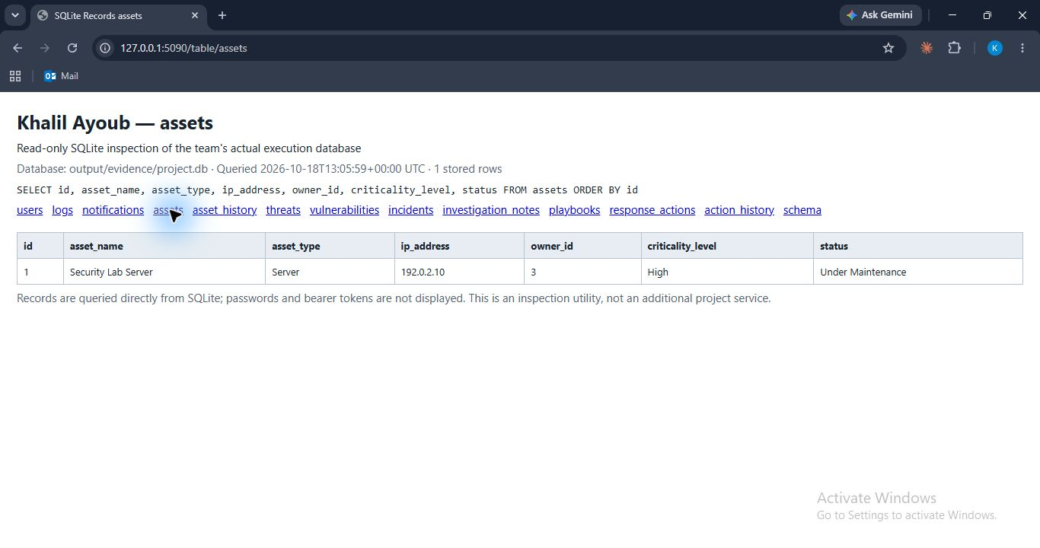
Database figure (Khalil Ayoub). Actual stored assets rows after the Postman run and cleanup, queried read-only from output/evidence/project.db.

Asset History (Khalil Ayoub)
Field | SQLite type | Constraint | References
id | INTEGER | Primary key
asset_id | INTEGER | Required | assets.id
user_id | INTEGER | Required | users.id
action | TEXT | Required
snapshot | TEXT | Required
timestamp | TEXT | Required
Final stored rows: 2.

Asset History stored records (Khalil Ayoub)
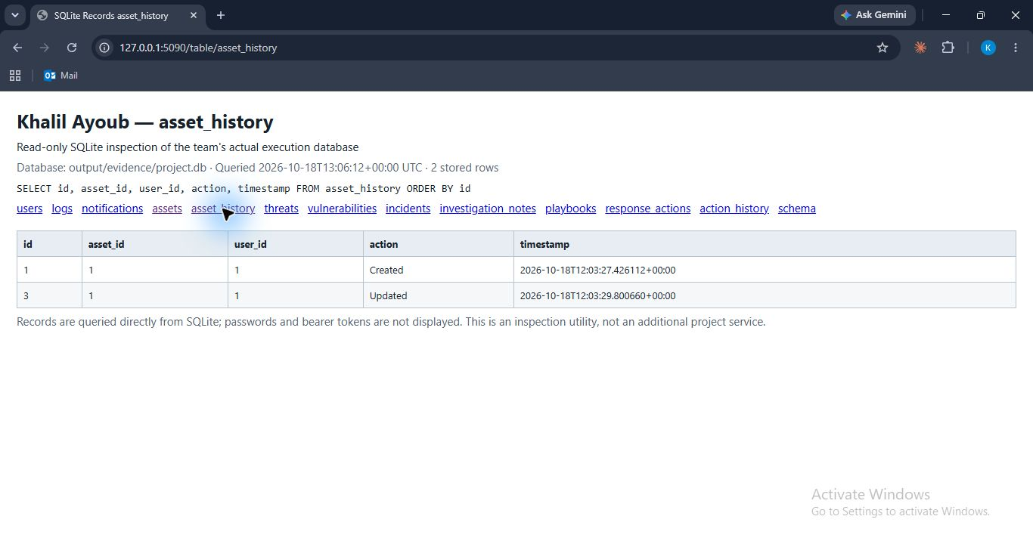
Database figure (Khalil Ayoub). Actual stored asset_history rows after the Postman run and cleanup, queried read-only from output/evidence/project.db.

Threats (Khalil Ayoub)
Field | SQLite type | Constraint | References
id | INTEGER | Primary key
threat_type | TEXT | Required
threat_value | TEXT | Required
description | TEXT | Required
severity | TEXT | Required
source | TEXT | Required
date_added | TEXT | Required
Final stored rows: 2.

Threats stored records (Khalil Ayoub)
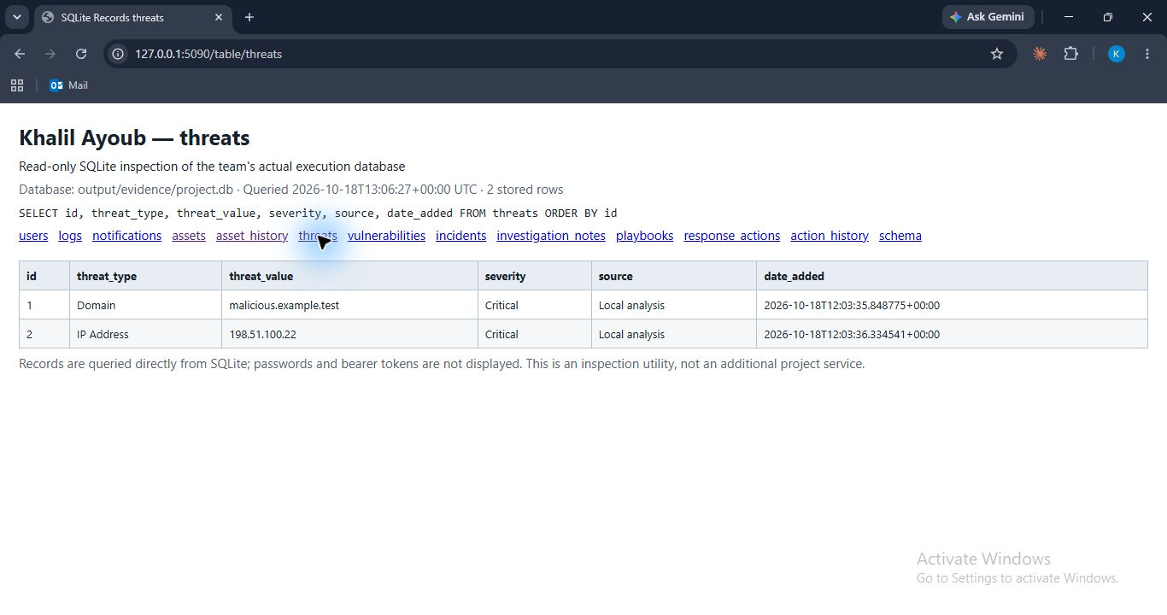
Database figure (Khalil Ayoub). Actual stored threats rows after the Postman run and cleanup, queried read-only from output/evidence/project.db.

Vulnerabilities (Khalil Ayoub)
Field | SQLite type | Constraint | References
id | INTEGER | Primary key
title | TEXT | Required
description | TEXT | Required
cve_identifier | TEXT | Required
cvss_score | REAL | Required
severity | TEXT | Required
asset_id | INTEGER | Required | assets.id
discovery_source | TEXT | Required
status | TEXT | Required
creation_date | TEXT | Required
resolution_date | TEXT | Optional
Final stored rows: 1.

Vulnerabilities stored records (Khalil Ayoub)
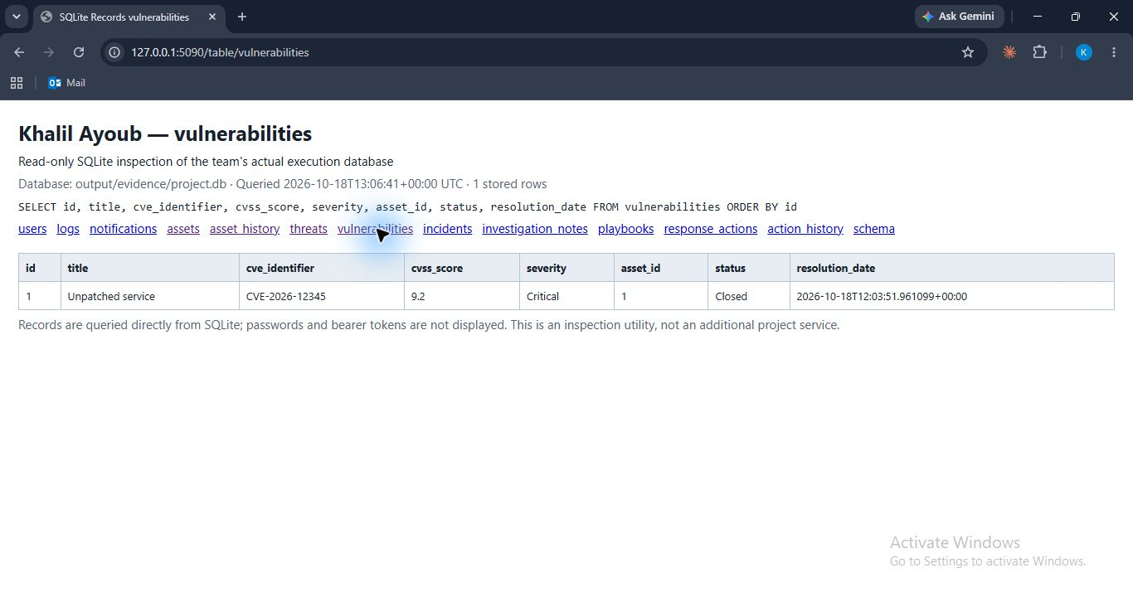
Database figure (Khalil Ayoub). Actual stored vulnerabilities rows after the Postman run and cleanup, queried read-only from output/evidence/project.db.

Incidents (Charbel Faddoul)
Field | SQLite type | Constraint | References
id | INTEGER | Primary key
title | TEXT | Required
description | TEXT | Required
category | TEXT | Required
severity | TEXT | Required
reporter_id | INTEGER | Required | users.id
asset_id | INTEGER | Optional | assets.id
assigned_analyst_id | INTEGER | Optional | users.id
status | TEXT | Required
creation_date | TEXT | Required
resolution_date | TEXT | Optional
Final stored rows: 2.

Incidents stored records (Charbel Faddoul)
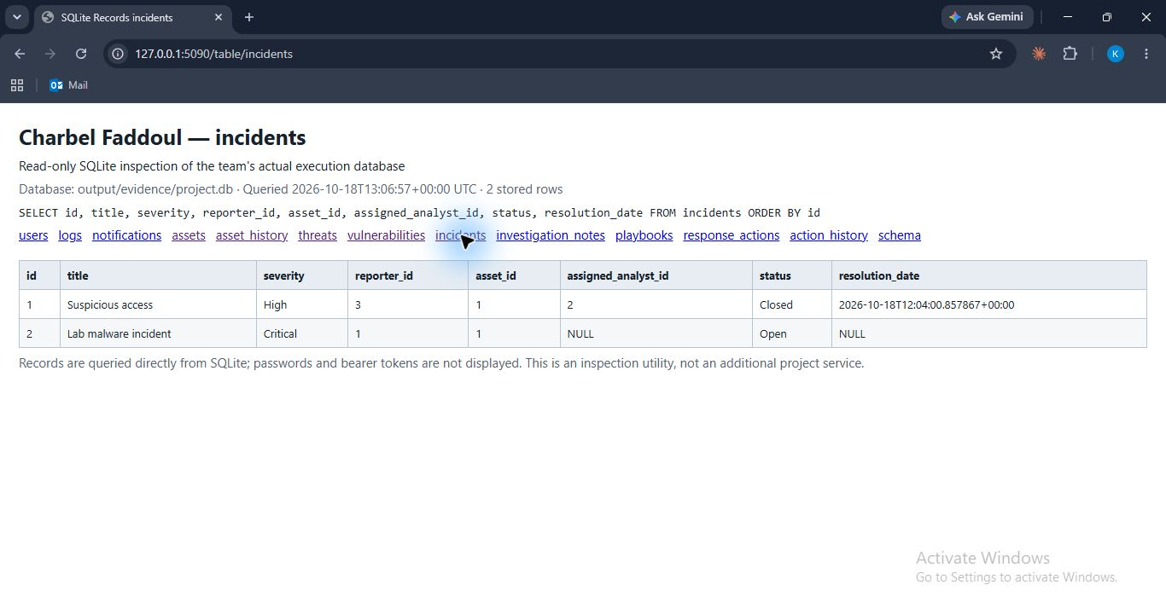
Database figure (Charbel Faddoul). Actual stored incidents rows after the Postman run and cleanup, queried read-only from output/evidence/project.db.

Investigation Notes (Charbel Faddoul)
Field | SQLite type | Constraint | References
id | INTEGER | Primary key
incident_id | INTEGER | Required | incidents.id
analyst_id | INTEGER | Required | users.id
note_content | TEXT | Required
creation_timestamp | TEXT | Required
Final stored rows: 1.

Investigation Notes stored records (Charbel Faddoul)
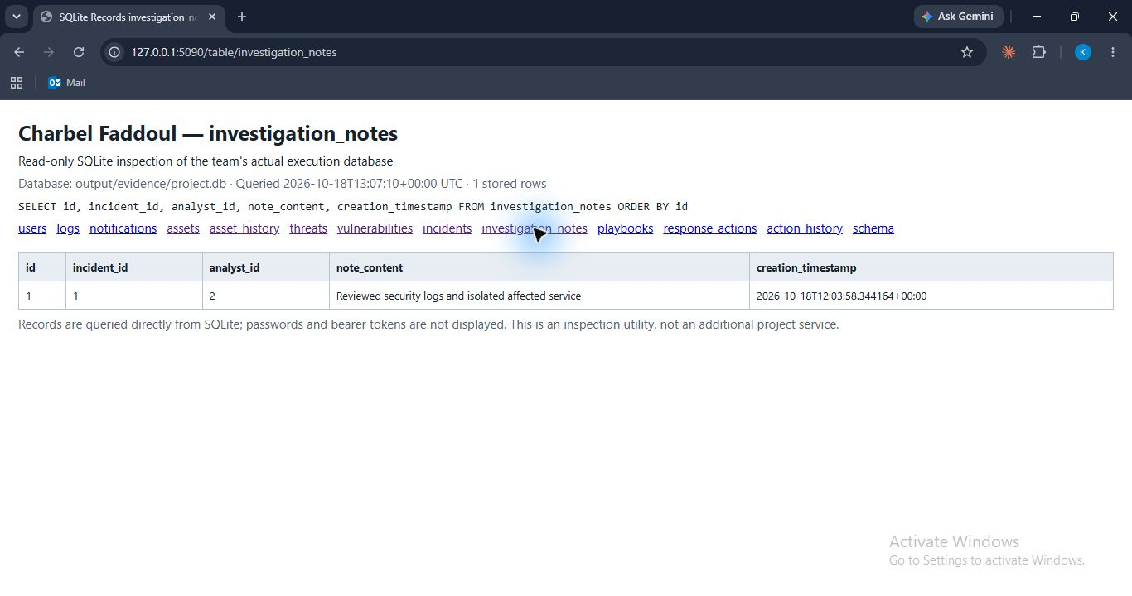
Database figure (Charbel Faddoul). Actual stored investigation_notes rows after the Postman run and cleanup, queried read-only from output/evidence/project.db.

Playbooks (Charbel Faddoul)
Field | SQLite type | Constraint | References
id | INTEGER | Primary key
name | TEXT | Required
description | TEXT | Required
incident_category | TEXT | Required
severity | TEXT | Required
created_by | INTEGER | Required | users.id
creation_date | TEXT | Required
Final stored rows: 1.

Playbooks stored records (Charbel Faddoul)
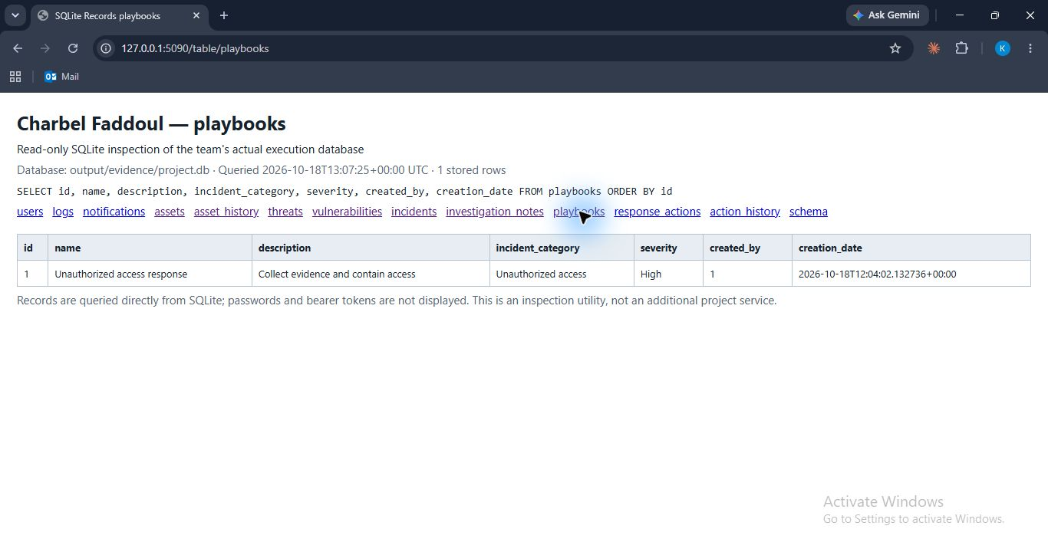
Database figure (Charbel Faddoul). Actual stored playbooks rows after the Postman run and cleanup, queried read-only from output/evidence/project.db.

Response Actions (Charbel Faddoul)
Field | SQLite type | Constraint | References
id | INTEGER | Primary key
playbook_id | INTEGER | Required | playbooks.id
description | TEXT | Required
step_number | INTEGER | Required
status | TEXT | Required
assigned_user_id | INTEGER | Optional | users.id
completion_date | TEXT | Optional
Final stored rows: 2.

Response Actions stored records (Charbel Faddoul)
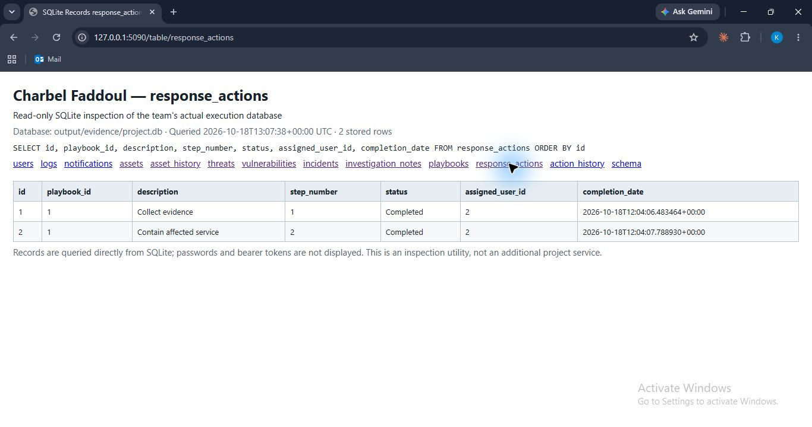
Database figure (Charbel Faddoul). Actual stored response_actions rows after the Postman run and cleanup, queried read-only from output/evidence/project.db.

Action History (Charbel Faddoul)
Field | SQLite type | Constraint | References
id | INTEGER | Primary key
action_id | INTEGER | Required | response_actions.id
status | TEXT | Required
assigned_user_id | INTEGER | Optional | users.id
changed_by | INTEGER | Required | users.id
timestamp | TEXT | Required
Final stored rows: 6.

Action History stored records (Charbel Faddoul)
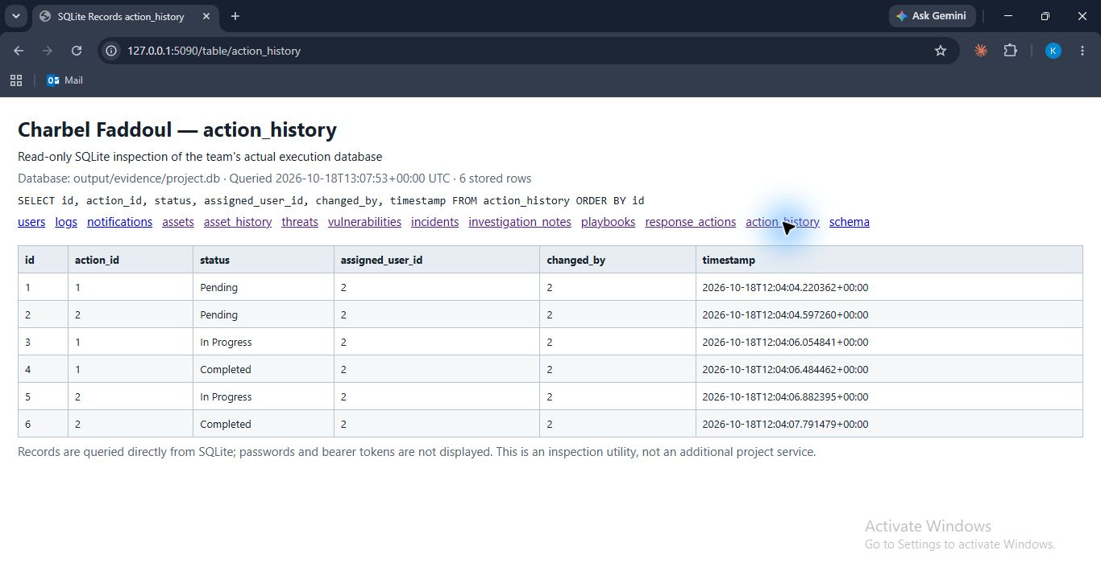
Database figure (Charbel Faddoul). Actual stored action_history rows after the Postman run and cleanup, queried read-only from output/evidence/project.db.

Database integrity and retention (Khalil Ayoub, Talia Semaan and Charbel Faddoul)
User deletion sets deleted_at and preserves historical foreign keys; deleted accounts cannot log in or verify tokens. Threat uniqueness is enforced on threat_type and threat_value. Response step numbers are unique within a playbook. Logs have no update API and a database trigger rejects UPDATE. Playbook deletion cascades to its actions and history; referenced assets are protected from deletion. Asset history records create and update snapshots.
SQLite integrity_check returned ok. foreign_key_check returned no violations. Timestamps are generated by the server in UTC. CVSS is constrained to the range zero through ten. The complete schema and populated evidence database are included with the submission files.
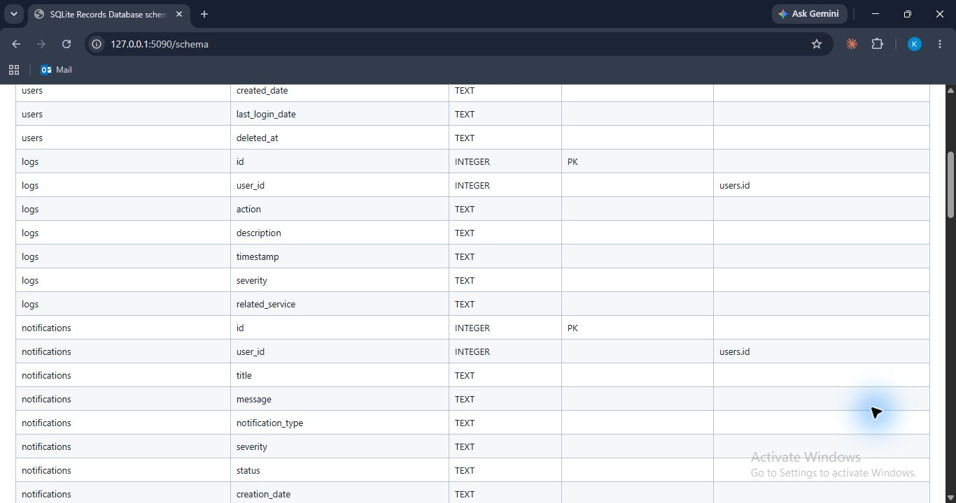
Schema figure (Khalil Ayoub, Talia Semaan and Charbel Faddoul). Actual SQLite structure shows primary keys and foreign keys for logs and notifications.

7 Error Handling and Validation (Khalil Ayoub, Talia Semaan and Charbel Faddoul)
All services return JSON errors with status error and a meaningful message. Invalid fields and values return 400, authentication errors 401, permission failures 403, missing resources 404 and duplicate or relationship conflicts 409. Dependency failures return 503. Unexpected server faults return 500 without exposing a traceback to API clients.
JSON objects are checked for required and unknown keys. Text is trimmed; enumerations, positive database ID ranges, IP addresses, email, threat formats, CVE identifiers and CVSS values are validated. SQL values are passed as bound parameters. Incident and vulnerability status changes must follow their defined sequence. Playbook actions require earlier steps to be complete. Authorization violations are recorded by the audit service.

002 Duplicate username rejected (Talia Semaan)
POST http://127.0.0.1:5001/talia-semaan/users/register
JSON body: {"full_name": "New Lab Employee", "username": "evidence_user", "email": "newuser@example.test", "password": "<local test password>", "department": "IT", "role": "Regular Employee/User"}
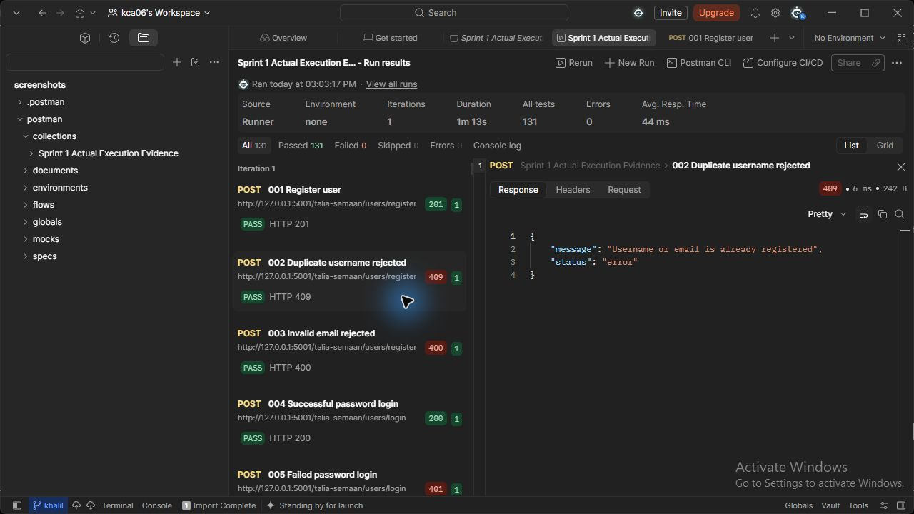
Figure 2 (Talia Semaan). users API - Duplicate username rejected. Actual HTTP 409 response; the runner assertion passed.

003 Invalid email rejected (Talia Semaan)
POST http://127.0.0.1:5001/talia-semaan/users/register
JSON body: {"full_name": "New Lab Employee", "username": "invalid_email_user", "email": "invalid", "password": "<local test password>", "department": "IT", "role": "Regular Employee/User"}
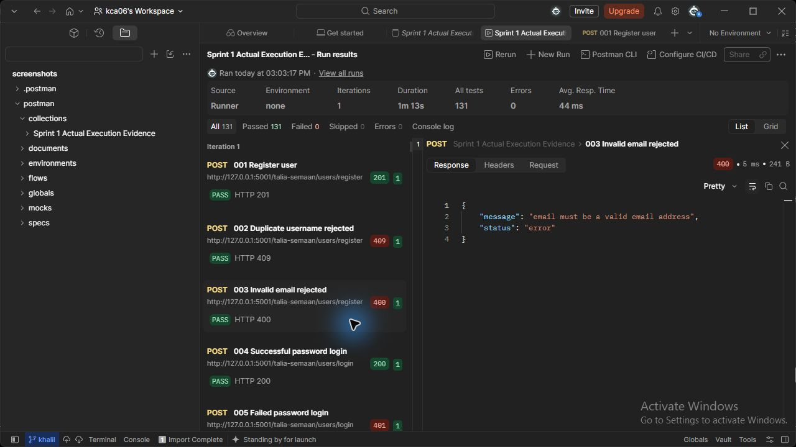
Figure 3 (Talia Semaan). users API - Invalid email rejected. Actual HTTP 400 response; the runner assertion passed.

009 Missing username (Talia Semaan)
GET http://127.0.0.1:5001/talia-semaan/users/no_such_user
Request body: none
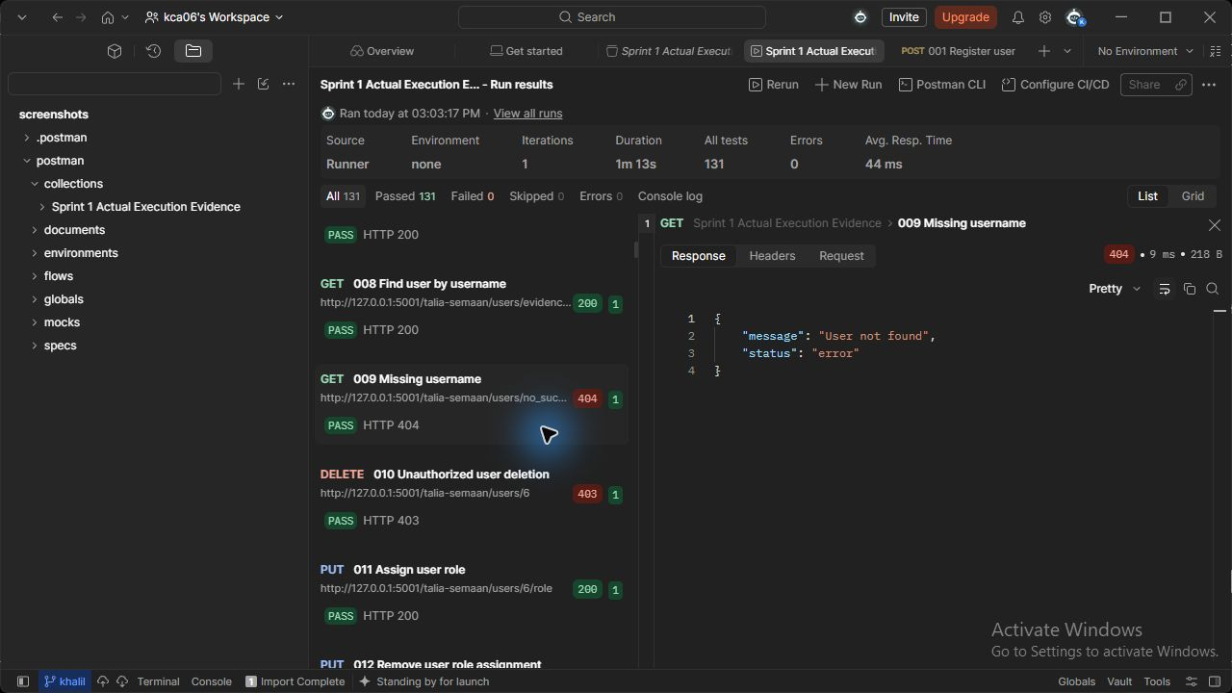
Figure 9 (Talia Semaan). users API - Missing username. Actual HTTP 404 response; the runner assertion passed.

018 Invalid IP address (Khalil Ayoub)
POST http://127.0.0.1:5002/khalil-ayoub/assets
JSON body: { "asset_name": "Security Lab Server", "asset_type": "Server", "ip_address": "999.1.2.3", "department": "IT", "owner_id": {{employee_id}}, "location": "AUB Lab", "criticality_level": "Critical" }
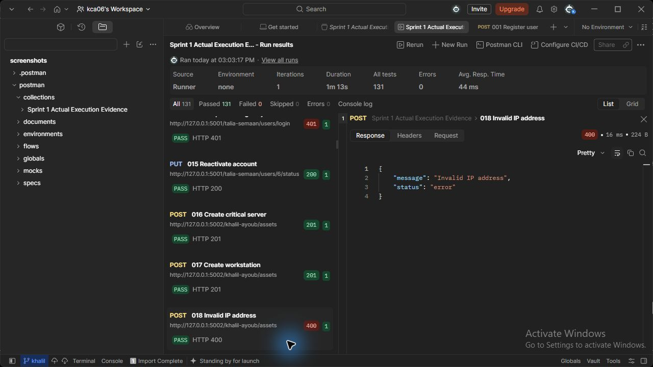
Figure 18 (Khalil Ayoub). assets API - Invalid IP address. Actual HTTP 400 response; the runner assertion passed.

019 Missing asset fields (Khalil Ayoub)
POST http://127.0.0.1:5002/khalil-ayoub/assets
JSON body: {"asset_name": "Incomplete"}
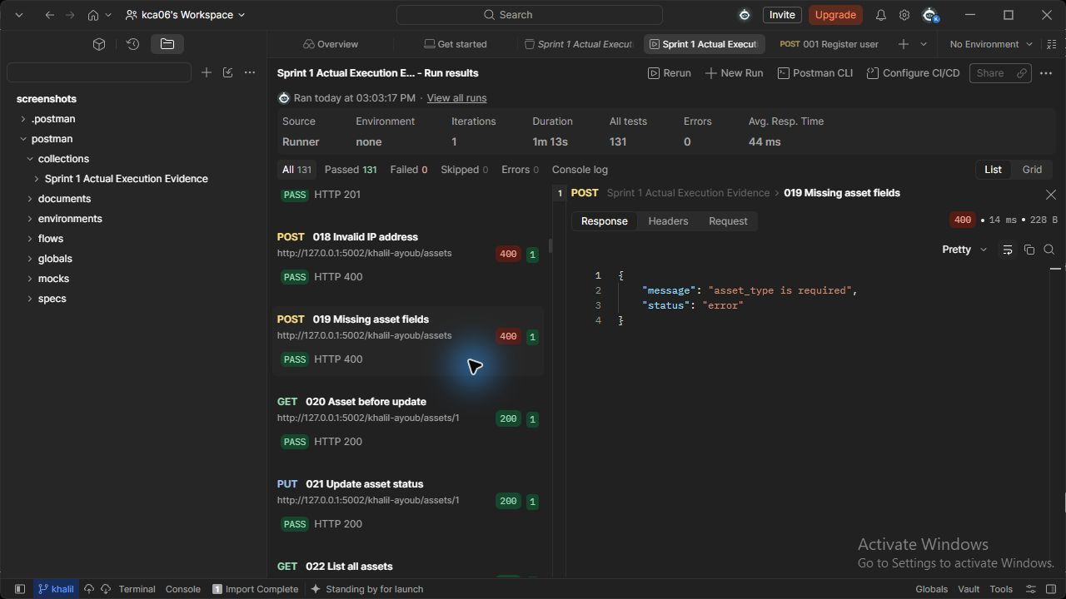
Figure 19 (Khalil Ayoub). assets API - Missing asset fields. Actual HTTP 400 response; the runner assertion passed.

024 Missing asset ID (Khalil Ayoub)
GET http://127.0.0.1:5002/khalil-ayoub/assets/999999
Request body: none
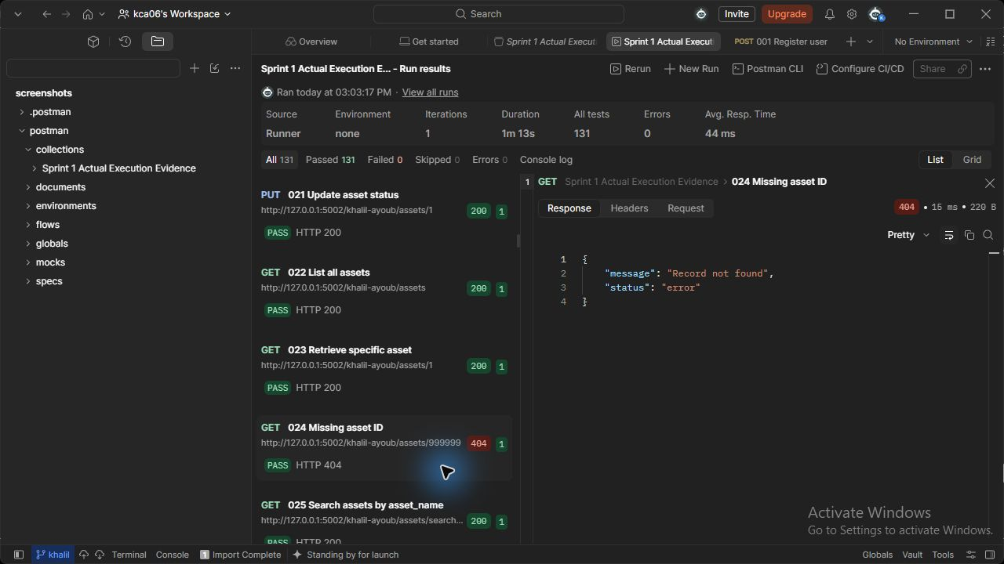
Figure 24 (Khalil Ayoub). assets API - Missing asset ID. Actual HTTP 404 response; the runner assertion passed.

035 Duplicate indicator rejected (Khalil Ayoub)
POST http://127.0.0.1:5004/khalil-ayoub/threats
JSON body: {"threat_type": "Domain", "threat_value": "malicious.example.test", "description": "Lab phishing indicator", "severity": "High", "source": "Local analysis"}
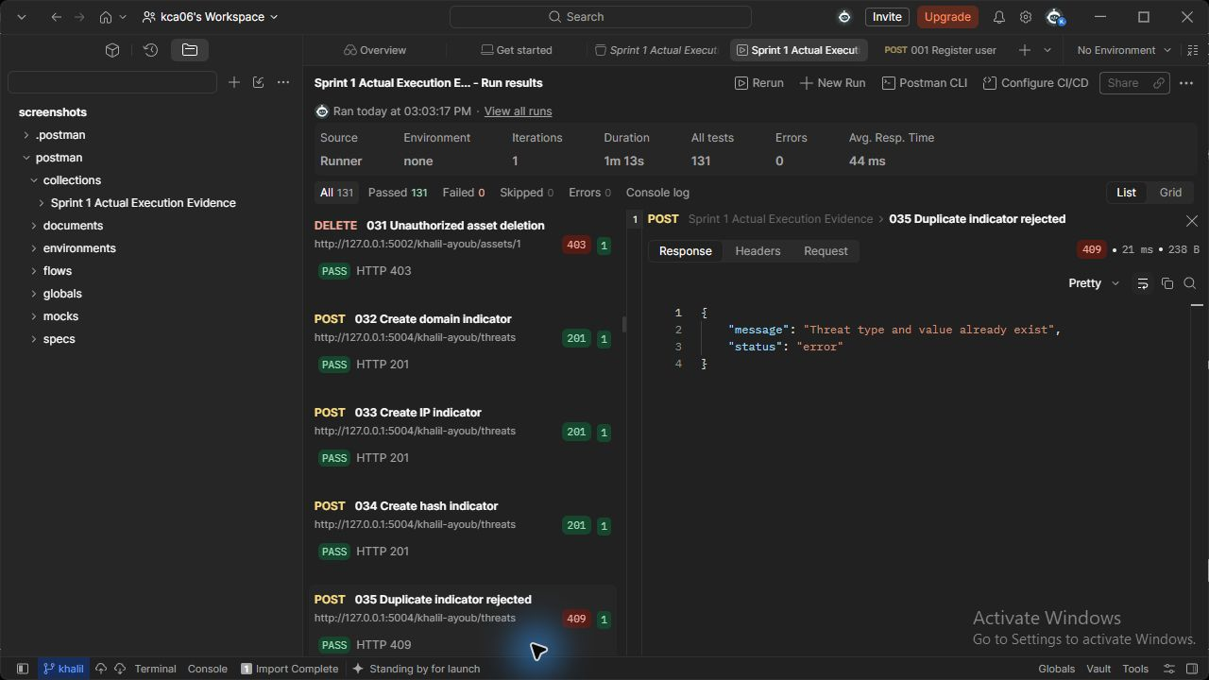
Figure 35 (Khalil Ayoub). threats API - Duplicate indicator rejected. Actual HTTP 409 response; the runner assertion passed.

036 Invalid file hash (Khalil Ayoub)
POST http://127.0.0.1:5004/khalil-ayoub/threats
JSON body: {"threat_type": "File Hash", "threat_value": "invalid-hash", "description": "Lab phishing indicator", "severity": "High", "source": "Local analysis"}
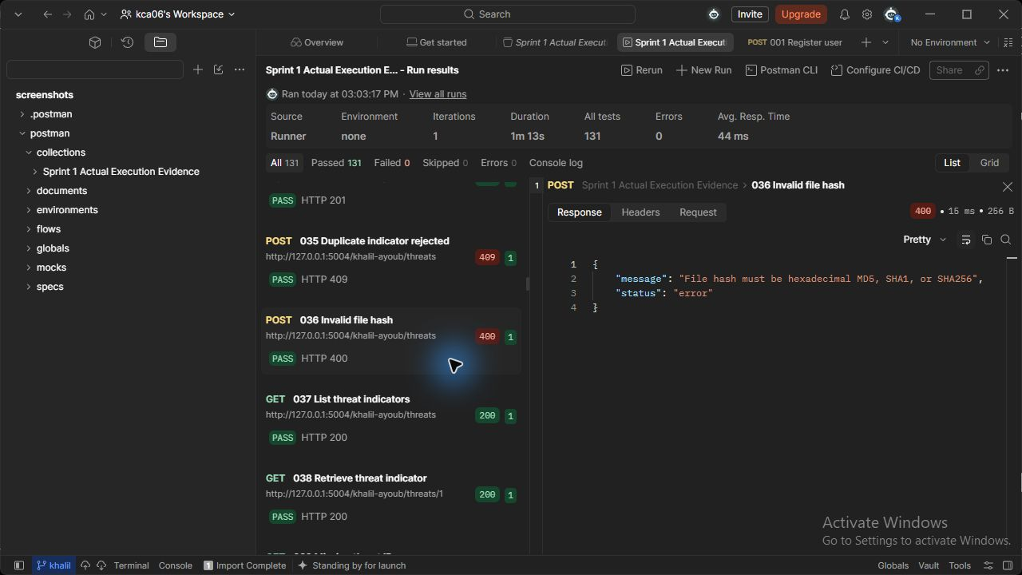
Figure 36 (Khalil Ayoub). threats API - Invalid file hash. Actual HTTP 400 response; the runner assertion passed.

039 Missing threat ID (Khalil Ayoub)
GET http://127.0.0.1:5004/khalil-ayoub/threats/999999
Request body: none
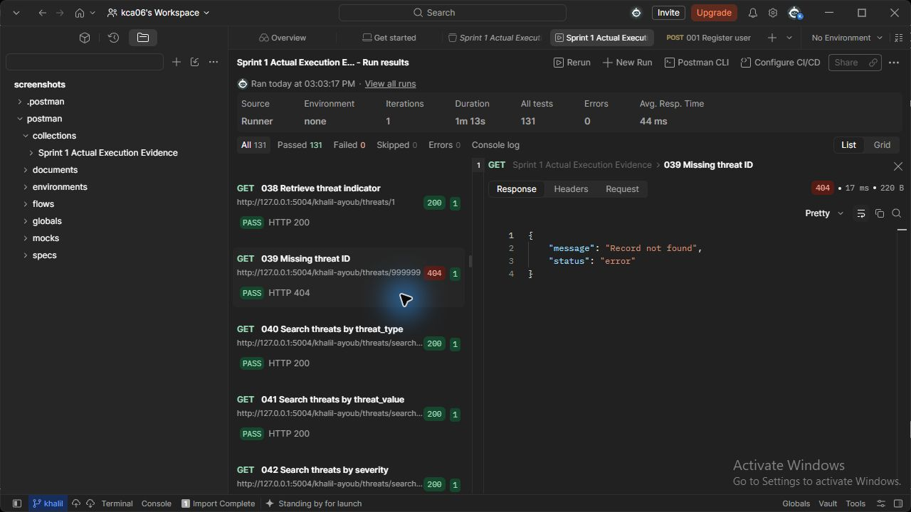
Figure 39 (Khalil Ayoub). threats API - Missing threat ID. Actual HTTP 404 response; the runner assertion passed.

048 Invalid CVSS rejected (Khalil Ayoub)
POST http://127.0.0.1:5007/khalil-ayoub/vulnerabilities
JSON body: { "title": "Unpatched service", "description": "Lab vulnerability affecting the server", "cve_identifier": "CVE-2026-12345", "cvss_score": 11, "severity": "Critical", "asset_id": {{asset_id}}, "discovery_source": "Local scan" }
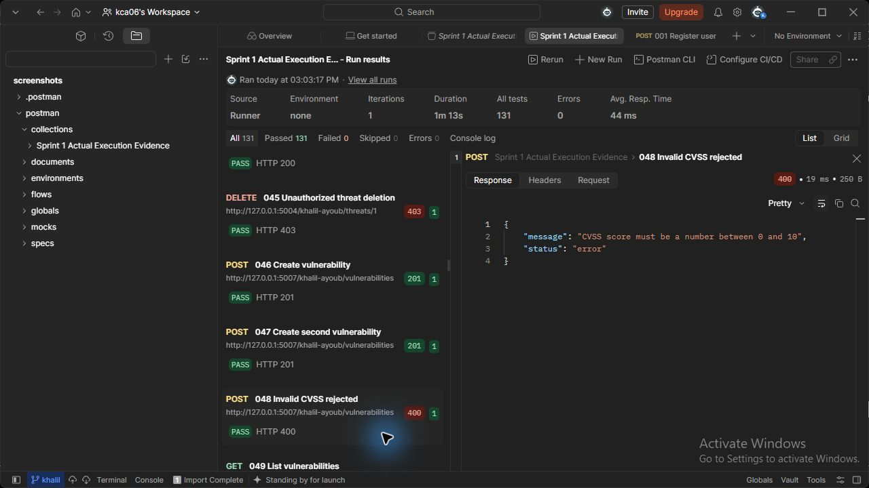
Figure 48 (Khalil Ayoub). vulnerabilities API - Invalid CVSS rejected. Actual HTTP 400 response; the runner assertion passed.

051 Missing vulnerability ID (Khalil Ayoub)
GET http://127.0.0.1:5007/khalil-ayoub/vulnerabilities/999999
Request body: none
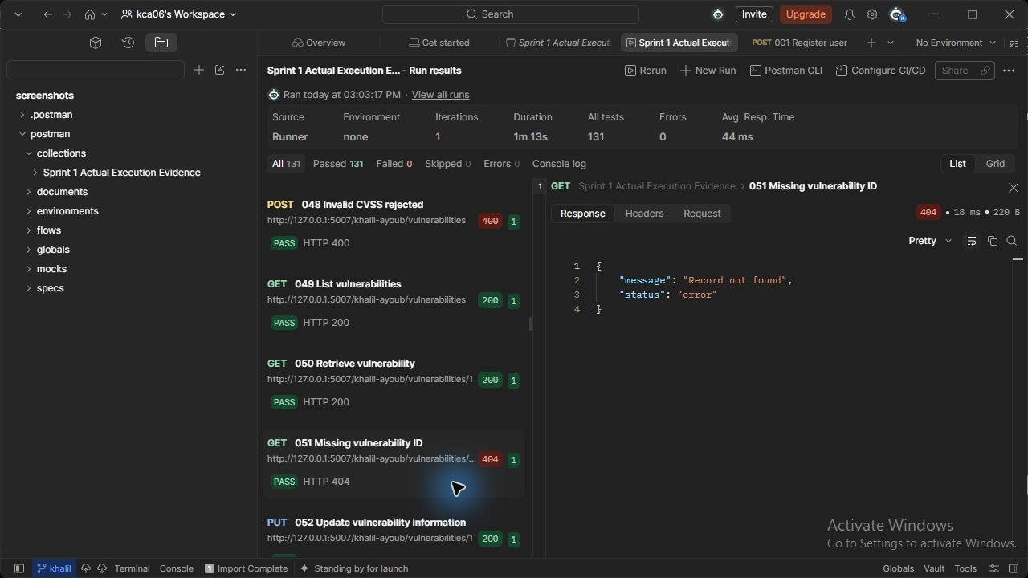
Figure 51 (Khalil Ayoub). vulnerabilities API - Missing vulnerability ID. Actual HTTP 404 response; the runner assertion passed.

057 Skipped lifecycle rejected (Khalil Ayoub)
PUT http://127.0.0.1:5007/khalil-ayoub/vulnerabilities/{{vulnerability_id}}
JSON body: {"status": "Closed"}
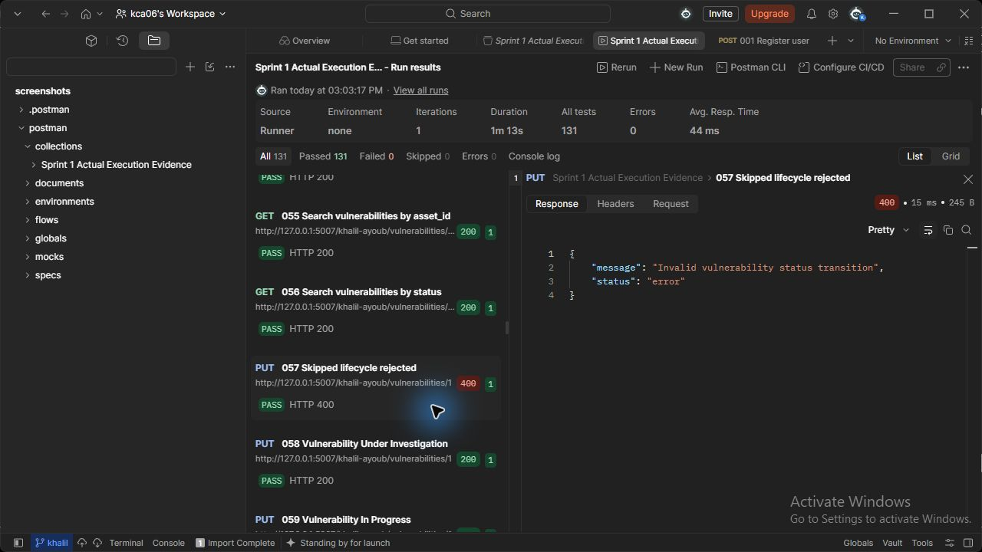
Figure 57 (Khalil Ayoub). vulnerabilities API - Skipped lifecycle rejected. Actual HTTP 400 response; the runner assertion passed.

067 Missing incident ID (Charbel Faddoul)
GET http://127.0.0.1:5003/charbel-faddoul/incidents/999999
Request body: none
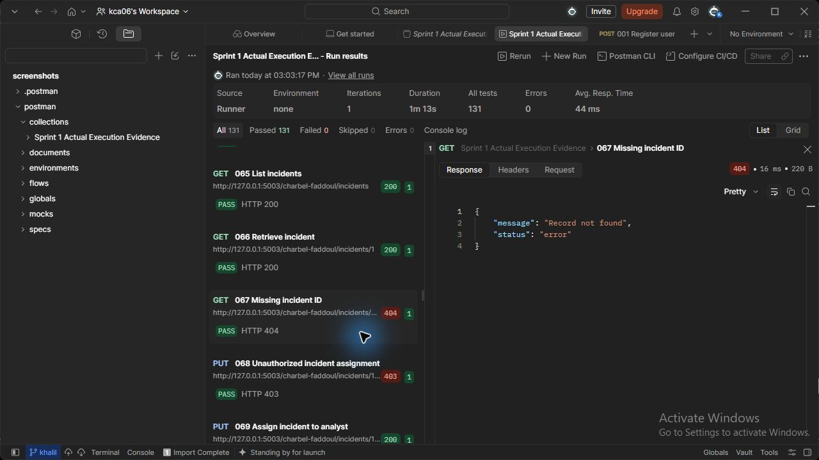
Figure 67 (Charbel Faddoul). incidents API - Missing incident ID. Actual HTTP 404 response; the runner assertion passed.

074 Skipped incident lifecycle rejected (Charbel Faddoul)
PUT http://127.0.0.1:5003/charbel-faddoul/incidents/{{incident_id}}/status
JSON body: {"status": "Closed"}
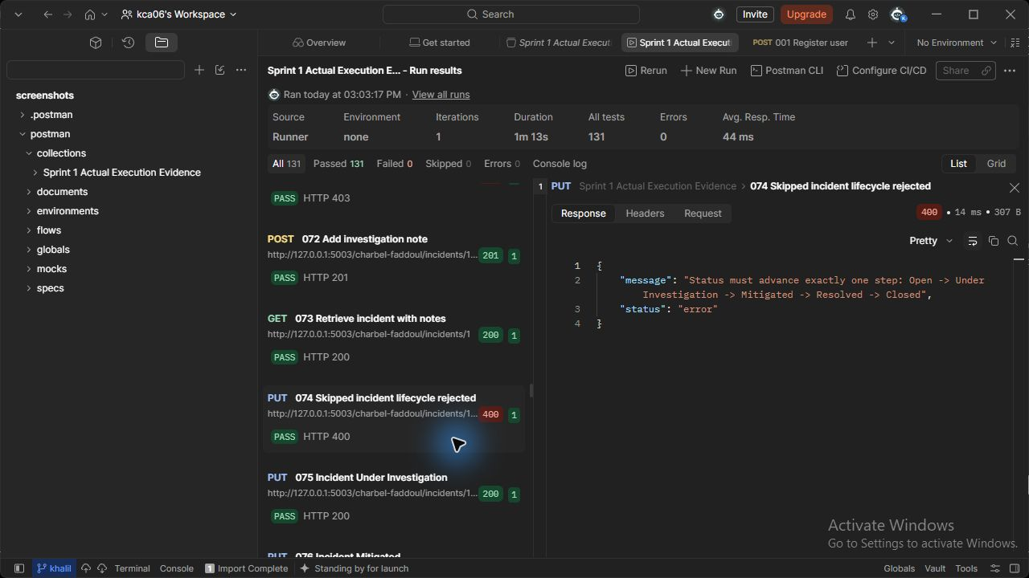
Figure 74 (Charbel Faddoul). incidents API - Skipped incident lifecycle rejected. Actual HTTP 400 response; the runner assertion passed.

084 Later action blocked (Charbel Faddoul)
PUT http://127.0.0.1:5009/charbel-faddoul/actions/{{action2_id}}/status
JSON body: {"status": "In Progress"}
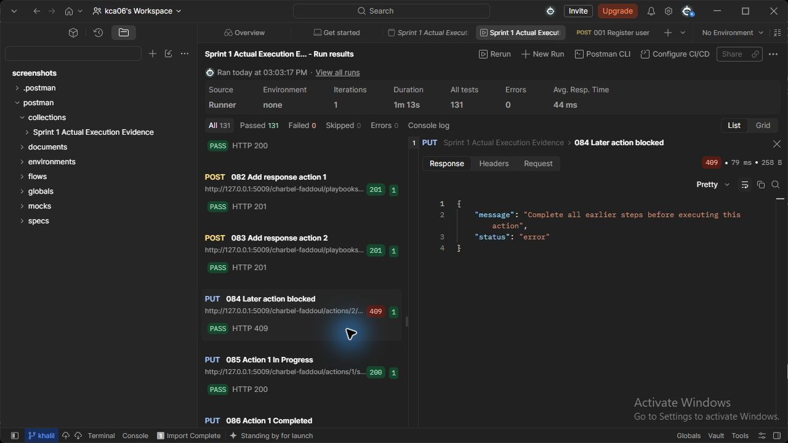
Figure 84 (Charbel Faddoul). playbooks API - Later action blocked. Actual HTTP 409 response; the runner assertion passed.

090 Missing playbook ID (Charbel Faddoul)
GET http://127.0.0.1:5009/charbel-faddoul/playbooks/999999
Request body: none
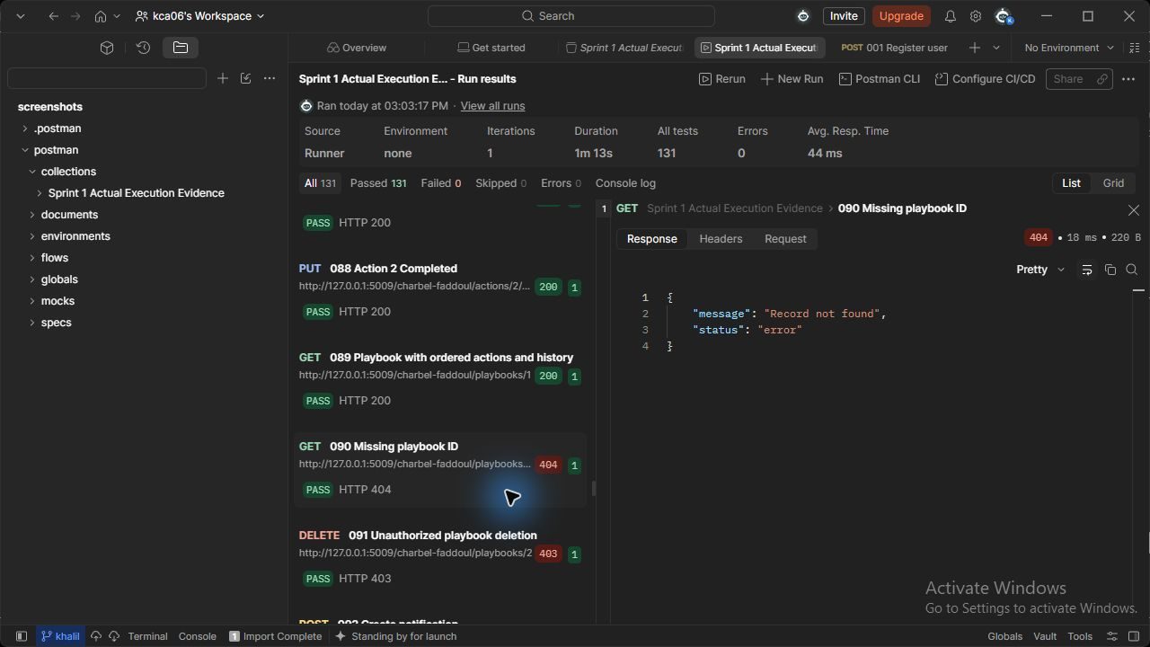
Figure 90 (Charbel Faddoul). playbooks API - Missing playbook ID. Actual HTTP 404 response; the runner assertion passed.

096 Missing notification ID (Talia Semaan)
GET http://127.0.0.1:5008/talia-semaan/notifications/999999
Request body: none
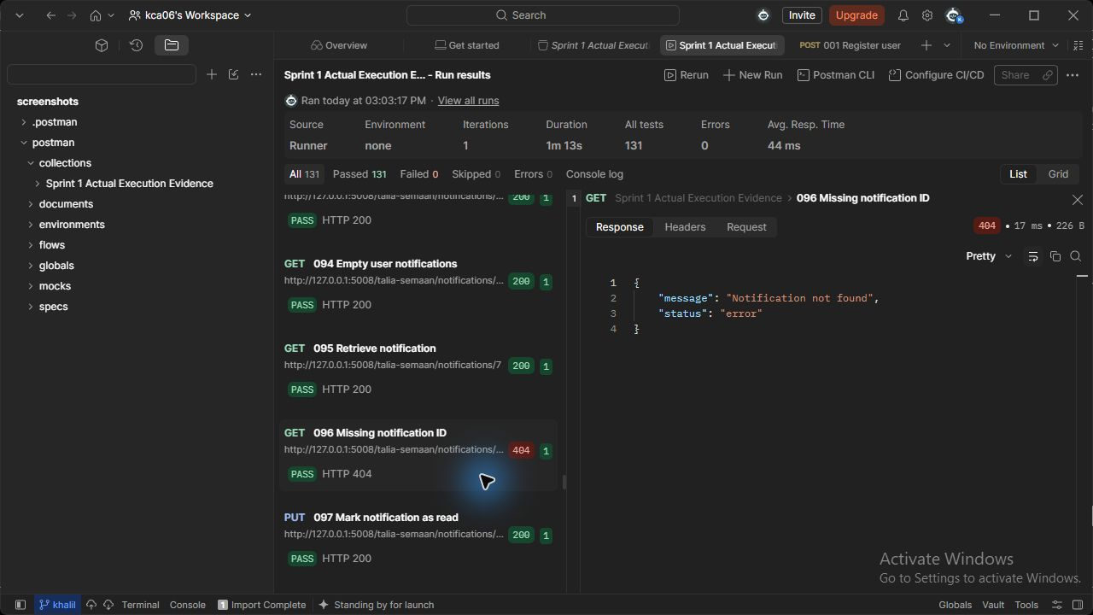
Figure 96 (Talia Semaan). notifications API - Missing notification ID. Actual HTTP 404 response; the runner assertion passed.

106 Missing log ID (Talia Semaan)
GET http://127.0.0.1:5005/talia-semaan/logs/999999
Request body: none
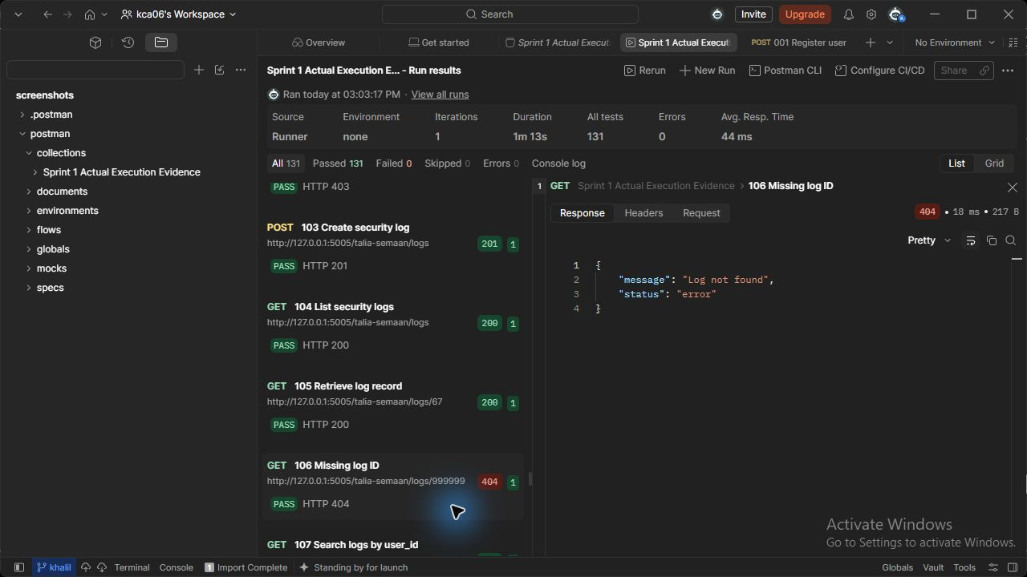
Figure 106 (Talia Semaan). logs API - Missing log ID. Actual HTTP 404 response; the runner assertion passed.

8 API Documentation (Khalil Ayoub, Talia Semaan and Charbel Faddoul)
The complete owner-specific references below document the nine services, inputs, returned data, roles and error cases. Import the three Postman collections and matching environments from postman after extracting the student ZIPs. Set real tokens and record variables for the local environment. Prepared examples describe API contracts; the execution figures in this report are the actual recorded evidence.

API reference Khalil Ayoub (Khalil Ayoub)

Part 1 API reference (Khalil Ayoub)
All paths below are prefixed with /{full-name-slug}. Use Authorization: Bearer TOKEN for public routes. Bodies and responses are JSON. Success wraps data as {"status":"success","data":...}; error wraps {"status":"error","message":"..."}. Create is 201, other success is 200. Errors: 400 malformed/invalid input, 401 missing/bad token, 403 forbidden role or unrelated asset, 404 missing record, 409 duplicate/reference conflict, 503 unavailable dependency, 500 unexpected internal error with no traceback returned.

Asset Management
Method and path | Request / parameters | Data returned | Roles
POST /assets | Required asset_name, asset_type, ip_address, department, owner_id, criticality_level. Optional operating_system, location, status | Stored asset including ID; status defaults Active | Admin
GET /assets | None | All assets ordered by ID | Admin, Auditor
GET /assets/{id} | Integer path ID | Asset plus related_incident_ids and related_vulnerability_ids | Admin, Auditor, Analyst on assigned-incident assets
PUT /assets/{id} | Any nonempty subset of asset_name, owner_id, department, criticality_level, status | Updated asset | Admin
DELETE /assets/{id} | Integer ID | Deleted ID and message; 409 if referenced by incident/vulnerability | Admin
GET /assets/search | Optional asset_name, asset_type, ip_address, department, criticality_level | AND-filtered case-insensitive literal substring results; no matches is [] | Admin, Auditor, Analyst restricted to assigned-incident assets
GET /assets/{id}/history | Integer ID | Timestamped create/update snapshots and acting user IDs | Admin, Auditor
GET /internal/assets/{id} | X-Service-Key instead of user token | Only id, status, owner_id; used by incident service | Trusted services
Asset types: Server, Workstation, Database, Application, Network Device, Cloud Resource. Criticality: Low/Medium/High/Critical. Status: Active/Inactive/Under Maintenance. IP supports IPv4/IPv6. Owner must be a real user validated by identity-service HTTP lookup. Missing/empty fields, unknown JSON keys, invalid types/enums are rejected. History is retained while the asset exists; deletes cascade its local history, with separate audit deletion-request record retained.
Example create request:
{"asset_name":"Lab Server","asset_type":"Server","ip_address":"192.0.2.10","department":"IT","owner_id":3,"criticality_level":"High"}
Illustrative shape only, not execution evidence: data includes the above fields plus id and status:"Active".

Threat Intelligence
Method and path | Request / parameters | Data returned | Roles
POST /threats | threat_type, threat_value, description, severity, source | Stored indicator with ID/date_added | Admin
GET /threats | None | All indicators | Admin, Analyst, Auditor
GET /threats/{id} | Integer ID | One indicator | Admin, Analyst, Auditor
GET /threats/search | threat_type, threat_value, severity, source | AND-filtered substring results | Admin, Analyst, Auditor
PUT /threats/{id} | Nonempty subset description, severity, source | Updated indicator | Admin
DELETE /threats/{id} | Integer ID | Deleted ID/message | Admin
Threat types: IP Address, Domain, File Hash, Malware Signature, Other Indicators. Validate actual IP, domain labels, or hexadecimal MD5/SHA1/SHA256. Normalize IP representation, lowercase domains/hashes, and remove trailing domain dot before checking compound uniqueness (type,value). Database uniqueness protects concurrent duplicates. Different types may share a value if formats permit. Severity uses Low/Medium/High/Critical. A creation attempts a Threat Alert notification to its creating administrator. Other roles cannot modify threats; employees cannot read them.
{"threat_type":"Domain","threat_value":"example.test","description":"Training indicator","severity":"High","source":"Local exercise"}

Vulnerability Management
Method and path | Request / parameters | Data returned | Roles
POST /vulnerabilities | title, description, cve_identifier, cvss_score, severity, asset_id, discovery_source; optional status=Open | Stored vulnerability with ID/creation_date | Admin
GET /vulnerabilities | None | All vulnerabilities | Admin, Analyst, Auditor
GET /vulnerabilities/{id} | Integer ID | One vulnerability | Admin, Analyst, Auditor
GET /vulnerabilities/search | cve_identifier, severity, asset_id, status | AND-filtered results; asset_id exact match | Admin, Analyst, Auditor
PUT /vulnerabilities/{id} | Nonempty subset description, severity, status, cvss_score, resolution_date | Updated vulnerability | Admin, Analyst
DELETE /vulnerabilities/{id} | Integer ID | Deleted ID/message | Admin
CVSS must be a finite JSON number in [0,10], not boolean/string. CVE format CVE-YYYY-NNNN or longer numeric suffix. Asset must exist and is checked through the asset service. New status Open; only next transition Open -> Under Investigation -> In Progress -> Resolved -> Closed. Repeating the current status is allowed. resolution_date is set automatically upon entering Resolved, preserved on Closed; clients cannot invent dates or clear a resolved date. Optional null is accepted before resolution. Severity is supplied explicitly, not automatically inferred from CVSS because the brief does not mandate a mapping. Creation attempts a Vulnerability Alert to asset owner.
{"title":"Training vulnerability","description":"Lab finding","cve_identifier":"CVE-2026-12345","cvss_score":8.1,"severity":"High","asset_id":1,"discovery_source":"Local exercise"}
Example status update: {"status":"Under Investigation"}. Direct Open -> Closed returns 400.

Dependency behavior
All protected operations verify current identity through Part 2. Missing/invalid token logging depends on audit availability. No identity or audit bypass is provided. Modification requests are validated, then logged through the audit API before a local transaction starts. Audit descriptions explicitly represent validated requests, including requests later rejected by FK conflict; they do not falsely claim completion. An audit outage blocks mutation with 503. This simple policy avoids shared-SQLite write-lock deadlocks.
If an alert service fails after a creation commits, the creation still returns 201 and saved data with notification_warning. That warning is not persisted; retry the internal notification using the saved ID after recovery. There is no automatic retry queue. Verify successful alert generation in the integrated normal-path evidence before submission.

API reference Talia Semaan (Talia Semaan)

Part 2 API Reference (Talia Semaan)
Base URL: http://127.0.0.1:<port>/talia-semaan. All successful responses use {"status":"success","data":...}. Errors use {"status":"error","message":"..."}. Protected public requests use Authorization: Bearer TOKEN; internal routes use X-Service-Key.

Users and identity (port 5001)
Passwords require at least 12 characters and are hashed with Werkzeug. Public registration may create only Regular Employee/User. A logged-in Security Administrator may create a privileged role. Account status is Active, Inactive, or Suspended; only active accounts can log in or verify. User profile responses never include password hashes.
Method and endpoint | Purpose, access, and input | Success / common errors
POST /users/register | Public account registration. Required JSON: full_name, username, email, password, department, role. | 201 safe user; 400 malformed, unknown field, invalid email, or short password; 403 privileged public registration; 409 duplicate identity.
POST /users/login | Public login. JSON has exactly one of username or email, plus password. | 200 includes data.token and safe user; 400 malformed; 401 invalid credentials/inactive account; 503 audit dependency unavailable.
PUT /users/{id} | Admin or own regular user. JSON accepts only full_name, email, department. | 200 safe user; 400 unknown/invalid fields; 403 wrong owner/role; 404 missing/deleted; 409 duplicate email.
DELETE /users/{id} | Admin only; logical deletion preserves foreign keys and history. | 200 deleted ID; 403 forbidden; 404 missing/deleted.
GET /users | Admin and Auditor. | 200 safe active/non-deleted users; 401 unauthenticated; 403 forbidden.
GET /users/{username} | Admin/Auditor; regular user may retrieve only self. | 200 safe user; 401, 403, or 404.
GET /users/id/{id} | Admin/Auditor helper for numeric cross-service IDs. | 200 safe user with ID and role; 401, 403, or 404.
PUT /users/{id}/role | Admin only. JSON: {"role":"Security Analyst"}; role removal uses Regular Employee/User. | 200 safe user; 400 invalid role; 403; 404.
PUT /users/{id}/status | Admin only. JSON: {"account_status":"Suspended"}. | 200 safe user; 400 invalid status; 403; 404.
POST /internal/verify | Service key required. JSON: {"token":"..."}. | 200 {id, full_name, role, account_status}; 401 invalid/expired/inactive/deleted; 403 bad service key.
The signed token contains user ID and expiry only; every check rereads current role, status, and deletion state. Tokens expire after eight hours. User deletion is logical: set deleted_at, exclude the account from login/list/detail/verification, and preserve its foreign-key history and reserved username/email.

Security audit logs (port 5005)
Allowed severity values: Information, Warning, Error, Critical. Admin creates, lists, reads, searches, and deletes; Auditor reads/lists/searches/by-user; Analyst reads an individual log or searches only. Employees have no access. Logs are immutable through the API: there is no update endpoint; the shared schema must provide the requested update-blocking trigger. Empty user-log searches return 200 with data: [].
Method and endpoint | Purpose, access, and input | Success / common errors
POST /logs | Admin creates; JSON requires user_id (integer or null), action, description, severity, related_service. | 201 stored log; 400 validation; 401/403; 409 relationship conflict.
GET /logs | Admin/Auditor list. | 200 array; 401/403.
GET /logs/{id} | Admin/Auditor/Analyst detail. | 200 record; 401/403/404.
GET /logs/search | Admin/Auditor/Analyst. Query filters: user_id, date (YYYY-MM-DD), action, severity, related_service. | 200 filtered array (possibly empty); 400 invalid filter; 401/403.
DELETE /logs/{id} | Admin only. | 200 deleted ID; 401/403/404.
GET /logs/user/{user_id} | Admin/Auditor only. | 200 matching array, including empty; 401/403.
POST /internal/logs | Service key only; same fields as public create. Timestamp is server-generated. | 201 stored record; 400 invalid field; 403 bad service key; 409 invalid user relation.
Identity service logs successful/failed login, user creation/deletion requests, role/status changes, and rejected authorization/authentication. Log text explicitly says "requested" when written before the transaction. Log writes are not recursively logged.

Notifications (port 5008)
Types: Incident Assignment, Security Alert, System Notification, Threat Alert, Vulnerability Alert. Severity: Low, Medium, High, Critical. Status is generated as Unread; read_date is null until first read, and repeated reads preserve the first timestamp. Admin can create/manage all; Auditor can read/search; Analysts and regular users can access only their own records and mark their own notifications read. Analysts can search their own records; regular users cannot search. Creation means a stored notification, not external delivery.
Method and endpoint | Purpose, access, and input | Success / common errors
POST /notifications | Admin creates. JSON requires user_id, title, message, notification_type, severity; status/timestamps are server-owned. | 201 notification; 400 invalid input; 401/403; 404 missing/inactive recipient.
GET /notifications/user/{user_id} | Admin/Auditor any user; Analyst/Employee self only. | 200 array, including empty; 401/403.
GET /notifications/{id} | Admin/Auditor any; Analyst/Employee own. | 200; 401/403/404.
PUT /notifications/{id}/read | Admin or owning Analyst/Employee; no body. | 200 updated notification; 401/403/404.
GET /notifications/search | Admin/Auditor; Analyst receives own records only. Filters: user_id, notification_type, severity, status. | 200 array; 400 invalid filter; 401/403.
DELETE /notifications/{id} | Admin only. | 200 deleted ID; 401/403/404.
POST /internal/notifications | Service key only; same client fields as create, with generated status and timestamps. | 201; 400 invalid input; 403 bad key; 404 missing/inactive recipient.

Internal user validation
GET /internal/users/{id} requires X-Service-Key, returns only id/role/account_status/deleted_at for a non-deleted user, or 404. This validates assignees without granting analysts public user-management access. User timestamps use created_date/last_login_date. Notification modifications are audited outside write transactions.

Cross-service patterns
Internal log and notification writes validate X-Service-Key using constant-time comparison and do not call identity verification, preventing recursion. Public user/log/notification requests verify bearer tokens through the users identity endpoint. A dependency outage returns 503; it never grants access. All query values are SQL-bound parameters. Postman examples are for manual execution and are not execution evidence.

API reference Charbel Faddoul (Charbel Faddoul)

API reference (Charbel Faddoul)
All paths below begin with /charbel-faddoul; use ports 5003 incidents, 5006 reports and 5009 playbooks. Every route requires Authorization: Bearer TOKEN. ID path parameters are positive integers. No endpoint defines query parameters. Bodies are nonempty JSON objects; unknown fields are rejected. Role shorthand: Admin = Security Administrator, Analyst = Security Analyst, Employee = Regular Employee/User, Auditor = Auditor.
Method/path | Roles | JSON body (illustrative request template) | Success | Purpose
POST /incidents | Admin/Employee | {"title": "Unexpected account access", "description": "Investigate unexpected access on the selected lab asset", "category": "Unauthorized access", "severity": "High", "asset_id": "{{asset_id}}"} | 201 | Create Open incident; employee reporter is authenticated identity. Admin may include reporter_id.
GET /incidents | Admin/Auditor | None | 200 | List all incidents including status and assigned_analyst_id.
GET /incidents/assigned | Analyst | None | 200 | List only incidents assigned to authenticated analyst.
GET /incidents/mine | Employee | None | 200 | List only incidents reported by authenticated employee.
GET /incidents/{{incident_id}} | Admin/Auditor/assigned Analyst/own Employee | None | 200 | Incident details and notes, ordered by note ID.
PUT /incidents/{{incident_id}}/assign | Admin | {"assigned_analyst_id": "{{analyst_id}}"} | 200 | Validate Active Security Analyst, save assignment, notify after commit.
PUT /incidents/{{incident_id}}/status | Admin/assigned Analyst | {"status": "Under Investigation"} | 200 | Advance exactly one incident lifecycle state; server resolution time.
POST /incidents/{{incident_id}}/notes | Admin/assigned Analyst | {"note_content": "Reviewed authentication evidence"} | 201 | Persist linked note with authenticated author and server timestamp.
GET /reports/summary | Admin/Auditor | None | 200 | Totals users/assets/incidents/threats; open_incidents, critical_threats, latest ten recent_activity.
GET /reports/incidents | Admin/Auditor | None | 200 | Total, by_severity and by_status from authorized incident HTTP list.
GET /reports/assets | Admin/Auditor | None | 200 | Total, critical and by_type from authorized asset HTTP list.
GET /reports/threats | Admin/Auditor | None | 200 | Total, by_severity, by_type and latest ten recent_indicators.
GET /reports/vulnerabilities | Admin/Auditor | None | 200 | Total, by_severity, by_status and critical.
GET /reports/activity | Admin/Auditor | None | 200 | Total activities, login_attempts, failed_logins and most_common_actions; uses shared login_succeeded/login_failed outcome labels by default.
POST /playbooks | Admin | {"name": "Account containment", "description": "Collect evidence then contain access", "incident_category": "Unauthorized access", "severity": "High"} | 201 | Create categorized response procedure with authenticated created_by.
GET /playbooks | Admin/Analyst/Auditor | None | 200 | List playbook fields without child actions.
GET /playbooks/{{playbook_id}} | Admin/Analyst/Auditor | None | 200 | Retrieve ordered actions and per-action history snapshots.
POST /playbooks/{{playbook_id}}/actions | Admin/Analyst | {"description": "Collect access evidence", "step_number": 1, "assigned_user_id": "{{analyst_id}}"} | 201 | Append unique positive increasing step. Optional Active assigned_user_id; initial Pending.
PUT /actions/{{action_id}}/status | Admin/Analyst | {"status": "In Progress"} | 200 | Optional status and/or assigned_user_id. Next-state only, earlier steps complete, Active assignee; completed immutable.
DELETE /playbooks/{{playbook_id}} | Admin | None | 200 | Delete parent and cascade actions/history; use a disposable demo playbook.

Response and error contracts (Charbel Faddoul)
All successes: {"status":"success","data":...}. Create/update/detail return a stored object; list returns an array. Incident details include notes; playbook detail includes actions ordered by step_number, each with history. Delete returns { "id": ID, "message": "Playbook deleted" } under data. The collection contains prepared bodies and assertions, with no claimed captured responses. Token and record variables must come from your own system.
Errors: {"status":"error","message":"meaningful explanation"}. 400 missing/unknown fields, wrong types, invalid enums, invalid lifecycle, absent assignee for execution or no-op update; 401 missing/invalid/expired token; 403 role/ownership/impersonation or analyst other-user lookup denied; 404 absent incident/playbook/action/reference; 409 duplicate/ordering/immutable-completed/concurrent/FK conflict; 503 unavailable authentication/audit/source dependency or missing activity login-label configuration. Every endpoint may return 401/403/503. Resource reads/mutations may return 404. Creation/mutation may return 400/409. A permission-denial audit outage may yield 503 before the intended 401/403 because common.protected requires audit service availability.

Field rules (Charbel Faddoul)
Incident required: title, description, category, severity, asset_id. Optional reporter_id defaults to identity; employee cannot override to someone else. Assignment requires assigned_analyst_id. Note requires note_content. Text fields are trimmed, nonempty and <=4000 characters. Severity is Low/Medium/High/Critical. Status and creation/resolution times cannot be supplied at creation. Status updates require exactly status; Open -> Under Investigation -> Mitigated -> Resolved -> Closed. Timestamp generated on Resolved and retained on Closed.
Playbook required: name, description, incident_category, severity. Action required: description, step_number; optional assigned_user_id. Step number is a unique positive integer greater than prior steps. Status update allows status and/or assigned_user_id, with at least one actual change. Assigned IDs must resolve to Active users; analysts validate assignees through a service-key-only identity lookup. Pending -> In Progress -> Completed, lower steps complete first, assigned user required to execute, Completed immutable. completion_date is server-generated and cannot be sent. Creation/status/assignment snapshots store changed_by and timestamp.

Report data (Charbel Faddoul)
Summary data: users/assets/incidents/threats integer totals, open_incidents, critical_threats, recent_activity (latest 10). Other reports return total plus grouped counts described above. Activity additionally returns total_activities, login_attempts, failed_logins, most_common_actions and login_action_labels. Login attempts = exact configured success outcomes + failure outcomes; separate attempt-start records are excluded. Invalid explicit outcome labels cause 503. Defaults are login_succeeded and login_failed. Empty totals are 0 and empty grouped maps are {}. Dependencies are fetched with the caller bearer token; their failures remain explicit. Recent items are ordered by server timestamps, latest first.

Postman use (Charbel Faddoul)
Import postman/part3.collection.json and postman/part3.environment.json. Set four real role tokens and numeric asset_id/analyst_id. Run ordered folders against disposable records; IDs are saved into the environment on successful creates. The two-action scenario demonstrates order rejection before progressing both steps. Error requests use the saved records; cleanup is last. Manually test missing token, real dependency outage, varied severities/types/statuses and real DB comparisons using EVIDENCE_CHECKLIST.md. All request examples are illustrative templates, not actual API execution evidence. Rebuild artifacts with python -m part3.build_postman.

9 Authentication and Authorization (Khalil Ayoub, Talia Semaan and Charbel Faddoul)
Passwords have a minimum length of twelve characters and are stored as Werkzeug salted password hashes. Login verifies the hash and accepts only active, non-deleted accounts. The identity service issues an HMAC SHA256 signed token containing the user ID and an eight hour expiry. This compact token format is implemented locally; it is not a standard JWT.
Every protected request verifies the signature and expiry and rereads the account role, status and deletion state through the identity service. Privileged registration, role changes and status changes require an administrator. Public registration creates regular users only. Internal calls validate a shared service key using constant-time comparison.
Role | Access
Security Administrator | Manage users, roles and operational data; generate reports.
Security Analyst | Assigned incidents and notes; related assets; threats and vulnerabilities; own notifications; playbook actions; allowed log reads/searches.
Regular Employee/User | Own account, own reported incidents and personal notifications.
Auditor | Read permitted organizational records and generate reports; cannot mutate records.
The figures below compare successful and failed authentication, missing tokens, forbidden roles, ownership checks and the same asset API with authorized and unauthorized roles.

004 Successful password login (Talia Semaan)
POST http://127.0.0.1:5001/talia-semaan/users/login
JSON body: {"username": "evidence_user", "password": "<local test password>"}
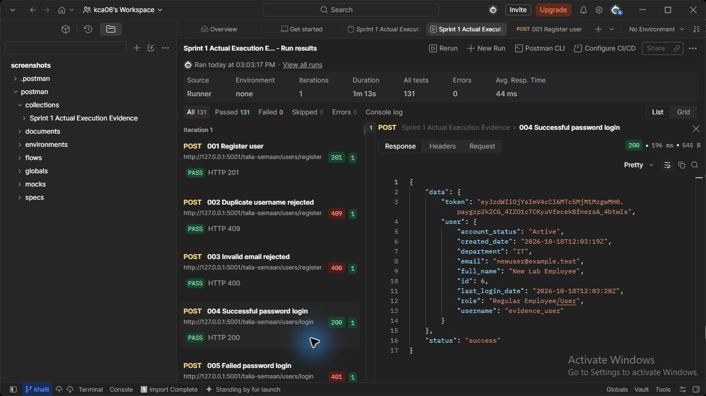
Figure 4 (Talia Semaan). users API - Successful password login. Actual HTTP 200 response; the runner assertion passed.

005 Failed password login (Talia Semaan)
POST http://127.0.0.1:5001/talia-semaan/users/login
JSON body: {"username": "evidence_user", "password": "incorrect-password"}
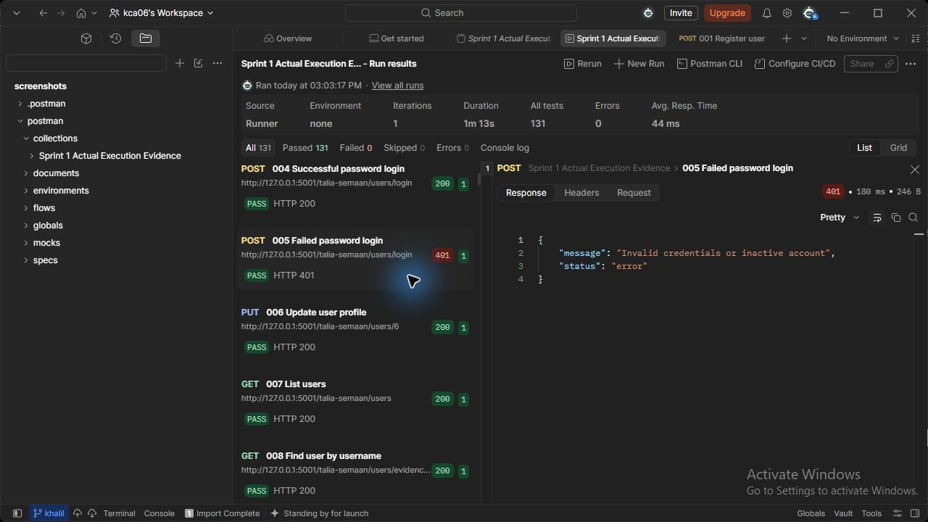
Figure 5 (Talia Semaan). users API - Failed password login. Actual HTTP 401 response; the runner assertion passed.

010 Unauthorized user deletion (Talia Semaan)
DELETE http://127.0.0.1:5001/talia-semaan/users/{{new_user_id}}
Request body: none
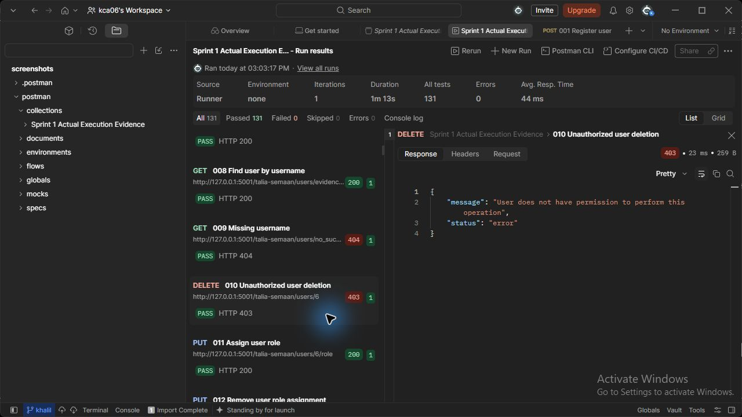
Figure 10 (Talia Semaan). users API - Unauthorized user deletion. Actual HTTP 403 response; the runner assertion passed.

014 Suspended login rejected (Talia Semaan)
POST http://127.0.0.1:5001/talia-semaan/users/login
JSON body: {"username": "evidence_user", "password": "<local test password>"}
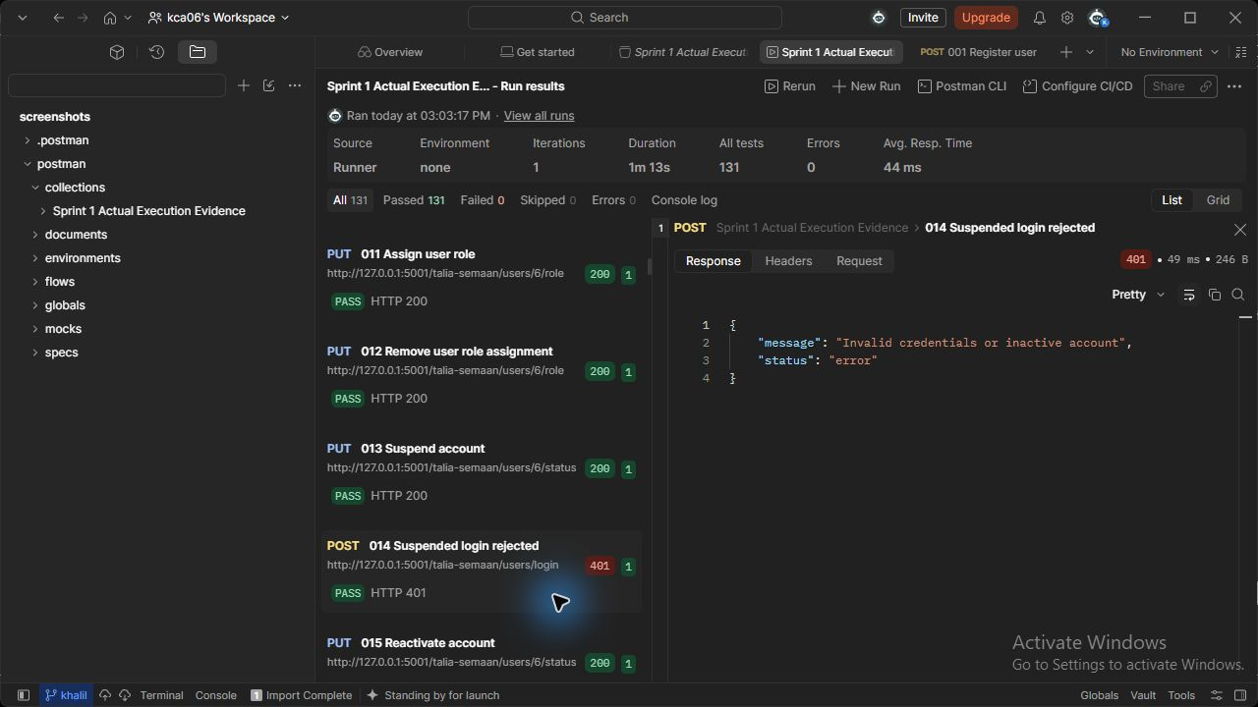
Figure 14 (Talia Semaan). users API - Suspended login rejected. Actual HTTP 401 response; the runner assertion passed.

031 Unauthorized asset deletion (Khalil Ayoub)
DELETE http://127.0.0.1:5002/khalil-ayoub/assets/{{asset_id}}
Request body: none
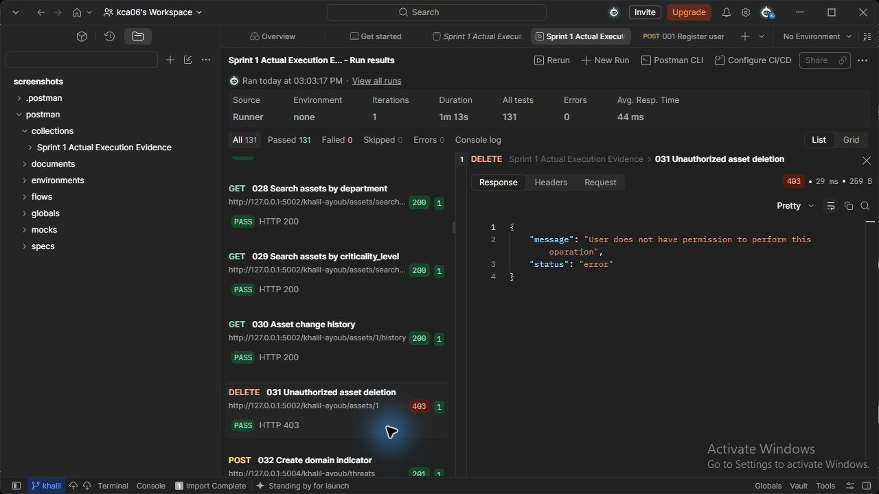
Figure 31 (Khalil Ayoub). assets API - Unauthorized asset deletion. Actual HTTP 403 response; the runner assertion passed.

045 Unauthorized threat deletion (Khalil Ayoub)
DELETE http://127.0.0.1:5004/khalil-ayoub/threats/{{threat_id}}
Request body: none
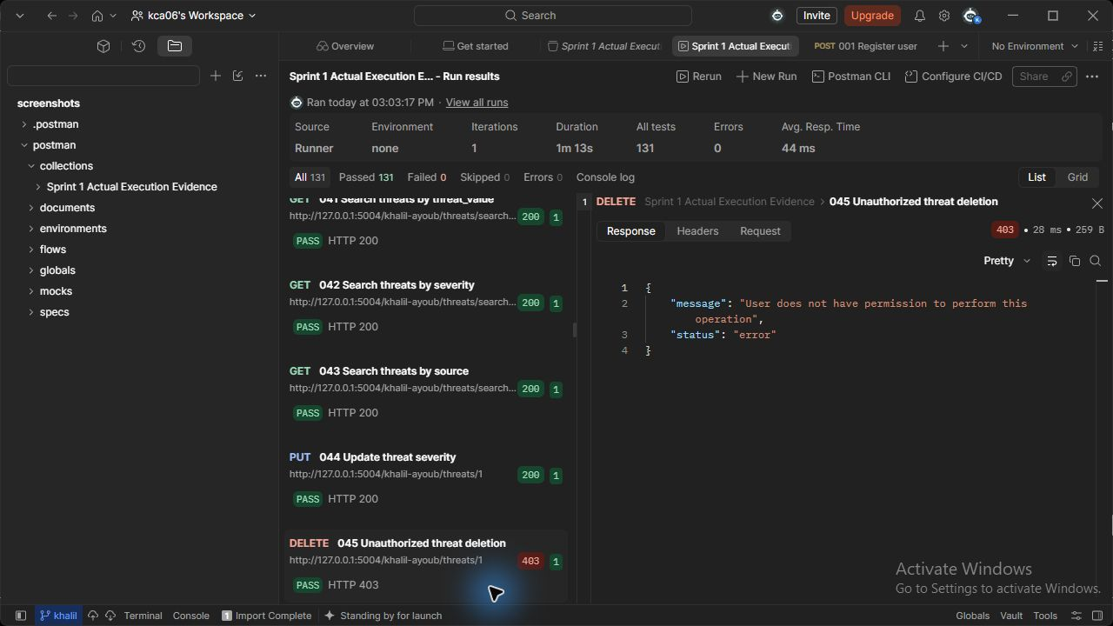
Figure 45 (Khalil Ayoub). threats API - Unauthorized threat deletion. Actual HTTP 403 response; the runner assertion passed.

062 Unauthorized vulnerability deletion (Khalil Ayoub)
DELETE http://127.0.0.1:5007/khalil-ayoub/vulnerabilities/{{vulnerability_id}}
Request body: none
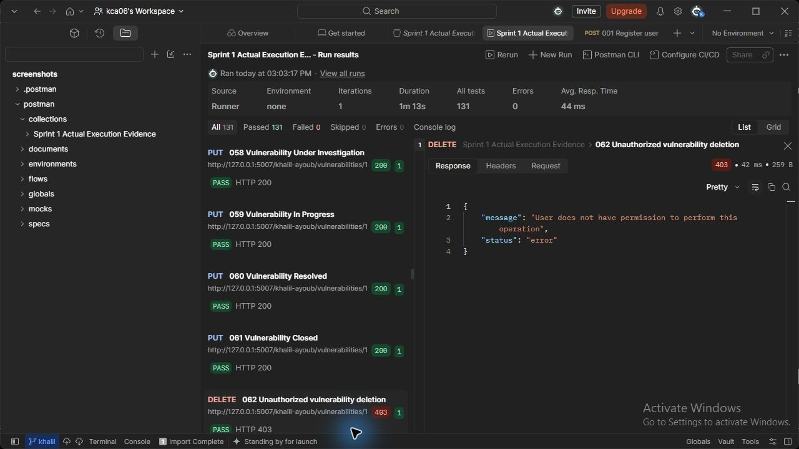
Figure 62 (Khalil Ayoub). vulnerabilities API - Unauthorized vulnerability deletion. Actual HTTP 403 response; the runner assertion passed.

068 Unauthorized incident assignment (Charbel Faddoul)
PUT http://127.0.0.1:5003/charbel-faddoul/incidents/{{incident_id}}/assign
JSON body: { "assigned_analyst_id": {{analyst_id}} }
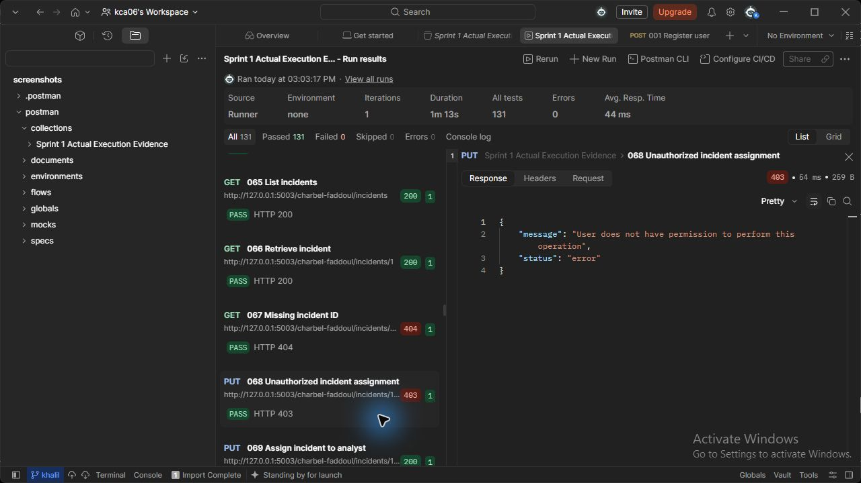
Figure 68 (Charbel Faddoul). incidents API - Unauthorized incident assignment. Actual HTTP 403 response; the runner assertion passed.

071 Cross-user incident access denied (Charbel Faddoul)
GET http://127.0.0.1:5003/charbel-faddoul/incidents/{{incident_id}}
Request body: none
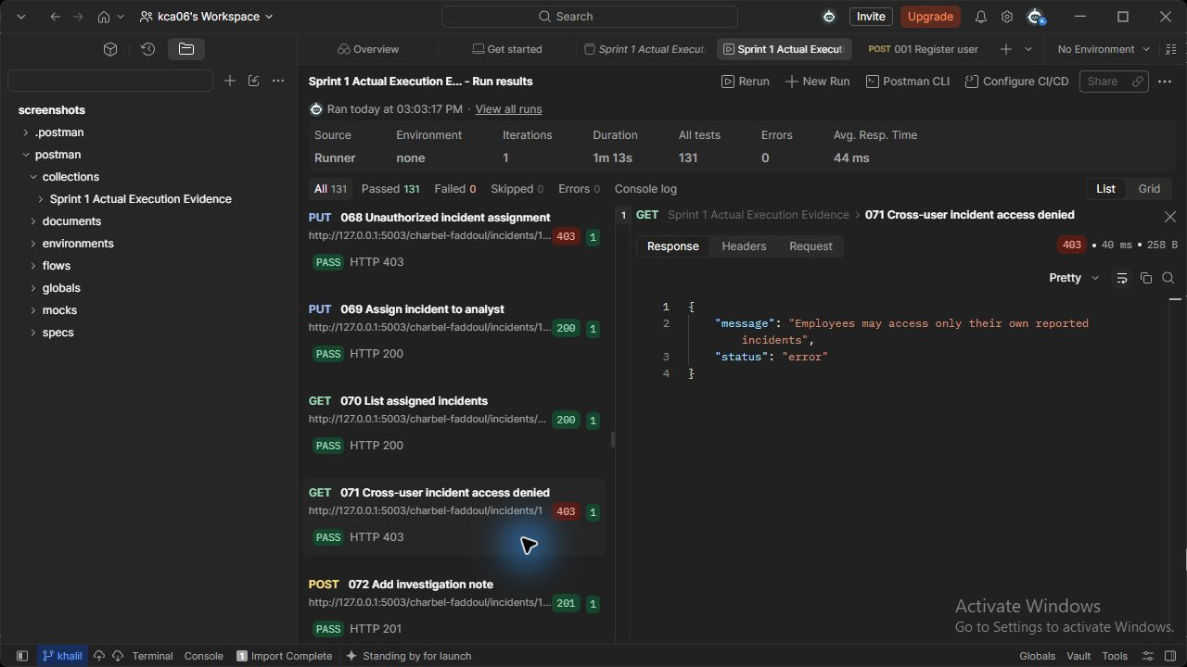
Figure 71 (Charbel Faddoul). incidents API - Cross-user incident access denied. Actual HTTP 403 response; the runner assertion passed.

091 Unauthorized playbook deletion (Charbel Faddoul)
DELETE http://127.0.0.1:5009/charbel-faddoul/playbooks/{{playbook2_id}}
Request body: none
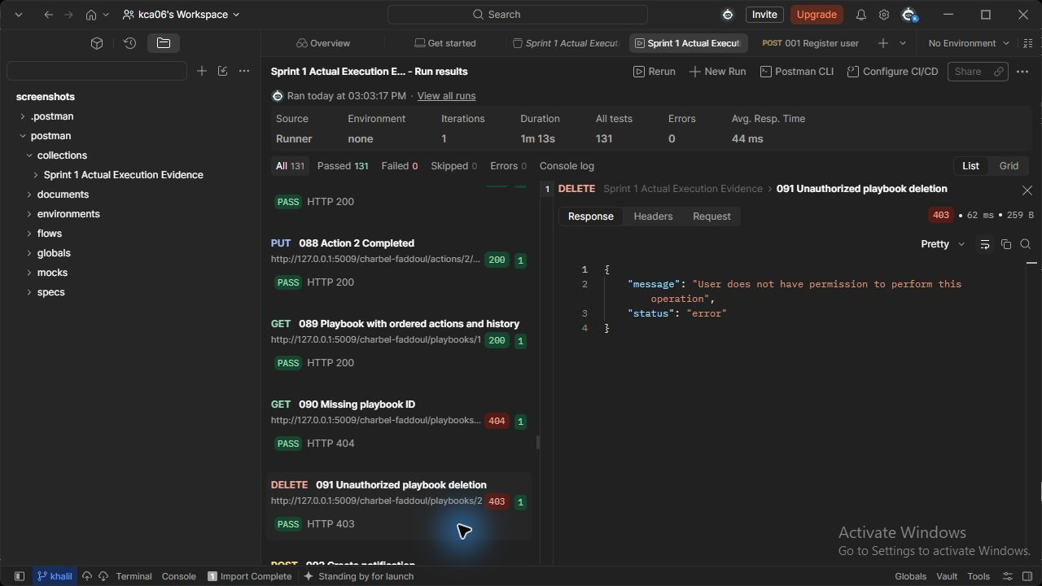
Figure 91 (Charbel Faddoul). playbooks API - Unauthorized playbook deletion. Actual HTTP 403 response; the runner assertion passed.

102 Unauthorized notification deletion (Talia Semaan)
DELETE http://127.0.0.1:5008/talia-semaan/notifications/{{notification_id}}
Request body: none
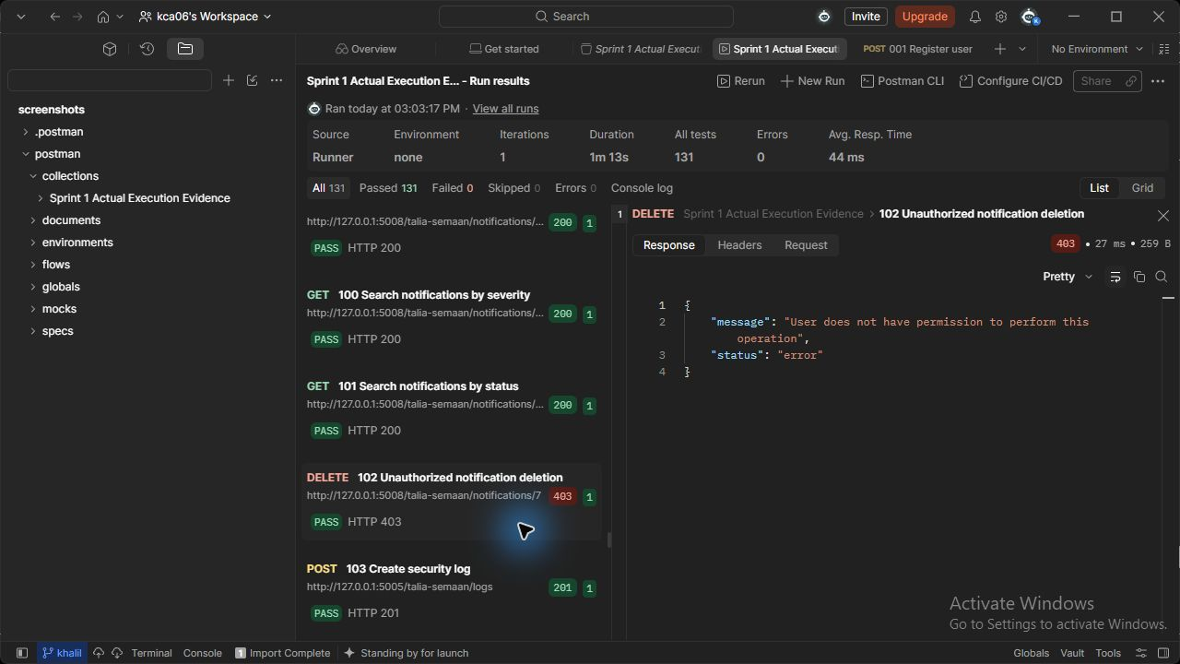
Figure 102 (Talia Semaan). notifications API - Unauthorized notification deletion. Actual HTTP 403 response; the runner assertion passed.

114 Unauthorized log deletion (Talia Semaan)
DELETE http://127.0.0.1:5005/talia-semaan/logs/{{log_id}}
Request body: none
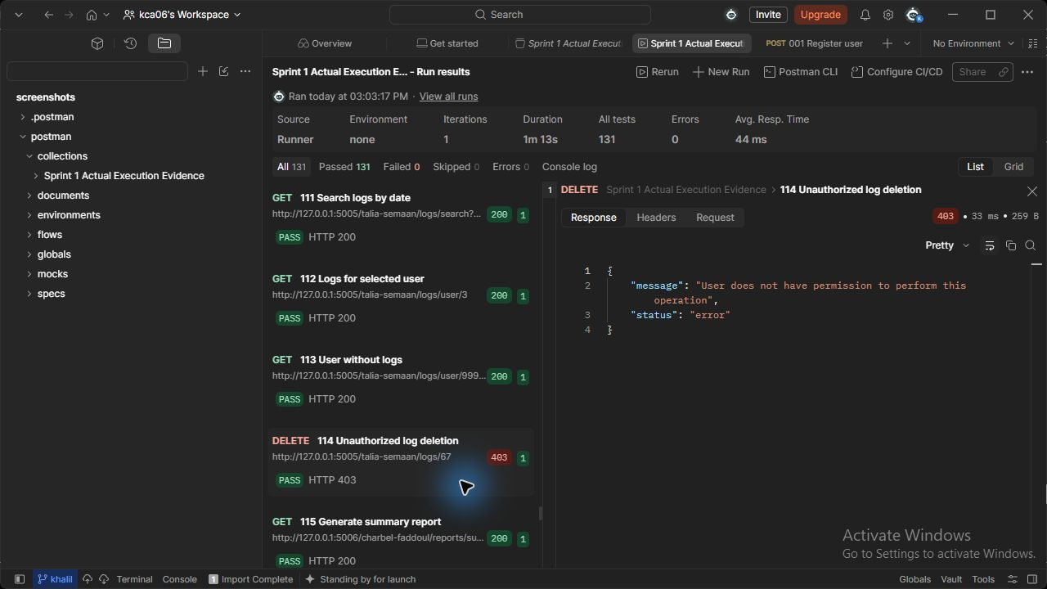
Figure 114 (Talia Semaan). logs API - Unauthorized log deletion. Actual HTTP 403 response; the runner assertion passed.

121 Unauthorized report generation (Charbel Faddoul)
GET http://127.0.0.1:5006/charbel-faddoul/reports/summary
Request body: none
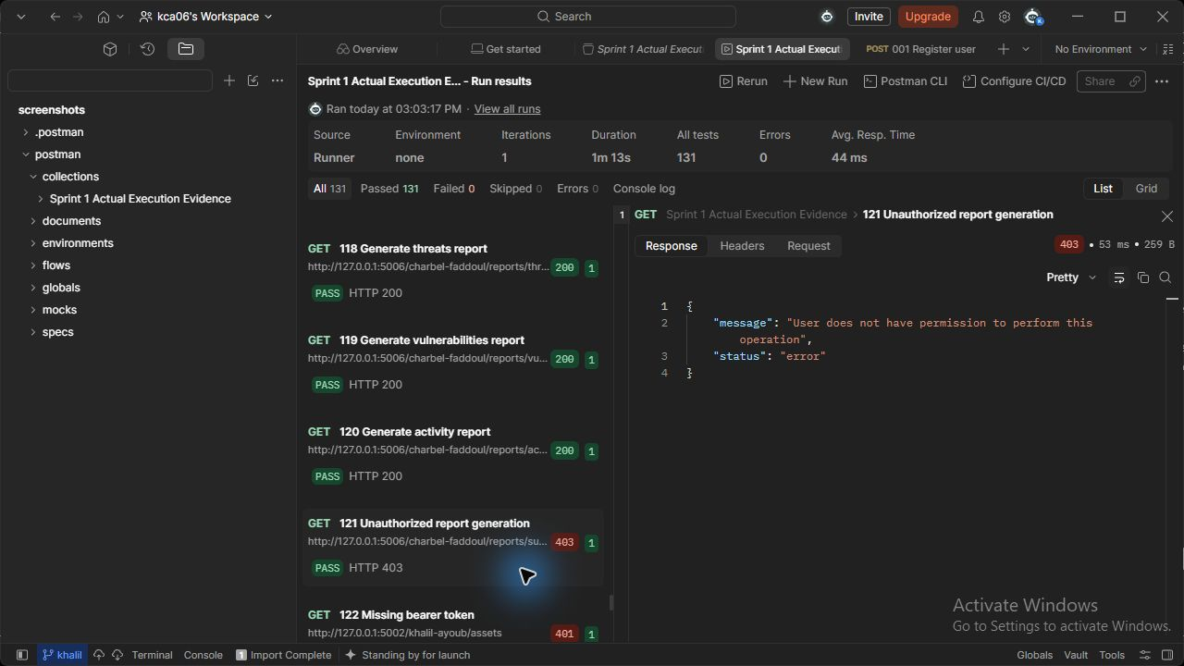
Figure 121 (Charbel Faddoul). reports API - Unauthorized report generation. Actual HTTP 403 response; the runner assertion passed.

122 Missing bearer token (Khalil Ayoub)
GET http://127.0.0.1:5002/khalil-ayoub/assets
Request body: none
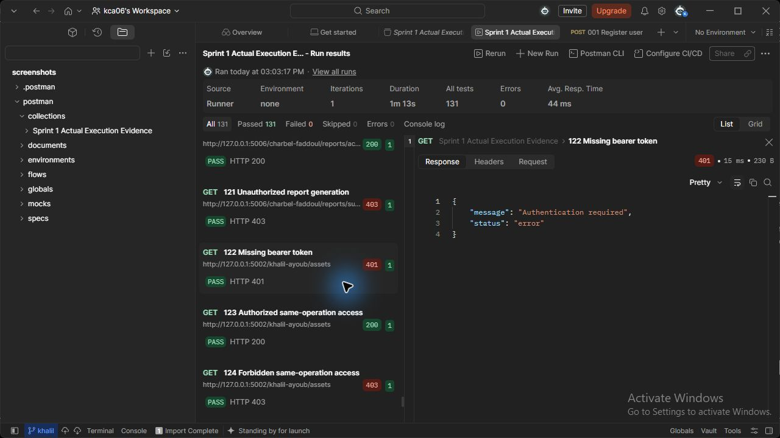
Figure 122 (Khalil Ayoub). assets API - Missing bearer token. Actual HTTP 401 response; the runner assertion passed.

123 Authorized same-operation access (Khalil Ayoub)
GET http://127.0.0.1:5002/khalil-ayoub/assets
Request body: none
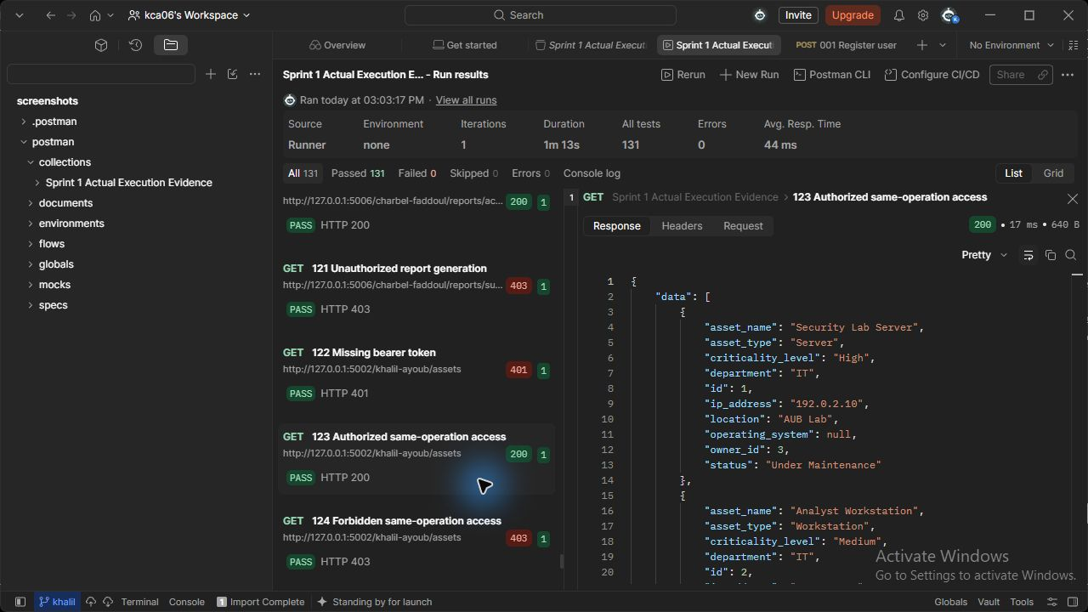
Figure 123 (Khalil Ayoub). assets API - Authorized same-operation access. Actual HTTP 200 response; the runner assertion passed.

124 Forbidden same-operation access (Khalil Ayoub)
GET http://127.0.0.1:5002/khalil-ayoub/assets
Request body: none
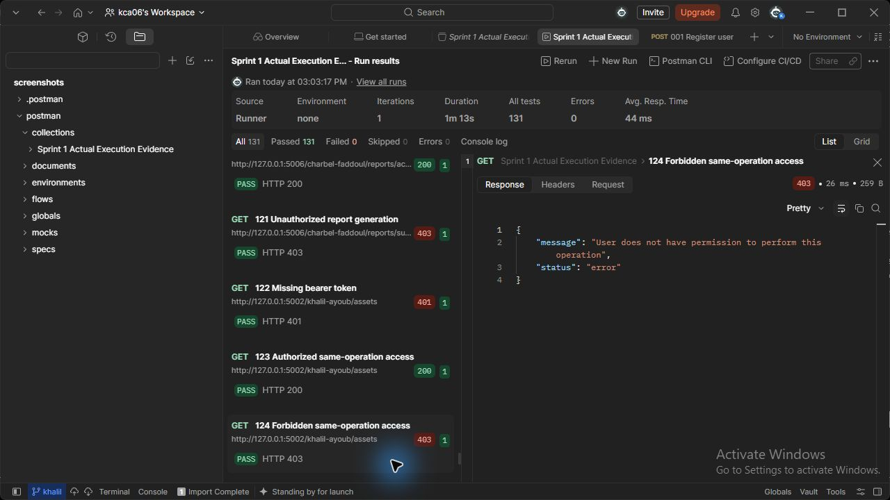
Figure 124 (Khalil Ayoub). assets API - Forbidden same-operation access. Actual HTTP 403 response; the runner assertion passed.

10 GitHub and Version Control (Khalil Ayoub, Talia Semaan and Charbel Faddoul)
Repository: https://github.com/Khalil-Ayoub/talia-semaan-khalil-ayoub-charbel-faddoul-435L
All nine services are merged into main. Khalil Ayoub submitted assets, threats and vulnerabilities through PR 1. Charbel Faddoul submitted corrected incidents, reports and playbooks through PR 3. Talia Semaan submitted users, logs and notifications through PR 4. All three pull requests were merged on 19 October 2026; the original student commits and personal branches are preserved.
The screenshots below are actual captures from the signed-in Chrome session on 19 October 2026. Student accounts appear in their commit history and pull request conversations. Khalil performed the merges and uploaded the common report and evidence. Charbel-Faddoul is the renamed Ta3awon account. Earlier PR 2 was closed without merging.
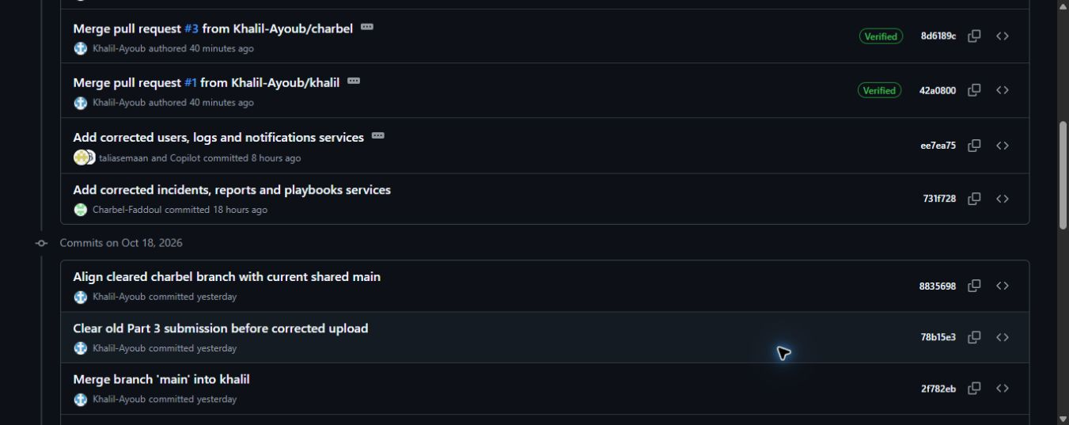
GitHub history (Khalil Ayoub, Talia Semaan and Charbel Faddoul). Main shows the merged branches and actual service commits by taliasemaan and Charbel-Faddoul, alongside Khalil-Ayoub integration commits.
Source: https://github.com/Khalil-Ayoub/talia-semaan-khalil-ayoub-charbel-faddoul-435L/commits/main/
Verified API exports remain in evidence/github-main-history.json and evidence/github-pull-requests.json. Original screenshot files and capture hashes are supplied with the evidence.

Verified repository contribution (Khalil Ayoub)
Assets, threat intelligence and vulnerabilities. Account: Khalil-Ayoub. Merged pull request: 1.
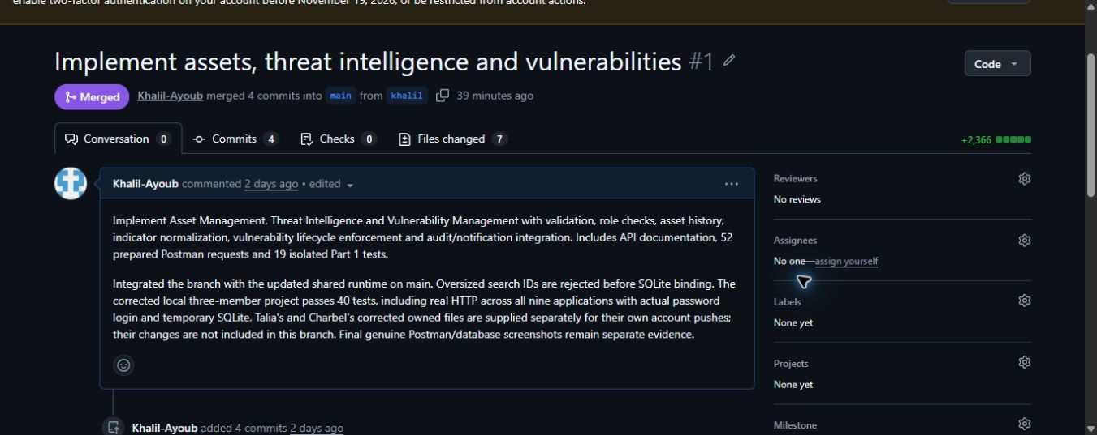
GitHub contribution (Khalil Ayoub). Actual merged PR 1 shows the student account and the description of the three owned services.
Pull request: https://github.com/Khalil-Ayoub/talia-semaan-khalil-ayoub-charbel-faddoul-435L/pull/1
Service implementation commit: 3b6e40269bc459276e5976963080acda59a12653
Khalil also maintains the shared runtime, schema, configuration, integration tests, common report and combined evidence. His merge commits record integration separately from student service commits.

Verified repository contribution (Charbel Faddoul)
Incidents, security reports and playbooks. Account: Charbel-Faddoul. Merged pull request: 3.
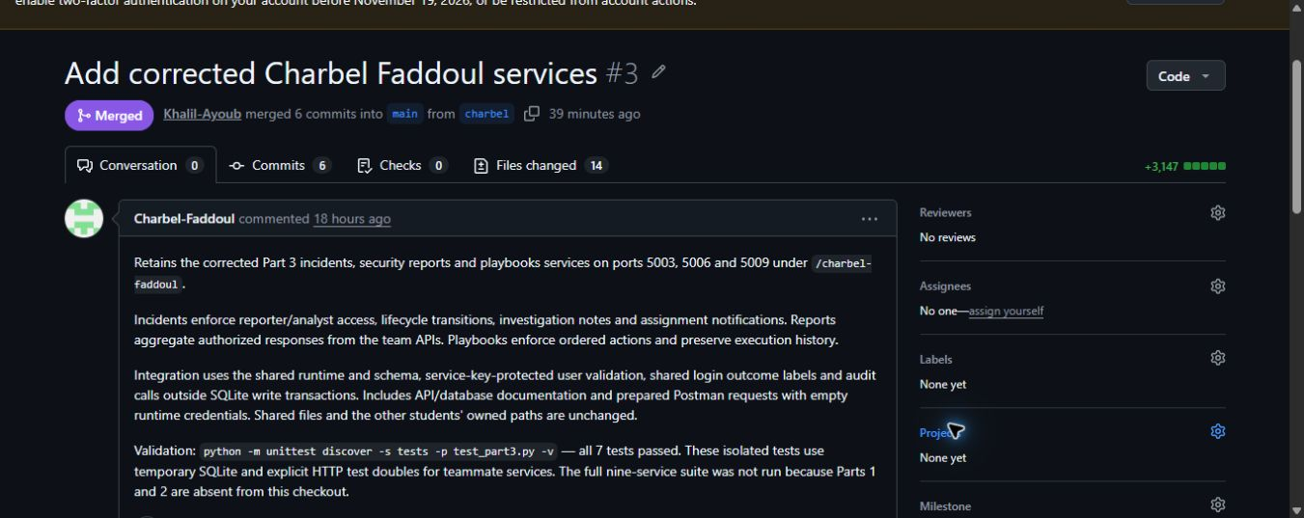
GitHub contribution (Charbel Faddoul). Actual merged PR 3 shows the student account and the description of the three owned services.
Pull request: https://github.com/Khalil-Ayoub/talia-semaan-khalil-ayoub-charbel-faddoul-435L/pull/3
Service implementation commit: 731f728f6149699068b430992288b19b2883523a

Verified repository contribution (Talia Semaan)
Users and identity, audit logs and notifications. Account: taliasemaan. Merged pull request: 4.
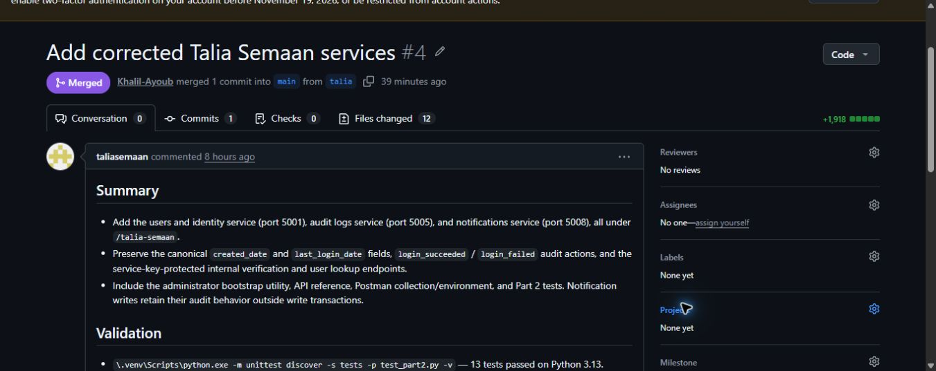
GitHub contribution (Talia Semaan). Actual merged PR 4 shows the student account and the description of the three owned services.
Pull request: https://github.com/Khalil-Ayoub/talia-semaan-khalil-ayoub-charbel-faddoul-435L/pull/4
Service implementation commit: ee7ea756aa99234abc0b66ce387543aaa47aacdd
GitHub records a Copilot co-author on Talia's commit. This metadata is preserved.

11 References (Khalil Ayoub, Talia Semaan and Charbel Faddoul)
Course assignment: Final Project Fall 2026-2027-Sprint 1, Software Tools Lab. Source of service, database, evidence and report requirements.
Flask documentation: https://flask.palletsprojects.com/ - routing, JSON responses, application factories and error handling.
Python sqlite3 documentation: https://docs.python.org/3/library/sqlite3.html - parameter binding and connections.
SQLite documentation: https://www.sqlite.org/foreignkeys.html and https://www.sqlite.org/lang_createtrigger.html - physical relationships and the immutable audit log trigger.
Werkzeug security helpers: https://werkzeug.palletsprojects.com/en/stable/utils/#module-werkzeug.security - password hashing and verification.
Requests documentation: https://requests.readthedocs.io/ - HTTP communication between services.
Postman documentation: https://learning.postman.com/docs/ - collection variables, runner and response assertions.
GitHub documentation: https://docs.github.com/en/pull-requests - branches, commits and pull requests.
AI assistance disclosure: Codex helped generate and revise code, integrate services, and prepare tests.

